

|  |
| --- |
| Whole Grains |
| * 100% whole wheat bread * Brown or wild rice * Whole wheat pasta * Whole wheat tortillas * Whole wheat crackers * Popcorn * Oatmeal * Whole grain cereal |
| Refined Grains |
| * White bread * White rice * White pasta * White tortillas * Saltines * Fritos |

**Wonderful Whole Grains!**

Happy “[**Whole Grains Month**](https://wholegrainscouncil.org/get-involved/celebrate-whole-grains-month-september)”! Let’s celebrate whole grains the entire month of September. First, what is a whole grain??

When a grain is **whole**, this means the *entire* grain is still there (nothing has been removed). Sometimes grains get processed into refined (*white*) flour and this takes away parts of the grain. This also takes away the healthy fiber and certain vitamins/minerals.

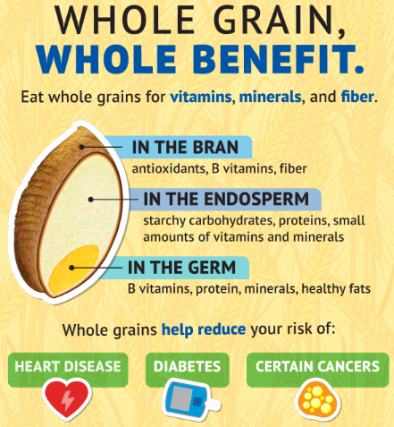

**Follow us on social media!**

[cid:image007.gif@01D088CC.43F0B9E0](http://www.tnsitechampions.com/)[](https://www.facebook.com/TNSiteChampions/)[](https://twitter.com/TNSiteChampions)[](https://www.instagram.com/workingforahealthiertn/)

**How do you enjoy whole grains?**

Let’s inspire each other on #WellnessWednesdays over on our [Facebook Page](https://www.facebook.com/WFHTN/)! (Be sure to let us know what department you’re with.)