

**March is National Nutrition Month!**

The [National Nutrition Month](https://www.eatright.org/food/resources/national-nutrition-month)® 2020 theme is ***Eat Right, Bite by Bite***. Make small goals and changes. Nutrition doesn't have to be overwhelming.

**Here are some tips to help you start making small changes:**

* **Make Half Your Plate Fruits and Vegetables –** Make 2 cups of fruit and 2 ½ cups of vegetables your daily goal. Experiment with different types, including fresh, frozen and canned.
* **Watch Portion Sizes –** Use half your plate for fruits and vegetables and the other half for grains and lean protein foods. To complete the meal, add a serving of fat-free or low-fat milk or yogurt.
* **Drink More Water –** Quench your thirst with water instead of drinks with added sugars.
* **Get Cooking –** Preparing foods at home can be healthy, rewarding and cost-effective. Master some kitchen basics, like dicing onions or cooking dried beans. Need recipe ideas? Click [HERE](https://www.tn.gov/wfhtn/resources/recipes.html)!
* **Slow Down at Mealtime –** Instead of eating on the run, try sitting down and focusing on the food you're about to eat. Dedicating time to enjoy the taste and textures of foods can have a positive effect on your food intake.

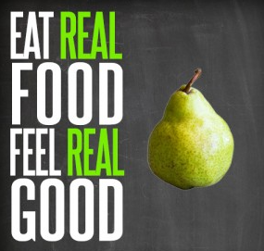

March Health Observances

[National Sleep Awareness Week](https://www.sleepfoundation.org/)

March 8-14, 2020

Let’s inspire each other on #WellnessWednesdays over on our [Facebook Page](https://www.facebook.com/WFHTN/)! (Be sure to let us know what department you’re with.)

**Follow us on social media!**

[cid:image007.gif@01D088CC.43F0B9E0](https://www.tn.gov/wfhtn)[](https://www.facebook.com/WFHTN)[](https://twitter.com/WFHTN)[](https://www.instagram.com/workingforahealthiertn/)[](https://www.youtube.com/user/TNSiteChampions)