**Keep Cool This Summer**

With summer fun comes a lot of potential health and safety challenges. Take a few minutes to read these tips to stay safe.

* **Outdoor Activities**
  + Limit your outdoor activity, especially midday when the sun is hottest.
  + Pace your activity. Start activities slow and pick up the pace gradually.
* **Hydration**
  + Drink plenty of fluids even if you don’t feel thirsty. Muscle cramping may be an early sign of heat-related illness.
  + For men, the Institute of Medicine (IOM) recommends a total of 13 cups of fluid each day. For women, they suggest 9 cups of fluid each day.
  + Stay hydrated by enjoying a variety of beverages, as well as eating [foods that have a high-water content](https://www.healthline.com/nutrition/19-hydrating-foods), such as fruits and vegetables. For drinks, focus on unsweetened beverages, like water, in order to limit calories from added sugars.
  + Make a goal and track your water intake daily with the [48-A-Day Water Challenge](https://www.tn.gov/content/dam/tn/wfhtn/documents/48-A-Day-Challenge-2019.pdf).
  + Try [Fruit Infused Water](https://www.tn.gov/wfhtn/resources/recipes/drinks/fruit-infused-water.html) for variety!
* **What to Wear** 
  + Wear loose, lightweight, light-colored clothing.
* Put on sunscreen and a wide-brimmed hat to protect your skin from the sun.
* **Prevent Heat-Related Illnesses**
* Seek medical care right away if you have symptoms of [heat-related illness](https://www.cdc.gov/niosh/topics/heatstress/heatrelillness.html).



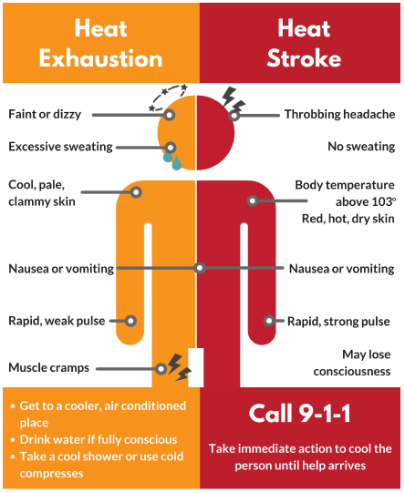

July Health Observances

[Park and Recreation Month](https://www.nrpa.org/events/july/)

[UV Safety Month](https://www.cancer.org/healthy/be-safe-in-sun.html)

**Let’s Inspire Each Other!**

Join us on #WellnessWednesdays over on our [Facebook Page](https://www.facebook.com/WFHTN/)! (Be sure to let us know what department you’re with.)

**Follow us on social media!**

[cid:image007.gif@01D088CC.43F0B9E0](https://www.tn.gov/wfhtn)[](https://www.facebook.com/WFHTN)[](https://twitter.com/WFHTN)[](https://www.instagram.com/workingforahealthiertn/)[](https://www.youtube.com/user/TNSiteChampions)