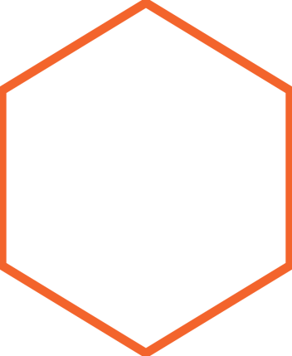



**National Humor Month**

|  |
| --- |
| [Studies](https://www.mayoclinic.org/healthy-lifestyle/stress-management/in-depth/stress-relief/art-20044456) show laughter increases the release of endorphins – those awesome chemicals in the brain that make us feel good. But, laughter isn’t just about feeling good because something’s funny. It actually boosts the immune system, lowers blood pressure, reduces tension and can improve cognition.  **Ways to Tickle Your Funny Bone**   * Set aside a "fun shelf” in your office or space in your desk drawer. Stock it with “fun-raisers.” * With permission, create a “humor break” space at work—include games. Pick a location where people can relax, get rejuvenated and refreshed. * Plan and take 5 one-minute “humor breaks” every day. * Shop for funny greeting cards. Buy some to have on hand for various occasions. * Take in a show at your local comedy club. * Sort through your photos and write funny captions to go with your favorites. When you need a pick-me-up, pull out the album. * Visit the humor section of your local bookstore or library. Check out a variety of media by funny people who match your sense of humor. * Play with your food. Make sandwich art and veggie rainbow and hummus dip. * Tell your favorite joke to at least five people on the same day. |
| A day without laughter is a day wasted. |
| **Humor Us**  Host a fun office activity and invite employees to participate (e.g., Laughter Yoga, Silly Hat Day or Fun Foods Party). [With permission](https://www.tn.gov/content/dam/tn/wfhtn/documents/WFHTN%20Photo%20Waiver%20Multi.pdf), share your photos on our social media sites or email [WFHT.TN@tn.gov](mailto:WFHT.TN@tn.gov).  [cid:image007.gif@01D088CC.43F0B9E0](https://www.tn.gov/wfhtn)[cid:image003.png@01D4AD68.9B4BFF00](https://www.facebook.com/WFHTN/)[cid:image004.png@01D4AD68.9B4BFF00](https://twitter.com/TNSiteChampions)[cid:image005.png@01D4AD68.9B4BFF00](https://www.instagram.com/workingforahealthiertn/)[cid:image006.png@01D4AD68.9B4BFF00](https://www.youtube.com/user/TNSiteChampions) |