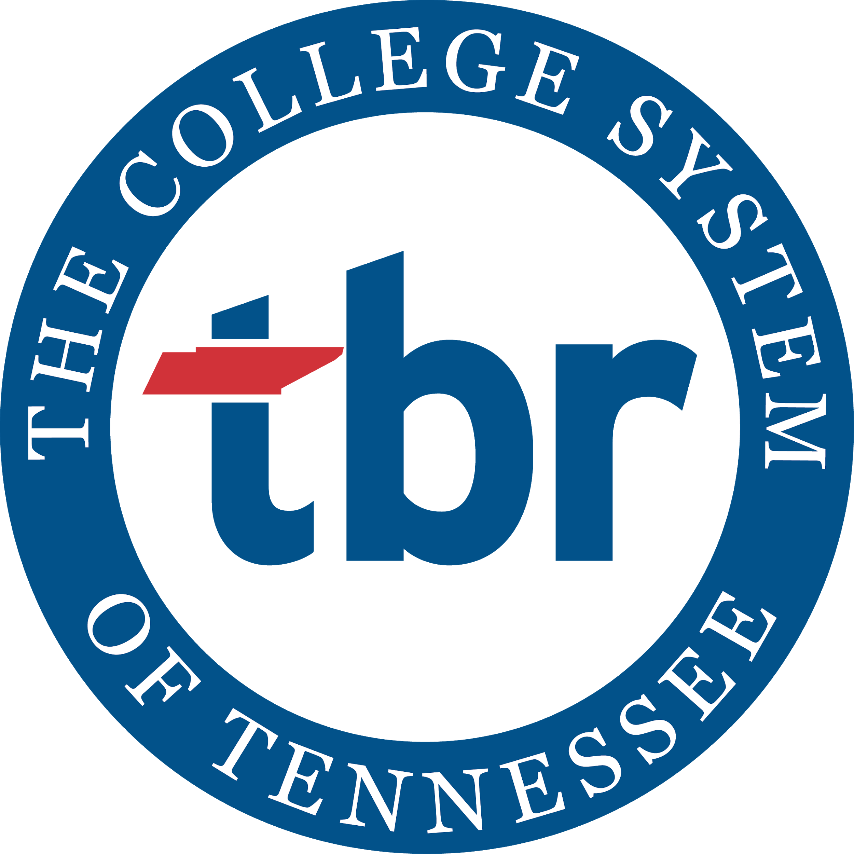
Serving Virtually in the Online Classroom
A Higher Education Track Presentation at 2021 TCVSL
Contact Dr. Melynda Conner, TBR HIP Specialist with any questions, melynda.conner@tbr.edu

Minimum Definition of TBR Service Learning
Service-learning is a teaching and learning strategy that integrates meaningful community service with instruction and reflection to enrich the learning experience, teach civic responsibility, and strengthen communities. Curriculum includes structured field-based “experiential learning” alongside community partners, which reinforces course learning outcomes. Within the TBR System, credit-bearing service-learning designated courses are incorporated into general education or college core requirements for a degree program.

TBR Service Learning Research
Positive outcomes of service-learning participation for the 2017 cohort:
- Higher probability of graduation & transfer
- Higher GPA
- Faster progression to graduation
Results improved with an increase in duration (more service hours) & frequency (more than one service-learning class).

Local but Remote Service Learning Activities
- Making cards of inspiration for residents and staff quarantined in assisted living facilities.
o Many individuals are currently isolated in senior living facilities. They are not able to see their family or leave for their own health protection. Mental health is an important part of overall health, including or emotional, psychological, and social well-being. Our mental health affects how we think, feel, and act, as well as how we handle stress, relate to others and make healthy choices. Cards of inspiration send out joy during this difficult time. You can use pre-made greeting cards or get crafty with homemade cards. Seniors especially enjoy uplifting words and colorful drawings that make them smile.

2. Sewing reusable cloth face masks for healthcare staff and patients.
  - Several facilities have a need for masks. Check with those in your town!

- Contributing to Library archives through a COVID-19 Living History project.
o A COVID-19 Story Living History Project is designed to collect and then tell the story of attending school during the COVID-19 Pandemic. How did your life change during the height of the pandemic? What about your daily routine changed? What didn’t? This type of archive provides a clearer picture of how COVID-19 influenced our country and our communities.
- Making story time and craft time videos for area public libraries.
  - Volunteers create a video of themselves reading a story for small children or explaining how to make a craft. They submit the video to be shared on the library’s website.

- Adapting jigsaw and other minimal piece puzzles for seniors affected by dementia.
  - Seniors in assisted living and memory care facilities find it helpful to have puzzle pieces sectioned and labeled so that they can complete the puzzle more easily. Volunteers label and color code the puzzle pieces and place them in zipped plastic bags for each puzzle section.
There are many helpful ways to engage in service-learning remotely. Reach out to your community partners and investigate new projects for your students today!

Online Only Virtual Service Learning Options
Zooniverse (zooniverse.org) – Assist researchers with answering interesting questions about our world. Aid in new discoveries or contribute to open-source sets of analyzed data.
Project Gutenberg (Gutenberg.org) -- Proofread electronic transcriptions of e-books published prior to 1927 with expired copyrights to help fulfill the mission of “preserving the literary history of the world in a freely available form for everyone to use.”
Cornell University’s eBird Project (ebird.org/home) – Track bird populations, record sightings, or upload pictures and sound files to help scientists and conservationists understand the population-level movements and needs of many species on a global scale.
Project Implicit (implicit.harvard.edu) – Volunteers take Implicit Association Tests that ask questions about our understandings and attitudes to learn more about the differences in values and beliefs between people and groups.

Virtual Service Learning Resources to Get You Started

1. Sandy, M.F. & Franco, Z.E. (2014). Grounding servlce-learning in the digital age: Exploring a virtual sense of geographic place through online collaborative mapping and mixed media. Journal of Higher Education Outreach and Engagement, 18(4), p. 201. Retrieved from https://files.eric.ed.gov/fulltext/EJ1051068.pdf

2. Waldner, L.S., McGorry, S.Y., & Widener, M.C. (2012). E-service-learning: The evolution of service-learning to engage a growing online student population. Journal of Higher Education Outreach and Engagement, 16(2), p. 123. Retrieved from https://usm.maine.edu/sites/default/files/center-collaboration-development/MMU_E-ServiceLearning.pdf

3. Service Learning in the Online Landscape: Exploration of Models, http://www.ccmountainwest.org/sites/default/files/E-SL_Billings_Powerpoint.pdf

4. Service Learning Projects in Online Courses: Delivery Strategies, https://files.eric.ed.gov/fulltext/EJ1141925.pdf

5. Engaging Online Students with their Communities, https://www.washington.edu/trends/engaging-online-students-with-their-communities/

6. Technology-enhanced service learning and community building activities, https://www.learningtogive.org/resources/service-learning-and-community-building-activities

7. The Center for Digital Civic Engagement’s Service Learning in Online Courses (long list of resources), https://cdce.wordpress.com/service-learning-in-online-courses/

Other Lists of Virtual Volunteering Opportunities:

https://www.operationwarm.org/blog/25-volunteer-jobs-to-do-from-home/

https://www.goodwill.org/blog/volunteer/build-your-career-by-volunteering-online/

https://www.careeraddict.com/online-volunteering-opportunities

Service Learning Done Well in 3 Easy Action Steps

Connect the service with classroom learning in relevant ways prior to the experience.

Integrate lessons and assignments related to the purpose of the service activity.
Do:
- Align the service with your course student learning objectives (SLOs).
- Articulate how the service will advance learning of course concepts.
- Clearly describe within the syllabus how the service experience functions as a teaching tool.
- Use assignments to prepare students for what you want them to gain from participating in the service.
Don’t:
- Assign students separate “service-learning assignments” and “regular assignments.”

Define the service experience.
Clarify what is expected of students and outline how they will be graded.
- Detail all service experience start and end dates.
- Clearly explain the specific service learning experience structure and deadlines on the syllabus.
- Provide a grading rubric that sets clear guidelines and demonstrates the integral role service will play in student learning and evaluation.

Collect student reflections as a graded assignment.
Students should be graded for their learning, not for their service. Reflective course assignments are used to connect academic content and service, allowing faculty to grade students’ demonstration of learning.
Reflection in your course should:

- prompt students to use course concepts to interpret service experiences.

- provide the opportunity for students to critically think at many levels.
What?
What happened? Who was involved? What were my own initial reactions and perspectives?
So What?
What impact did the service have on the community and on me? What lessons did I learn and what perspectives did I gain?
Now What?
How will my experience inform my future choices? How can I apply my new learning/perspective to other situations?

Additional Resources
4 Virtual Volunteer Opportunities that Make Great Service Learning Projects
40 Reflection Questions by Edutopia
eService-Learning: Creating Experiential Learning and Civic Engagement through Online and Hybrid Courses by Strait and Nordyke
Examples of Service Learning Reflection Questions based on the What? So what? Now what? Model
Online Service Learning: Exercises for Students by University of Tennessee’s Department of Teaching and Learning Innovation
Writing Student Learning Objectives

References
Eyler, J. & Giles, D. (1997). “The Importance of Program Quality in Service-Learning,” in A. S. Waterman (Ed.), Service-Learning: Applications from the research. Mahwah: Lawrence Erlbaum Associates, 63-66.
IOH Toolkit. (2016). Chapter 7: Service Learning. Northeastern University. https://www.northeastern.edu/oralhealth/toolkit/7-service-learning/integration-of-service-learning-into-course-assignments/
TBR. (2020). Service Learning. https://www.tbr.edu/academics/studentaffairs/hip-taxonomy-service-learning

