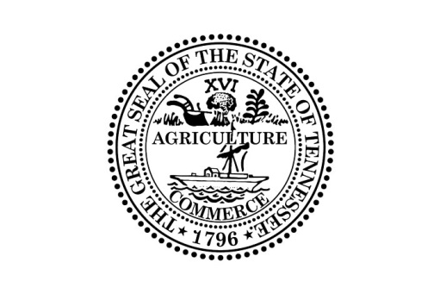

Public Meeting Notice

The Tennessee Financial Literacy Commission (“TNFLC”) Board will be meeting at 3:00 P.M. (Central Time) on April 9, 2019 in the Executive Conference Room located at the Tennessee State Capitol, Ground Floor; 600 Charlotte Avenue; Nashville, Tennessee 37243. TNFLC will consider the following contracts:

- Approval of FY19-20 Budget;
- Election of Officers
- Contract with Dr. Nichole Saulsberry-Scarboro to provide teacher training summits in financial literacy
- Update on TNFLC initiatives
- Other Business.

This meeting will be conducted permitting participation by electronic or other means of communication pursuant to Tenn. Code Ann. § 8-44-108. Please contact Bill Parker, Director of the Tennessee Financial Literacy Commission at (615) 532-5892 for more information.

Individuals with disabilities who wish to participate in these proceedings and require an accommodation should contact Bill Parker, Director of the Tennessee Financial Literacy Commission no fewer than two (2) days prior to the scheduled meeting date to allow time for the Treasury Department to arrange for an accommodation. You may contact the Tennessee Financial Literacy Commission at Andrew Jackson Building, 15th Floor; 502 Deaderick Street; Nashville, Tennessee 37243; (615) 532-5892, or Bill Parker by email at Bill.Parker@tn.gov.

