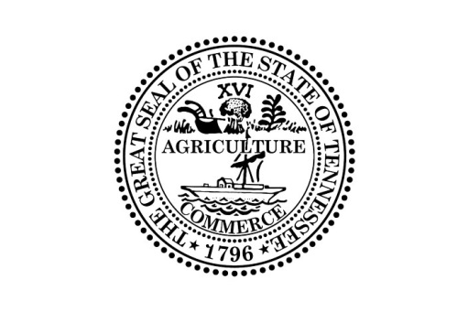

Public Meeting Notice

The Collateral Pool Board will be meeting at 2:00 P.M. (Central Time) on February 3, 2020 in Conference Room 8C on the 8th Floor of the Cordell Hull Building, located at 425 5th Ave. North, Nashville, Tennessee 37243. An agenda will be posted at a later date.

This meeting may be conducted permitting participation by electronic or other means of communication pursuant to Tenn. Code Ann. § 8-44-108. Please contact Roger Henry, Assistant Cash Manager, at (615) 532-8722 for more information.

Individuals with disabilities who wish to participate in these proceedings and require an accommodation should contact Roger Henry, Assistant Cash Manager, no fewer than two (2) days prior to the scheduled meeting date to allow time for the Treasury Department to arrange for an accommodation. You may contact the Collateral Pool Board at Andrew Jackson Building, 13th Floor; 502 Deaderick Street; Nashville, Tennessee 37243; (615) 532-8722, or Roger Henry by email at roger.d.henry@tn.gov.

