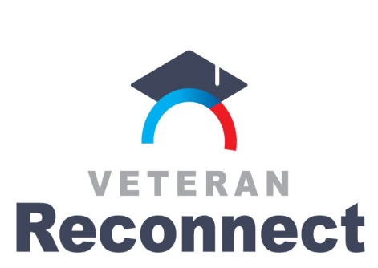

2018-2019 Veteran Reconnect Grants
Prior Learning Assessment (PLA):
Sustainability Initiative
Frequently Asked Questions

What is the page limit and format for the proposals?
The narrative portion of the proposal should be limited to 15 pages. This does not include the cover page, project abstract, budget template, and appended lists. Use no smaller than 11 point font and 1.5 spacing.

How are the proposals scored? What is each section worth?
Each section may be awarded up to four points. Each section is weighted for a total of 100 percent. Please note the percentage breakdown below:
Section | Percentage of Score
Webinar | 6%
1 | 4%
2 | 18%
3.1 | 10%
3.2 | 8%
3.3 | 10%
3.4 | 8%
3.5 | 8%
3.6 | 8%
4 | 20%
TOTAL: | 100%

In section 1, what populations of veterans and service members should be included?
You can include Post-9/11 GI Bill recipients at your institution. Also you can find county census data. Here are three websites with census data that may be useful:

- US. Census quickfacts can select county data:
https://www.census.gov/quickfacts/fact/table/tn,US/PST045217

- US Census provides visualization of county:
https://www2.census.gov/library/visualizations/2015/comm/vets/tn-vets.pdf

- US Veterans Affairs Website:
https://www.va.gov/vetdata/veteran_population.asp

In section 3.5, are there certain activities that you are looking for?
Reviewers will be looking for action items completed in the first couple months (October 2018-December 2018). These could include meetings, collaboration with campus stakeholders, ways to engage faculty and academic affairs administrators, etc. In prior rounds, we have seen the most successful PLA initiatives have made great strides within the first 3 months.

Who will review the submissions?
Reviewers will include those with an understanding of veterans and/or prior learning assessment. We will also randomly match reviewers to proposal submission keeping conflict of interest in mind. Reviewers will be a mix of representatives from state agencies and from the community as advocates for furthering student veterans’ academic success.

If awarded a grant, will funding be issued as an amendment to the grant from Round 3? If so, can funds be carried forward from the Round 3 grant into the project period for Round 4? If not, will it be possible to request a no-cost extension for Round 3 funding?
Yes, this Round 4 grant will be an amendment to your current contract from Round 3, instead of creating a new contract. At this point, there should be no issues with carrying forward your funds from the current contract. By including Round 4 as an amendment, institutions will not have to close out two separate contracts and will have the ability to carry forward funds from the original contract.

Can funds be used for salaries or stipends?
Funds can be used for salaries/stipends for the Sustainability Initiative. There is no salary limitation on the proposed budget as long as it is within $25,000 limit listed in the RFP. However, there would need to be a justification of the amount being used for continued salary and how it would be linked to current or new enhancements within the new proposal. Keep in mind, this new grant amendment is not about keeping someone employed for an extended period of time. The new amendment is about continuing the good work already in progress for improvement, and enhancing upon the work you’re already doing from Round 3 Veterans Reconnect that may need more time to complete. As with any successful program, continuous process improvement is essential to success.

