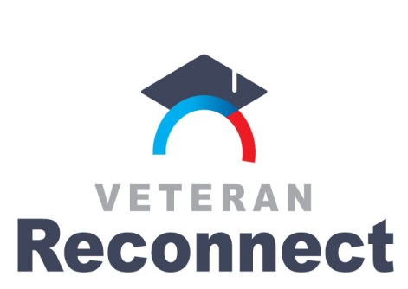

2018-2019 Veteran Reconnect Grants
Prior Learning Assessment (PLA):
Process Initiative
Frequently Asked Questions

What is the page limit and format for the proposals?
The narrative portion of the proposal should be limited to 15 pages. This does not include the cover page, project abstract, budget template, self-evaluation, and appended lists. Use no smaller than 11 point font and 1.5 spacing.

How are the proposals scored? What is each section worth?
Each section may be awarded up to four points. Each section is weighted for a total of 100 percent. Please note the percentage breakdown below:
Section | Percentage of Score
Webinar | 6%
1 | 4%
2 | 18%
3.1 | 10%
3.2 | 8%
3.3 | 10%
3.4 | 8%
3.5 | 8%
3.6 | 8%
4 | 20%
TOTAL: | 100%

In section 3.5, are there certain activities that you are looking for?
This could be any number of activities that relate to veterans PLA and the process improvement or enhancements the institution proposes to work on during the grant period. In regards to the first few months, these are the first few activities that would get the process started so as to avoid road blocks when time is too busy to focus on veterans PLA. Examples could be: establish veterans PLA review team; convene veterans PLA council/committee; review ACE Military Guide to determine relevant occupational specialties and military training; etc. These are just a few activity ideas that may be relevant to the overall project.

In section 1, what populations of veterans and service members should be included?
You can include Post-9/11 GI Bill recipients at your institution. Also you can find county census data. Here are three websites with census data that may be useful:

- US. Census quickfacts can select county data:
https://www.census.gov/quickfacts/fact/table/tn,US/PST045217

- US Census provides visualization of county:
https://www2.census.gov/library/visualizations/2015/comm/vets/tn-vets.pdf

- US Veterans Affairs Website:
https://www.va.gov/vetdata/veteran_population.asp

Who will review the submissions?
Reviewers will include those with an understanding of veterans and/or prior learning assessment. We will also randomly match reviewers to proposal submission keeping conflict of interest in mind. Reviewers will be a mix of representatives from state agencies and from the community as advocates for furthering student veterans’ academic success.

