NCD Catalog Submissions
Definitions:
A Full Re-Approval requires that the school submit their most current catalog(s) along with the completed VA Form 22-10287 in its entirety. All programs on the WEAMs form must be listed on the TN-SAA Program Submission List for continued programs or programs to be withdrawn. All new programs should be signified as such. The Full Re-Approval must be submitted every 36 months.
An Approval Modification application is required when a new course catalog is published, policy changes have been made or programs are added, withdrawn or modified.
To fill out the form for an Approval Modification:
Complete all three section on page one of the Application for Approval, Organizations Other Than Institutions of Higher Learning.
Worksheet A-page 2 and following of the application:
Please ensure the following areas are completed:
- PART I WORKSHEET A: Complete all sections
- PART II WORKSHEET A: Only complete this section If changes in the catalog were made to any of the areas effect any areas of Part II of Worksheet A- Item 11
  - Example: the modification includes changes to the Institutions Grading System 11b, 11c would need to be completed for this item

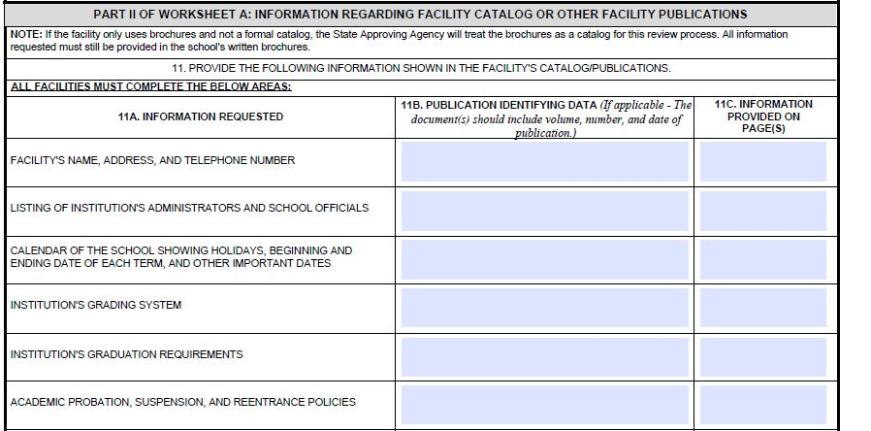

- PART III WORKSHEET A: Complete all sections based off appropriate accreditation status.
- PART IV WORKSHEET A:Read each item in Part IV and initial those that pertain to your school (Accredited, Non-Accredited, New, All) (Accredited refers to an accrediting agency that is recognized by the Department of Education).
- PART V WORKSHEET A: Complete all sections.
- PART VIII: Item 22- Remarks: Proved a brief description of the modifications being made (Examples: Submitting a new catalog, adding new programs, change of ownership, updated programs, new location, etc.)
If this Catalog Modification includes changes such as adding new programs, modifications to currently approved programs, or withdraw of currently approved programs, please complete the following steps:
- Fill out the TN-SAA Program Submission List
  - Ensure that you are using the correct worksheet for your facility type. This selection is at the bottom. If changes to NCD programs are being requested, both worksheets will need to be updated.
- You will ONLY LIST NEW PROGRAMS, WITHDRAWN PROGRAMS, OR PROGRAMS WITH MODIFICATIONS
  - For a modification, you DO NOT need to list all programs that are approved and listed on the WEAMS form. Only programs that reflect a change need to be listed.
Submit the completed VA Form 22-10288 and your current catalog with supporting documents to the TN-SAA using the Catalog Modification Submission Link
- https://stateoftennessee.formstack.com/forms/ihl_ncd_catalog_approvals_1232020_copy_2_copy_copy

