Catalog Submissions
Definitions:
A Full Re-Approval requires that the school submit their most current catalog(s) along with the completed VA Form 22-10287 in its entirety. All programs on the WEAMs form must be listed on the TN-SAA Program Submission List for continued programs or programs to be withdrawn. All new programs should be signified as such. The Full Re-Approval must be submitted every 36 months.
An Approval Modification application is required when a new course catalog is published, policy changes have been made or programs are added, withdrawn or modified.
To fill out form for a Modification:
When filling out the VA Form 22-10287 for an Approval Modification, please ensure the following areas are completed:
- PART I: Complete sections 1-13.
- PART I: Complete item 14 only if requesting new instructional modalities.
- PART II: If changes in the catalog effect any areas under Part II of Information Regarding Facility Catalog or Other Facility Publications- indicate the change in item 15
  - Example: the modification includes changes to the academic calendar 15b, 15c would need to be completed for this item

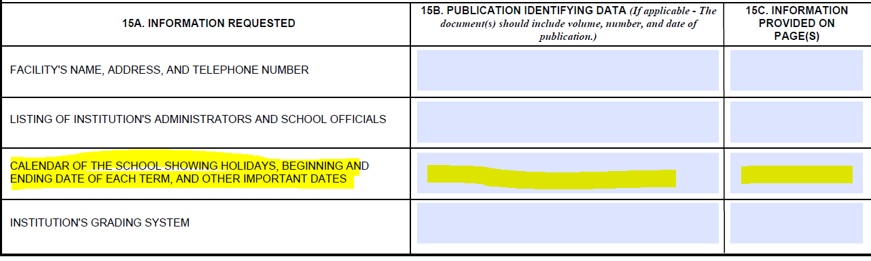

- PART V:
  - Complete all questions for the appropriate accreditation status -Information Regarding Operational Status of the Facility
- Part VI: Complete all questions.
  - Read each item in Part VI and initial those that pertain to your school (Accredited, Non-Accredited, All) (Accredited refers to an accrediting agency that is recognized by the Department of Education).
- PART VII: Complete all sections.
- PART VIII: In the Remarks section: List the action that you would like to have reviewed (Example: new program, change of ownership, updated programs, new location, etc.
- PART IX: Complete all sections
- PART X: Complete all sections
If this Approval Modification includes the addition, modification or withdrawal of programs, please complete the following steps:
- Fill out the TN-SAA Program Submission List
  - Ensure that you are using the correct worksheet for your facility type. This selection tabs are located at the bottom of the spreadsheet. If changes to IHL and NCD programs are being requested, both worksheets will need to be updated.
- You will ONLY LIST NEW PROGRAMS, WITHDRAWN PROGRAMS, OR PROGRAMS WITH MODIFICATIONS
  - For a modification, you DO NOT need to list all programs that are currently approved for your school. Only programs that reflect a change need to be listed.
Submit the completed VA Form 22-10287 along with supporting documents to the TN-SAA using the Approval Modification Link:
https://stateoftennessee.formstack.com/forms/ihl_ncd_catalog_approvals_1232020_copy_2_copy_copy

