Documentation for Category B: Emergency Protective Measures

This document is to provide general direction on documentation required to support costs incurred from eligible Emergency Protective Measures under the Federal Emergency Management Agency (FEMA) Public Assistance program. It is divided into five areas: Labor, Equipment, Materials, Fees Paid, and Other. The attachments supplied with this guidance are what the Federal Emergency Management Agency (FEMA) uses. For the labor, equipment, and materials, the spreadsheets provided do not have to be used if you already have a system that covers the required information (or could with minor editing). If you do not have a system, these can help you accumulate much of the data needed.

Labor

When documenting labor costs, there are specific questions that must be answered. Using the following formula provides all the information needed to support labor costs: who, what, when, where, how long, and how much. Documentation covering those questions is what is needed for internal employees, mutual aid, and donated services.

- Who is the worker (Name, Title)
- What the worker did (Task)
- When the worker worked (Date)
- Where the worker worked (Location)
- How long the worker worked (Written record)
- How much did the worker get paid (payroll record, fringe benefits calculation and payroll policy)

If you use the Force Account Labor Record, you will need to add information to show the location where the worker worked and what task the worker performed. You can also use FEMA’s Fringe Benefit Calculation Worksheet for calculating the fringe benefits of each worker.

Documentation that supports claimed labor costs include timesheets, payroll records, payroll policy, and fringe benefits calculation. FEMA reviews the payroll policy to ensure the employees are being paid according to the established policy.

Equipment

Much of the equipment documentation mirrors that of the labor. The same formula is used with variations on the questions. In addition, the documentation covering these questions is what is needed for internal work, mutual aid, and donated equipment. As stated before, if you have all the information required in your own spreadsheet or organized system, this is sufficient. If not, the Force Account Equipment Record is excellent for capturing all the data required.

- Who operated the equipment
- What equipment and what task was performed with the equipment
- When was the equipment used
- Where was the equipment used
- How long was the equipment used
- How much cost for equipment is determined using FEMA’s 2019 Schedule of Equipment Rates. However, if you have your own schedule of equipment rates, FEMA will use whichever is the lesser.

If you use the Force Account Equipment Record, you will need to add information to show the location where the equipment was used and what task was performed with the equipment. Make sure that the person who is operating the equipment is also on the labor record for the same time period as the equipment.

Documentation that supports claimed equipment costs include an equipment log or record.

Material

Material documentation uses the same formula with variations of the questions. As stated before, if you have all the information required in your own spreadsheet or organized system, this is sufficient. If not, the Force Account Materials Summary Record is excellent for capturing all the data required.

- Who is the vendor
- What materials were used (description)
- When were the materials purchased and used
- Where were the materials used
- How much to replace the materials

Unless the locations of where the materials were used required a separate listing, you can use the comments field of the Force Account Materials Summary Record to input the location of where the materials were used.

Documentation that supports claimed material costs include the procurement policy, bids, purchase orders, invoices, cancelled checks, etc. It is dependent on the purchases. Whatever is required by your procurement policy is reviewed to ensure it was followed.

Fees Paid

Note: If response activities are ongoing and you are – or are anticipating – contract services, please ensure that you read and follow the guidance below.

For procurement, the documentation should show where the procurement policy has been followed. Also, 2 Code of Federal Regulations §200.318 requires applicants to use the most stringent of Federal, State, and Local procurement. The below slide shows the results of comparing Tennessee and Federal procurement requirements. You can use the Most Restrictive column to compare against your own procurement policy.

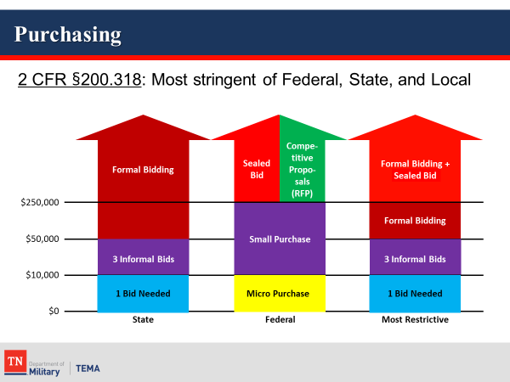

Types of documentation required for purchases is the same as shown under Materials. For contracting, the documentation includes, but may not be limited to, the following:

- Procurement Policy
- Bid Advertisement
- Bid Summary
- Qualified Bidders
- Contract including required Contract Clauses
- Invoices/Statements
- Canceled Checks

The best resource for Federal procurement information applicable to the Public Assistance program is via the Procurement Disaster Assistance Team (PDAT) website, www.fema.gov/procurement-disaster-assistance-team. Among other great subjects, this website includes a 2019 PDAT Contract Provisions Template and a PA Reasonable Cost Evaluation Job Aid.

Other

The Categorical Information Checklist for Category B contains a lot of information. It is set up to include all possible types of eligible work. Some of the documentation needed is not contained in the previous four areas. Fill in what you can where it applies to your claimed costs.

All costs do not have to be in one report. It’s actually preferable for them to be logically grouped. Separate your costs into the five groups provided in this document.

If you have any questions on what is considered eligible, FEMA’s Public Assistance Program and Policy Guide contains a section on eligible activities under Category B, Emergency Protective Measures. This publication can be downloaded from FEMA’s website at https://www.fema.gov/media-library/assets/documents/111781.

