**FOR IMMEDIATE RELEASE**

July 30, 2021

**CONTACT:** Nichole Lawrence

**CELL:** 731-225-6041

**I-40 Hernando DeSoto Bridge Repair**

Daily Update

The contractor is ahead of schedule and the eastbound lanes will now reopen tomorrow night! It is possible the westbound lanes could reopen before Friday. We will keep you posted on the exact day and time. **\*Please note this schedule is barring any complications.\***

**Reopening Plan:**

* **Saturday, July 31 at 10 p.m. CST: All I-40 Eastbound Lanes Open**
* **Friday, August 6 (time TBA): All I-40 Westbound Lanes Open**

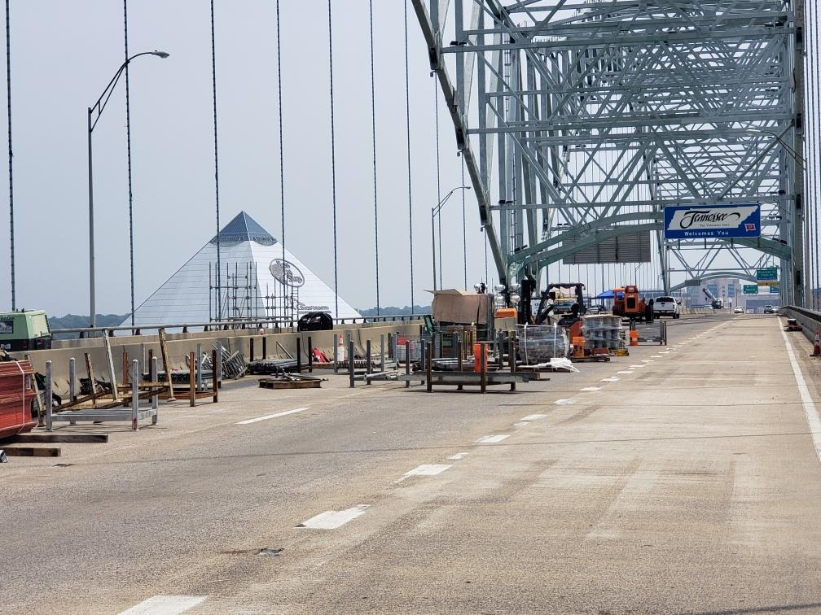 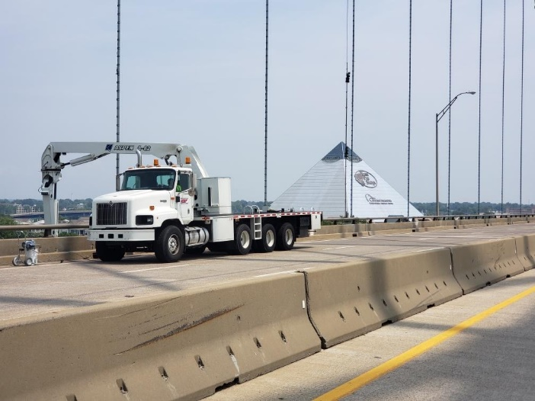

**Eastbound Cleanup Snooper Truck painting WB side**

The bridge remains an active work zone. We ask motorists to pay attention to the interstate DMS, portable message boards, and SmartWay for specific traffic information.

Load testing was completed on the bridge Wednesday. The purpose of the testing was to generate standardized performance data using known truck weights at specific locations along the length of the bridge. The data collected will help rate the bridge's performance in the future. The testing is not connected to the opening of the bridge to traffic.

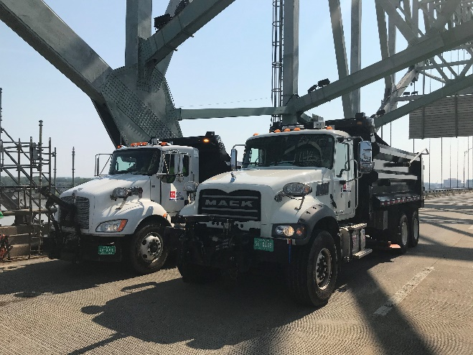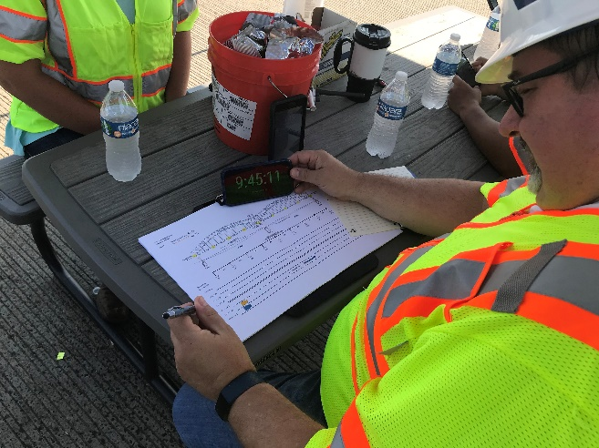

**Load Testing**

A reminder, we added two portable cameras: One on the bridge and one to monitor traffic at the I-55 Crump Interchange.

* <https://smartway.tn.gov/camera/2327>
* <https://smartway.tn.gov/camera/2326>

All interstate traffic in the Memphis area is still being diverted to I-55. To help you plan ahead, every Monday, we are posting [estimated average travel delays for the week](https://www.tn.gov/tdot/projects/region-4/i-40-hernando-desoto-bridge.html) on our website so you can see which days and times to avoid. You can also view real-time digital message signs alerting you of any incidents.

TDOT HELP trucks are stationed on both sides of the I-55 bridge to respond quickly to any incidents and keep lanes open. Below are direct links to the [TDOT SmartWay](https://smartway.tn.gov/) cameras posted at the east and west approaches of I-55 for live traffic information.

[West Approach to I-55 River Crossing](https://smartway.tn.gov/traffic?features=incident,traffic,messageSign,cameras&position=35.15976118,-90.14262298,14)

[East Approach to the I-55 River Crossing](https://smartway.tn.gov/traffic?features=incident,traffic,messageSign,cameras&position=35.11247994,-90.07716707,15)

We are still holding daily meetings with ARDOT, our consultants, Tennessee Highway Patrol, Memphis Police Department, and FHWA to develop and expedite the repair project while managing traffic along

the alternate routes.

**\*Please note updates are twice a week, Monday and Friday**.* You can follow @myTDOT on Facebook, Twitter, and Instagram for the latest. We continue to update our photo album on Facebook called [I-40 Hernando DeSoto Bridge – Memphis, Tennessee](https://www.facebook.com/media/set/?vanity=myTDOT1&set=a.10157986173622551). We also have a webpage dedicated to the bridge repair. For updates and press releases, click on **Library** from your menu options: <https://www.tn.gov/tdot/projects/region-4/i-40-hernando-desoto-bridge.html>.

###