FOR IMMEDIATE RELEASE
July 2, 2021

CONTACT: Nichole Lawrence
CELL: 731-225-6041

I-40 Hernando DeSoto Bridge Repair
Daily Update

As 24/7 operations continue, the contractor is making significant progress on the repairs. All structural and splice plates have been installed at the fracture location. Below is work that will be happening over the next several days.

- Minor miscellaneous drilling remains on some small connection pieces.
- Final bolting and torqueing are ongoing and should be completed by tonight.
- De-stressing of the post-tensioning (PT) system should be completed on Saturday.
- Once the PT system is de-stressed, removing the PT Rods and weldment/anchors will begin
next week.
- Removal of the rigging from the upper truss section will also begin next week.
- Several miscellaneous bracing and connection pieces that were initially removed to accommodate the work are being re-installed.

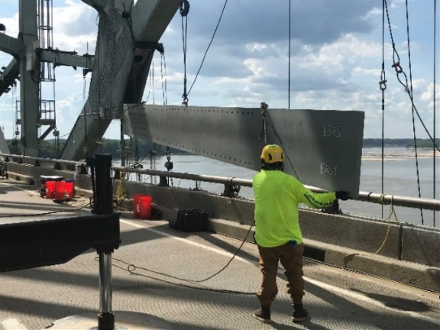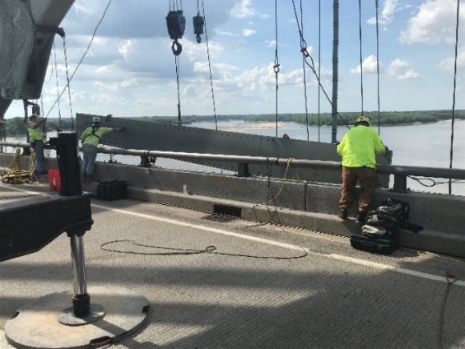

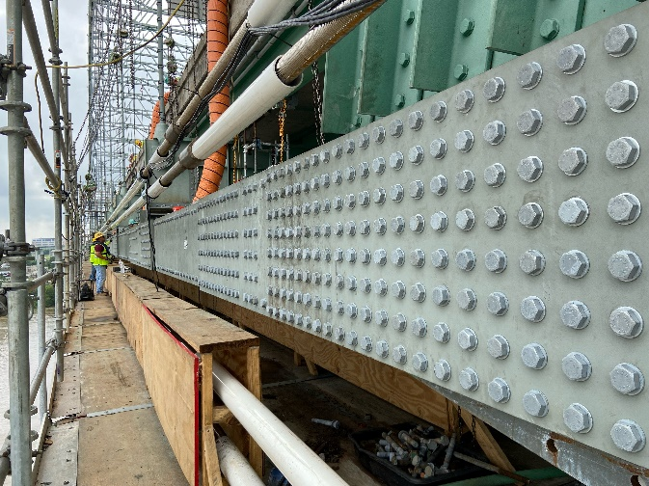
Last Big Plate Installed

Today the department received a draft report on the inspection. No failures were found but we have identified locations that may need some additional repairs. We have asked the contractor to proceed with sourcing the various materials we’ll need for those repairs. No detailed schedule yet but our original end of July date is still the goal. The safety of the workers and the public is our number one priority.

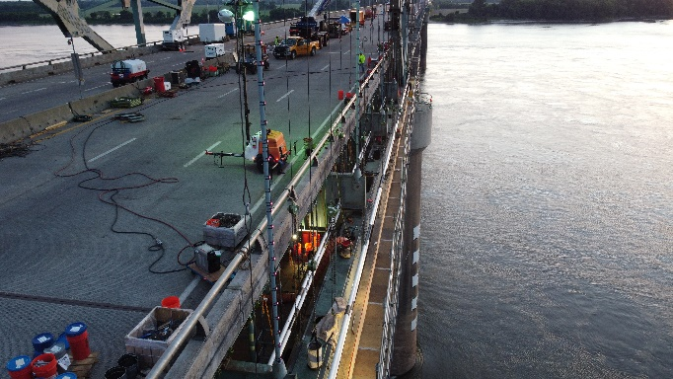
Drone Pics

A reminder, we have added two new portable cameras: One to monitor work on the I-40 bridge and one to monitor traffic at the I-55 Crump Interchange.
- https://smartway.tn.gov/camera/2327
- https://smartway.tn.gov/camera/2326

All interstate traffic in the Memphis area is being diverted to I-55. To help you plan ahead, every Monday, we are posting estimated average travel delays for the week on our website so you can see which days and times to avoid. You can also view real-time digital message signs alerting you of any incidents.

TDOT HELP trucks are stationed on both sides of the I-55 bridge to respond quickly to any incidents and keep lanes open. Below are direct links to the TDOT SmartWay cameras posted at the east and west approaches of I-55 for live traffic information.

West Approach to I-55 River Crossing
East Approach to the I-55 River Crossing

We are holding daily meetings with ARDOT, our consultants, Tennessee Highway Patrol, Memphis Police Department, and FHWA to develop and expedite the repair project while managing traffic along
the alternate routes.

*Please note due to the holiday, your next update will be on Tuesday.* You can follow @myTDOT on Facebook, Twitter, and Instagram for the latest. We continue to update our photo album on Facebook called I-40 Hernando DeSoto Bridge – Memphis, Tennessee. We also have a webpage dedicated to the bridge repair. For updates and press releases, click on Library from your menu options: https://www.tn.gov/tdot/projects/region-4/i-40-hernando-desoto-bridge.html.

###

