FOR IMMEDIATE RELEASE
July 16, 2021

CONTACT: Nichole Lawrence
CELL: 731-225-6041

I-40 Hernando DeSoto Bridge Repair
Daily Update

Contractors are making progress on the phase three repairs. The first six plates arrived on site yesterday and are being installed now. Design plans for the remaining ten plates are being finalized for fabrication. The prep work continues cutting access holes for the additional plates and building the platform, which will be complete by Sunday. 24/7 operations are expected to resume next week.

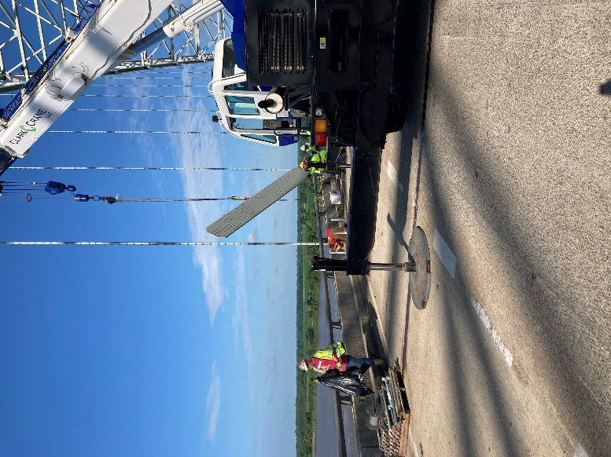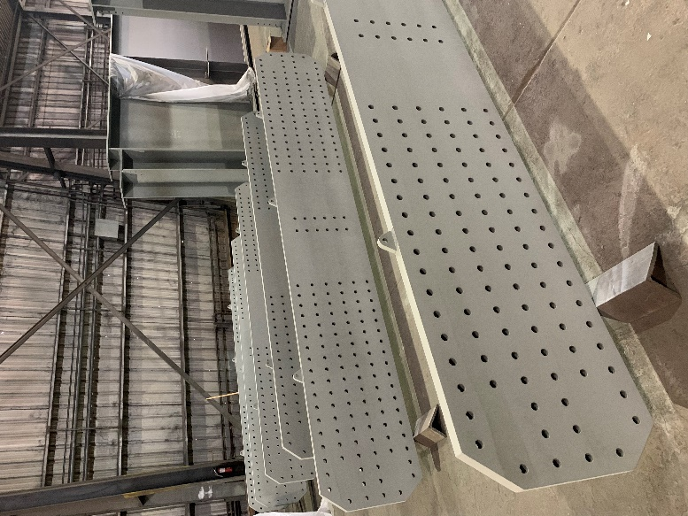
New Plate Installation AFCO Plate Fabrication

A reminder, we have added two new portable cameras: One to monitor work on the I-40 bridge and one to monitor traffic at the I-55 Crump Interchange.
- https://smartway.tn.gov/camera/2327
- https://smartway.tn.gov/camera/2326

All interstate traffic in the Memphis area is being diverted to I-55. To help you plan ahead, every Monday, we are posting estimated average travel delays for the week on our website so you can see which days and times to avoid. You can also view real-time digital message signs alerting you of any incidents.

TDOT HELP trucks are stationed on both sides of the I-55 bridge to respond quickly to any incidents and keep lanes open. Below are direct links to the TDOT SmartWay cameras posted at the east and west approaches of I-55 for live traffic information.

West Approach to I-55 River Crossing
East Approach to the I-55 River Crossing

We are holding daily meetings with ARDOT, our consultants, Tennessee Highway Patrol, Memphis Police Department, and FHWA to develop and expedite the repair project while managing traffic along
the alternate routes.

*Please note updates are twice a week, Monday and Friday.* You can follow @myTDOT on Facebook, Twitter, and Instagram for the latest. We continue to update our photo album on Facebook called I-40 Hernando DeSoto Bridge – Memphis, Tennessee. We also have a webpage dedicated to the bridge repair. For updates and press releases, click on Library from your menu options: https://www.tn.gov/tdot/projects/region-4/i-40-hernando-desoto-bridge.html.

###

