FOR IMMEDIATE RELEASE
June 28, 2021

CONTACT: Nichole Lawrence
CELL: 731-225-6041

I-40 Hernando DeSoto Bridge Repair
Daily Update

As 24/7 operations continue, the contractor is making significant progress on the repairs. They now have seven of the eight permanent plates in place. The drilling and bolting of these plates are ongoing. Fabrication of other miscellaneous steel components continues, and delivery is expected this week.

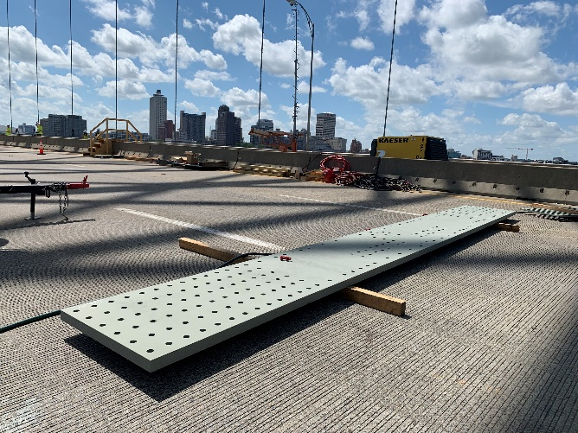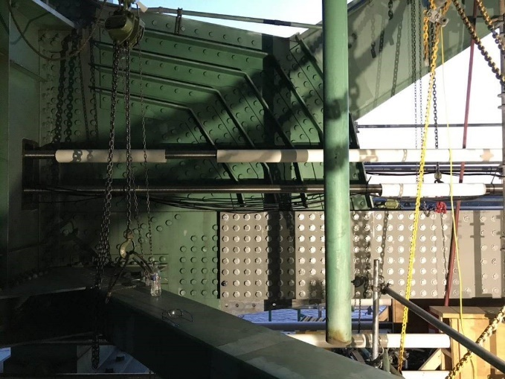
Permanent Plates

In-depth field inspections of the bridge are complete. We are now awaiting the final report. The safety of the workers and the public is our number one priority.

A reminder, we have added two new portable cameras: One to monitor work on the I-40 bridge and one to monitor traffic at the I-55 Crump Interchange. Click on the camera icon and hit play to stream the live video.
- Location 1 (Portable Camera at I55/Crump Interchange)
- Location 2 (Portable Camera on I-40 Bridge)

All interstate traffic in the Memphis area is being diverted to I-55. To help you plan ahead, every Monday, we are posting estimated average travel delays for the week on our website so you can see which days and times to avoid. You can also view real-time digital message signs alerting you of any incidents.

TDOT HELP trucks are stationed on both sides of the I-55 bridge to respond quickly to any incidents and keep lanes open. Below are direct links to the TDOT SmartWay cameras posted at the east and west approaches of I-55 for live traffic information.

West Approach to I-55 River Crossing
East Approach to the I-55 River Crossing

We are holding daily meetings with ARDOT, our consultants, Tennessee Highway Patrol, Memphis Police Department, and FHWA to develop and expedite the repair project while managing traffic along
the alternate routes.

*Please note updates will now be twice a week, Monday and Friday*. You can follow @myTDOT on Facebook, Twitter, and Instagram for the latest. We continue to update our photo album on Facebook called I-40 Hernando DeSoto Bridge – Memphis, Tennessee. We also have a webpage dedicated to the bridge repair. For updates and press releases, click on Library from your menu options: https://www.tn.gov/tdot/projects/region-4/i-40-hernando-desoto-bridge.html.

###

