**FOR IMMEDIATE RELEASE**

June 21, 2021

**CONTACT:** Nichole Lawrence

**CELL:** 731-225-6041

**I-40 Hernando DeSoto Bridge Repair**

Daily Update

As 24/7 operations continue, the contractor is making significant progress on the repairs. Post-tensioning (PT) stressing started over the weekend, and this morning crews were able to remove the inner phase one plating. They are now removing the fractured member of the tie beam.

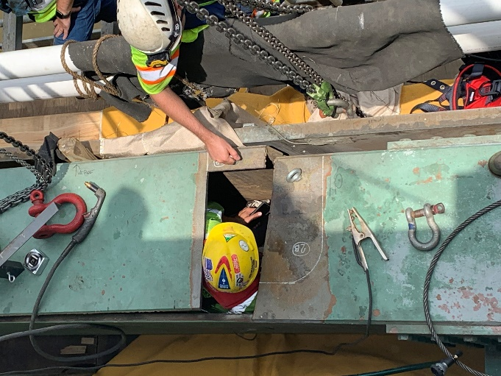

**Cutting out fractured piece from tie beam**

What's Next:

* Once the fractured section is removed, the phase one outboard plate will be removed.
* Once this work is completed, the PT stressing operation will resume.
* Once the PT stressing operations are completed, installation of the permanent inboard structural plating will begin.
* The permanent repair plates have started to arrive. Deliveries of this steel will be ongoing through early next week.

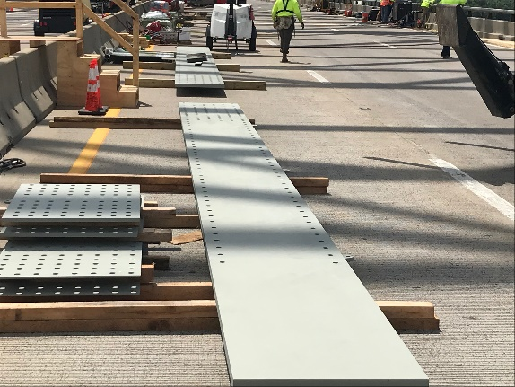

**Permanent Steel Plates**

In-depth inspections of the bridge continue. If any issues are found during the repairs, it could affect the bridge's opening date. The safety of the workers and the public is our number one priority.

All interstate traffic in the Memphis area is being diverted to I-55. To help you plan ahead, every Monday, we are posting [estimated average travel delays for the week](https://www.tn.gov/content/dam/tn/tdot/region-4/i-40-hernando-desoto-bridge/New%206-20%20Memphis%20Bridge%20Travel%20Times.pdf) on our website so you can see which days and times to avoid. You can also view real-time digital message signs alerting you of any incidents.

TDOT HELP trucks are stationed on both sides of the I-55 bridge to respond quickly to any incidents and keep lanes open. Below are direct links to the [TDOT SmartWay](https://smartway.tn.gov/) cameras posted at the east and west approaches of I-55 for live traffic information.

[West Approach to I-55 River Crossing](https://smartway.tn.gov/traffic?features=incident,traffic,messageSign,cameras&position=35.15976118,-90.14262298,14)

[East Approach to the I-55 River Crossing](https://smartway.tn.gov/traffic?features=incident,traffic,messageSign,cameras&position=35.11247994,-90.07716707,15)

We are holding daily meetings with ARDOT, our consultants, Tennessee Highway Patrol, Memphis Police Department, and FHWA to develop and expedite the repair project while managing traffic along

the alternate routes.

**\*Please note updates will now be twice a week, Monday and Friday\***. You can follow @myTDOT on Facebook, Twitter, and Instagram for the latest. We continue to update our photo album on Facebook called [I-40 Hernando DeSoto Bridge – Memphis, Tennessee](https://www.facebook.com/media/set/?vanity=myTDOT1&set=a.10157986173622551). We also have a webpage dedicated to the bridge repair. For updates and press releases, click on **Library** from your menu options: <https://www.tn.gov/tdot/projects/region-4/i-40-hernando-desoto-bridge.html>.

###