FOR IMMEDIATE RELEASE
June 18, 2021

CONTACT: Nichole Lawrence
CELL: 731-225-6041

I-40 Hernando DeSoto Bridge Repair
Daily Update

The contractor is making significant progress on the repairs. The post-tensioning (PT) process could begin as soon as Sunday, but a lot of prep work must be done first. Crews are working day and night.

- Weldment/PT anchor installation is ongoing. Final drilling/bolting/welding will continue through today and tomorrow.
- Installation of PT bars has started. Work on this will continue through today and tonight and should be completed by Saturday.
- Offloading and installing PT equipment, jacks, etc., will start today and continue through the weekend.
- 24/7 operations started Wednesday night.
- Permanent plate fabrication has begun, and delivery of the first plates can be expected next week.

As a reference, this animation explains the process in very simple terms.

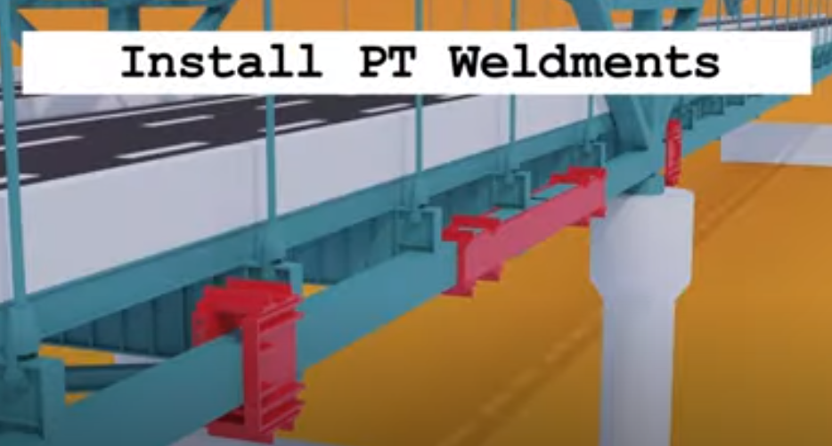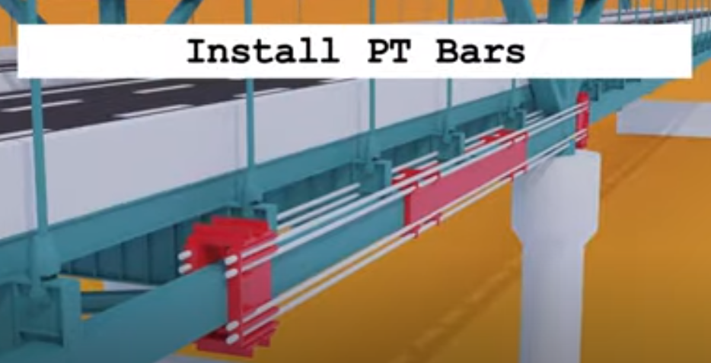
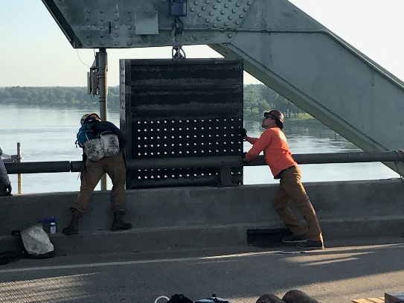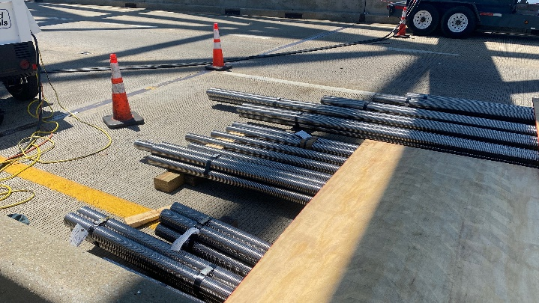

In-depth inspections of the bridge continue. If any issues are found during the repairs, it could affect the bridge's opening date. The safety of the workers and the public is our number one priority.
All interstate traffic in the Memphis area is being diverted to I-55. The second lane we added to the I-55 southbound ramp to help alleviate some congestion and advance flow through the Crump Interchange appears to be working. Comparing Week 2 (Thursday, May 20) after the I-40 Bridge Closure event to this week (Thursday, June 17), we have recorded the following percent change in the day to day peak travel delay numbers:

- SB saw a 77% reduction (55 minutes versus 16 minutes)
- NB saw a reduction of 51% (56 minutes to 27 minutes)

As for local traffic issues, TDOT is working with the city of Memphis to alleviate some of the downtown congestion by opening I-40 west from the I-40/I-240 interchange (midtown) up to the Danny Thomas (US 51) interchange.

To help you plan ahead, every Monday, we are posting estimated average travel delays for the week on our website so you can see which days and times to avoid. You can also view real-time digital message signs alerting you of any incidents.

TDOT HELP trucks are stationed on both sides of the I-55 bridge to respond quickly to any incidents and keep lanes open. Below are direct links to the TDOT SmartWay cameras posted at the east and west approaches of I-55 for live traffic information.

West Approach to I-55 River Crossing
East Approach to the I-55 River Crossing

We are holding daily meetings with ARDOT, our consultants, Tennessee Highway Patrol, Memphis Police Department, and FHWA to develop and expedite the repair project while managing traffic along
the alternate routes.

*Please note updates will now be twice a week, Monday and Friday*. You can follow @myTDOT on Facebook, Twitter, and Instagram for the latest. We continue to update our photo album on Facebook called I-40 Hernando DeSoto Bridge – Memphis, Tennessee. We also have a webpage dedicated to the bridge repair. For updates and press releases, click on Library from your menu options: https://www.tn.gov/tdot/projects/region-4/i-40-hernando-desoto-bridge.html.

###

