FOR IMMEDIATE RELEASE
June 7, 2021

CONTACT: Nichole Lawrence
CELL: 731-225-6041

I-40 Hernando DeSoto Bridge Repair
Daily Update

The contractor is making significant progress on the repairs. Fabrication of materials continues, as does work on the bridge.

Here's the latest on materials/fabrication:
- 3,000 bolts for the post-tensioning (PT) arrived Wednesday. Crews are replacing old with the new one by one.
- The PT weldments/anchors, fabricated by G&G Steel out of Russellville, AL, will be delivered this weekend.
- The PT rods are being fabricated. The first shipment is expected Monday, 6/14.
- Steel strengthening plates and splice plates for the permanent repair are also being fabricated. No timeline yet for delivery.

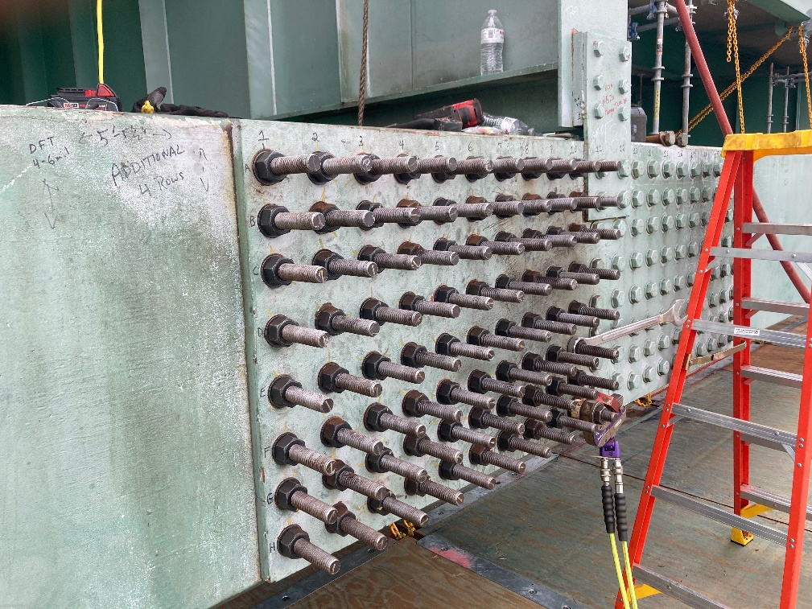
Bolts for post-tensioning (PT)

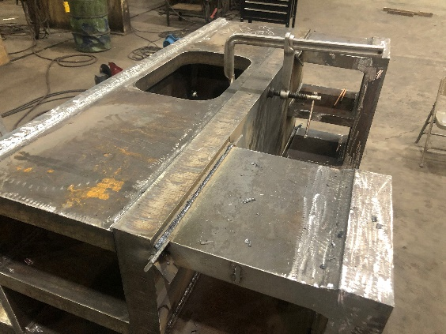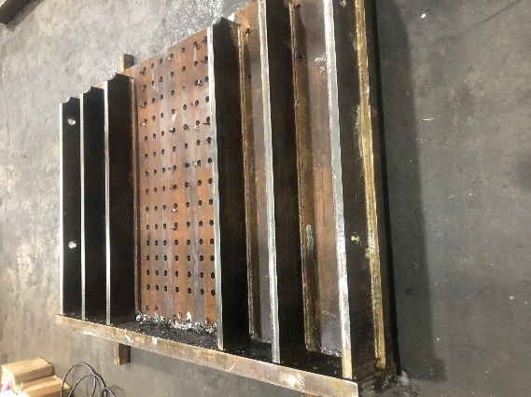
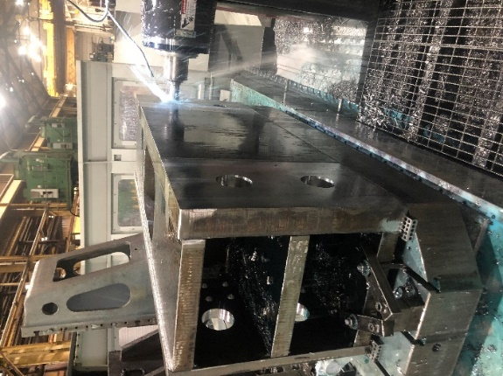
Fabrication of PT weldments/anchors

Construction work expected through the weekend:
- Hang additional rigging for Phase II work
- Finish miscellaneous steel removal for PT and Phase II work
- Attachment of PT anchors/weldments to the tie-beam
- Hang PT rod supports from floor beams in preparation for PT rod delivery on Monday
- Install Lower PT supports and protection on the platform
- Cut holes in floor beams for PT rods
- Remove and replace stiffeners at floor beams

In-depth inspections of the bridge are also happening. So far, there is nothing of concern. However, if any issues are found during the repairs, it could affect the bridge's opening date. The safety of the workers and the public is our number one priority.

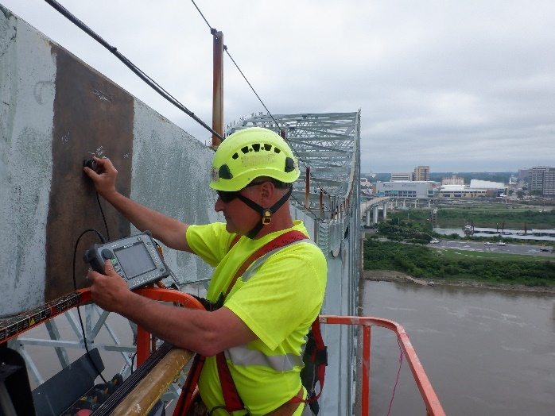
Non-Destructive Testing (NDT) sends soundwaves into the steel

All interstate traffic in the Memphis area is being diverted to I-55. We are adding a second lane to the I-55 southbound ramp to help alleviate some congestion and advance flow through the Crump Interchange. Crews will be paving and restriping over the weekend. If everything goes as planned, we anticipate the work being complete by the Monday morning commute.

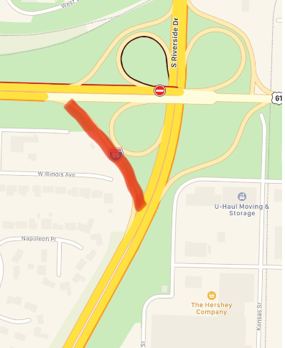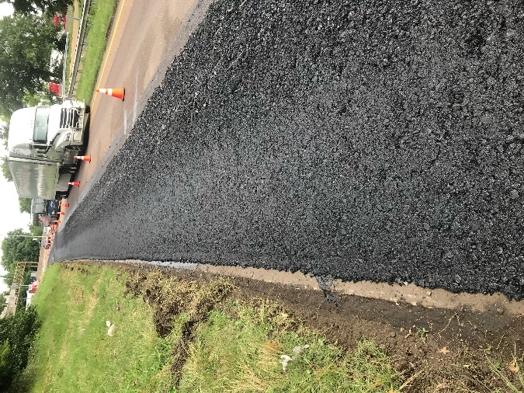

To help you plan ahead, average travel times for the past seven days will be posted on our website every Monday so you can see which days and times to avoid. You can also view real-time digital message signs alerting you of any incidents.

TDOT HELP trucks are stationed on both sides of the I-55 bridge to respond quickly to any incidents and keep lanes open. Below are direct links to the TDOT SmartWay cameras posted at the east and west approaches of I-55 for live traffic information.

West Approach to I-55 River Crossing
East Approach to the I-55 River Crossing

We are holding daily meetings with ARDOT, our consultants, Tennessee Highway Patrol, Memphis Police Department, and FHWA to develop and expedite the repair project while managing traffic along
the alternate routes.

*Please note updates will now be twice a week, Monday and Friday*. You can follow @myTDOT on Facebook, Twitter, and Instagram for the latest. We continue to update our photo album on Facebook called I-40 Hernando DeSoto Bridge – Memphis, Tennessee. We also have a webpage dedicated to the bridge repair. For updates and press releases, click on Library from your menu options: https://www.tn.gov/tdot/projects/region-4/i-40-hernando-desoto-bridge.html.

###

