FOR IMMEDIATE RELEASE
May 20, 2021

CONTACT: Nichole Lawrence
CELL: 731-225-6041

I-40 Hernando DeSoto Bridge Repair
Daily Update

Today Kiewit Infrastructure Group is expected to start prepping the worksite. That includes installing a temporary platform needed to begin work on phase one of the bridge repairs. They hope to have it assembled by tomorrow afternoon. Preparations will continue through the weekend. Repair plans are being finalized.

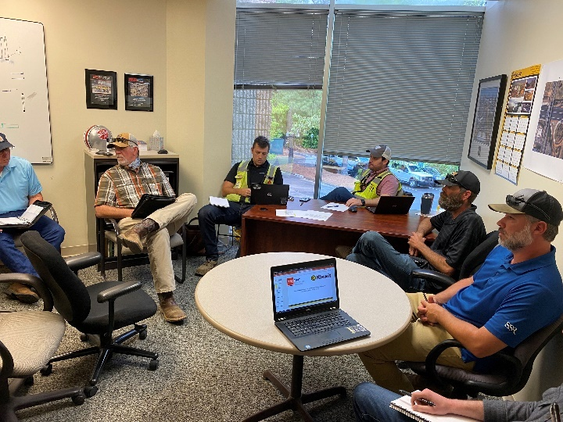
First Face-to-Face Construction Meeting with Kiewit in Memphis
The repair will be performed in two phases. Both phases will need to be completed before traffic can re-open on the bridge.
- Phase one involves installing fabricated steel plates on each side of the fractured member to hold the heavy equipment necessary for the permanent repairs.
- Phase two consists of removing and replacing the damaged piece.
Fabrication of the steel plates needed for phase one repair is happening at Stupp Bridge Company in Bowling Green, KY. TDOT crews will pick up the load of 33,000+ pounds of steel and deliver it to the worksite when ready, possibly as soon as this weekend.

TDOT inspection of the I-55 Bridge continues today with drones on the Arkansas side. The inspection team is back on land but plans to return to the water on Monday to view the hard-to-achieve places by boat. The high winds are hampering efforts. Once they’re done gathering data, the inspectors will have hours of drone footage to go through. The process is expected to go well into next week.

All interstate traffic in the Memphis area is being diverted to I-55. TDOT traffic engineers are working on two options to improve traffic flow at the I-55 and Crump Interchange. TDOT HELP trucks are stationed on both sides of the I-55 bridge to respond quickly to any incidents and keep lanes open. Additionally, we are utilizing message boards across Shelby County to assist with messaging. Below are direct links to the TDOT SmartWay cameras posted at the east and west approaches of I-55 for live traffic information.

West Approach to I-55 River Crossing
East Approach to the I-55 River Crossing

Today in Memphis, TDOT and ARDOT officials briefed Acting Federal Highway Administrator Stephanie Pollack on the latest developments with the I-40 bridge and provided an overview of planned work.

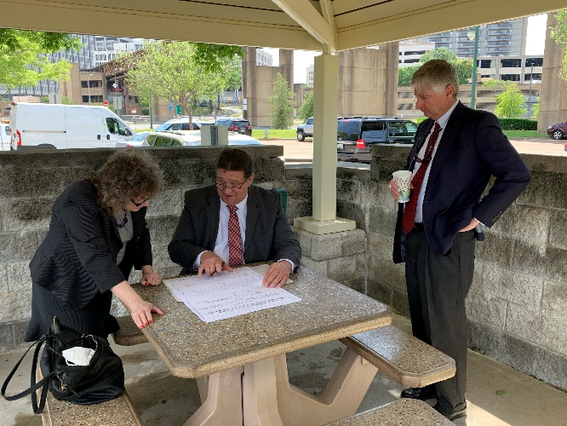
Meeting with FHWA in Memphis

We continue to hold daily meetings with ARDOT, our consultants, Tennessee Highway Patrol, Memphis Police Department, and FHWA to develop and expedite the repair project while managing traffic along the alternate routes.

We have a webpage dedicated to the bridge repair: https://www.tn.gov/tdot/projects/region-4/i-40-hernando-desoto-bridge.html. You can also follow us on social media for the latest.

###

