Executive Project Status Report
 | Project Name | Project #  PIN | Location |  |  |  |  | 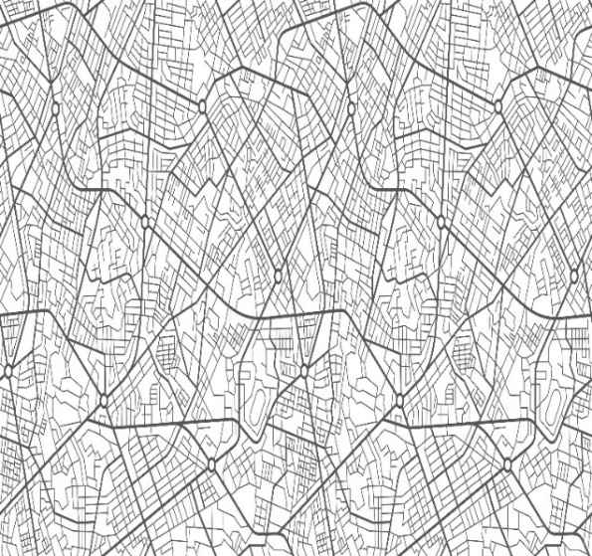  Project Map  (click on the image to browse and insert map image)
TDOT Project Manager: Name
Phone, Email
Consultant Project Manager: Name
Phone, Email
 | Project Description: Project Type, Funding Source, Short Description
 | What’s Changed Since Last Update? |  |  |  |  | Project Risks
 | Identify changes to scope, schedule, budget, quality, risk (SSBQR.) |  |  |  |  | Identify risks impacting scope, schedule, budget (SSB.)
 | Project Budget |  |  |  |  | Project Schedule
 |  | Estimated | Programmed |  |  |  | Actual  Finish | Baseline Forecast
 | PE Design | $1.00 | $1.00 |  |  | Kickoff Complete | MM/DD/YYYY | MM/DD/YYYY
 | PE ROW | $1.00 | $1.00 |  |  | Scoping Complete | MM/DD/YYYY | MM/DD/YYYY
 | PE Utilities | $1.00 | $1.00 |  |  | PCD Signed | MM/DD/YYYY | MM/DD/YYYY
 | PE Other | $1.00 | $1.00 |  |  | Env. Doc Complete | MM/DD/YYYY | MM/DD/YYYY
 | Constr. Eng. Mgt. | $1.00 | $1.00 |  |  | ROW Acquisition Begins | MM/DD/YYYY | MM/DD/YYYY
 | Incentives/Contingency | $1.00 | $1.00 |  |  | Footprint Established | MM/DD/YYYY | MM/DD/YYYY
 | Constr. Contract Price | $1.00 | $1.00 |  |  | Plan in Hand Complete | MM/DD/YYYY | MM/DD/YYYY
 | Other | $1.00 | $0.00 |  |  | PS&E Review Complete | MM/DD/YYYY | MM/DD/YYYY
 | TOTAL | $ 8.00 | $ 7.00 |  |  | Letting | MM/DD/YYYY | MM/DD/YYYY
 | Estimated costs above as of: |  | MM/DD/YYYY |  |  | (Baseline Forecast as of signed PCD)
 | Percent Complete

