Safety Funding, better known as HISP funding, is provided to the Pavement Program for use with items eligible as safety upgrades such as pavement marking, addition of rumbles, addition of snowplowable pavement markers, or guardrail adjustments for example. The program is provided with an overall budget that is split between the Regions based on lane-miles. This budget will be applied to state route projects throughout the fiscal year until it is exhausted after which safety eligible items will be funded by the general paving budget.
Safety Funding Analysis is performed immediately following the Plan-in-Hand (PIH) review for each project. The analysis shall be based on all plan materials and resolutions of the comments provided during the PIH review. The overall cost of safety improvements for each project will be determined by completion of the Safety Funding Analysis Form.
In the Safety Funding Analysis Form, enter the value of the Existing Quantity in the applicable column for each item based on the materials shown in the PDFR document for the project on the Linear Marking, Individual & Other Marking, and Pavement Appurtenances tabs. Please enter values even for items that are not replaced in-kind so that upgraded proposed items may be tracked. This would apply, for example, if the existing marking lines are 4” and the proposed marking lines are 6”.
Based on all project data and Plan-in-Hand review resolutions, enter the Proposed Quantity in the applicable column for all items on the Linear Marking, Individual & Other Marking, and Pavement Appurtenances tabs.
The Safety Eligible Quantity column will self-populate as shown in the Example section of the Linear Marking tab.
If no existing value is reported in the project PDFR, then only the Proposed Quantity column requires data.
In the Safety Funding Analysis Form, enter the value of the Safety Eligible Quantity for each item based on all project data and Plan-in-Hand review resolutions on the Catch Basin section of the Pavement Appurtenances, Guardrail, and Signs tabs. All these items will be considered safety improvements as they will be replacing existing items considered not within the current standard for safety parameters or are added measures determined necessary for overall route safety.
When all safety eligible items have been determined, the cost of each eligible item should be determined by conducting a search using the Average Unit Price tools.
Ensure that the selection is set to “Item Search” as shown by the red arrow in Figure S-1.
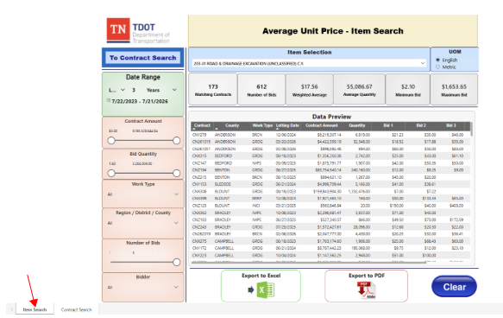
Figure S-1
Set the date range to last 3 years as shown in Figure S-2. This will capture the previous 3 (three) years from the date of the search.
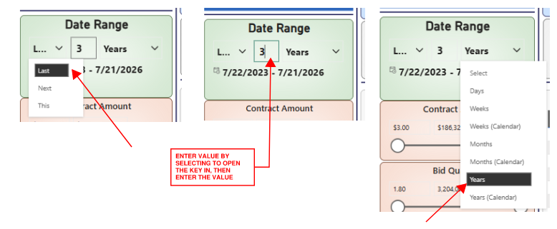
Figure S-2
The default options for Contract Amount and Bid Quantity will remain as is.
The Work Type selections will be adjusted from All by selecting the arrow and will be Asphalt Paving and Surface Treatment (Bituminous) and will indicate Multiple Selections as seen in Figure S-3.
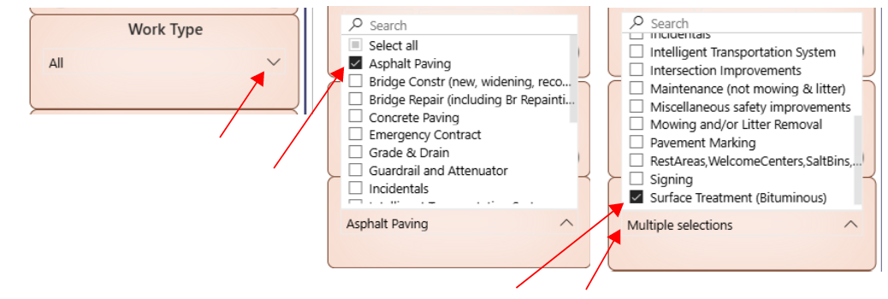
Figure S-3

The Region/District/County setting for the initial search will be the Region in which the project is located as seen in Figure S-4.
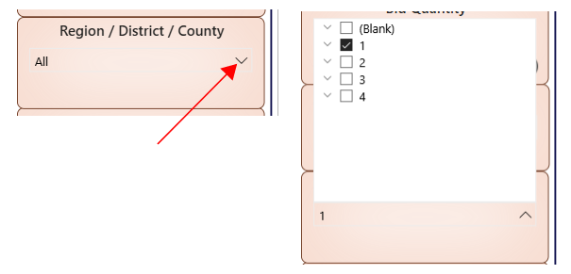
Figure S-4
Number of Bids and Bidder selections shall remain set as default.
The search criteria are now designated and shall remain as is throughout the items search for the project.
Item selection requires an item-by-item search for each eligible item in the project. To search for each item, the item number must be entered in the item selection. To activate the search key, click in the item block where the default item is shown. When the search tool opens, enter the desired item number as shown in Figure S-5.
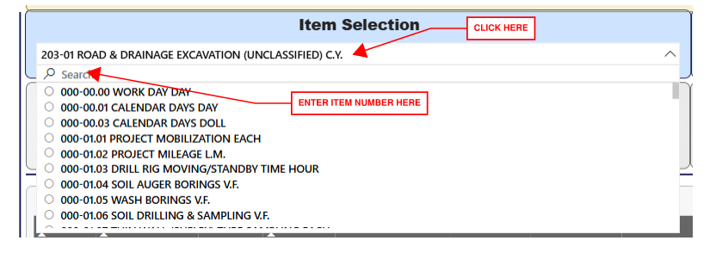
Figure S-5
Then select the item when shown by selecting the circle adjacent to the item number as shown in Figure S-6.
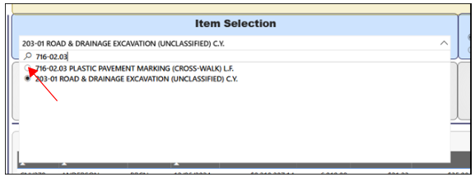
Figure S-6
This will provide the number of matching contracts, number of bids and weighted average of that item.
If the Matching Contracts value is greater than 5 as shown in Figure S-7, the weighted average value should be reported in the Average Unit Price column in the Safety Funding Analysis Form for the corresponding item.
If the number of matching contracts is less than 5 for any item, edit the search by adding the remaining Regions to the selection group for a State-wide search report the resulting Weighted Average cost in the Average Unit Price column in the Safety Funding Analysis Form for the corresponding item.

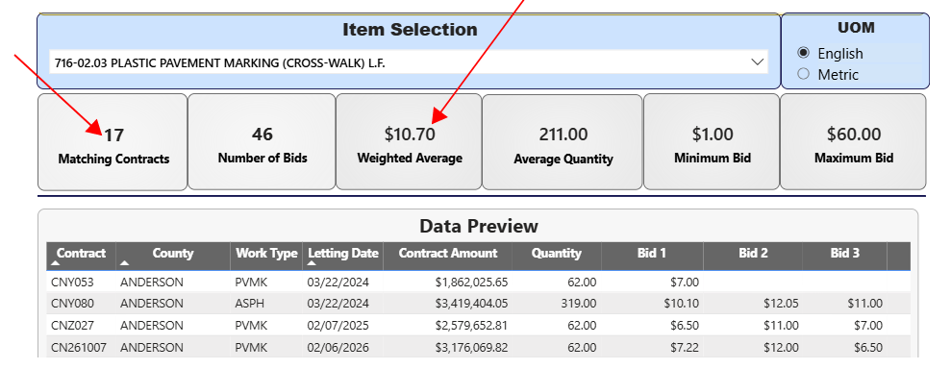
Figure S-7

If the eligible quantity for an item is 0, then it will not be necessary to enter a cost value for that item since there will be no recognized cost. If the existing quantity is greater than the proposed for reasons such as the proposed item is different and thus an upgrade, do not enter a cost value for that item as it would produce a negative dollar value.
Once the document has been completed and an overall safety cost for the project has been determined, the document will be filed in the ProjectWise folder for the applicable project. If no safety eligibility is determined for a project either by the lack of any eligible items or by the overall total costs of all eligible items being less than $10,000.00, then it will be necessary to notify the Program Operations Division that a project number edit is necessary to remove the state and federal safety (HSIP) funding prior to submitting plan documents for the P&SE.

