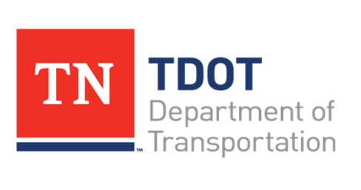

**Office of Local Program Development - CEI Training Course (2022)**

The Office of Local Program Development is offering a Construction Engineering and Inspection (CEI) Training Course, which is required for all local governments and CEI’s to take every five years.

The course has two levels of certification:

1.       The first level (One-Day Training Class) will address the needs of local government officials and administrators concerned with managing program funding and overseeing the construction phase. This class will teach you what to expect out of your CEI. Only local governments are allowed to attend this class.

2.       The second level (Two-Day Training Class) will focus on those local governments that wish to perform their own CEI and consultants who wish to perform the CEI for local governments. The primary goal of the second level training is to ensure that CEI’s fully understand the extent of their responsibilities. This class will walk through the forms, procedures, and potential issues during the construction phase.

**TDOT Region 4, Jackson (Region 4 Auditorium)**

Gov’t Officials & Administrators - July 26, 2022 10:00 AM – 2:30 PM

CEI Professionals (2day class) - July 27, 2022 9:00 AM – 4:00 PM

July 28, 2022 8:30 AM – 12:00 PM

**How to Register**

Space is limited. To Register Contact: Teresa Layhew

615-460-0527

[tlayhew@ssr-inc.com](mailto:tlayhew@ssr-inc.com)

**Costs**

Consultant costs for the two day course is $75 per attendee (certificates will be provided for 10 professional development hours for the two-day course). There is no charge for government personnel. Payment is requested in advanced via company check payable to: ***Tennessee Department of Transportation (only)***

Mail payment to: SSR, Inc.

c/o Teresa Layhew

2995 Sidco Drive

Nashville, TN 37204

If you are on the list attached below, you are currently Level 1 certified (eligible to manage a CEI): <https://www.tn.gov/content/dam/tn/tdot/programdevelopment/localprograms/training/CEI%20Training%20Level%201%20Certified%202015-2021.pdf>

If you are on the list attached below, you are currently Level 2 certified (eligible to conduct CEI services on locally managed projects): <https://www.tn.gov/content/dam/tn/tdot/programdevelopment/localprograms/training/CEI%20Training%20Level%202%20Certified%202015-2021.pdf>

Class information can always be found on the Local Programs’ website: <https://www.tn.gov/tdot/program-development-and-administration-home/local-programs/local-programs-training.html>