Project Information Sheet
State Route 115 (Alcoa Highway)
Corridor Improvement Project
From North of the Little River and Blount County line
To Maloney Road
Knoxville, Knox County
Pin # 100241.02 / State # 47026-1269-04 / Federal # STP-NH-115(27)

This 2.4 mile section of State Route 115, from just north of the Little River to Maloney Road, is one of four segments of an overall corridor improvement project. This project is intended to:
- Increase the traffic capacity of S.R. 115
- Correct deficiencies of the existing roadway
- Reduce crashes and improve safety
Additional goals include minimizing impacts to environmental resources within the project area and improving pedestrian and bicycle connectivity.
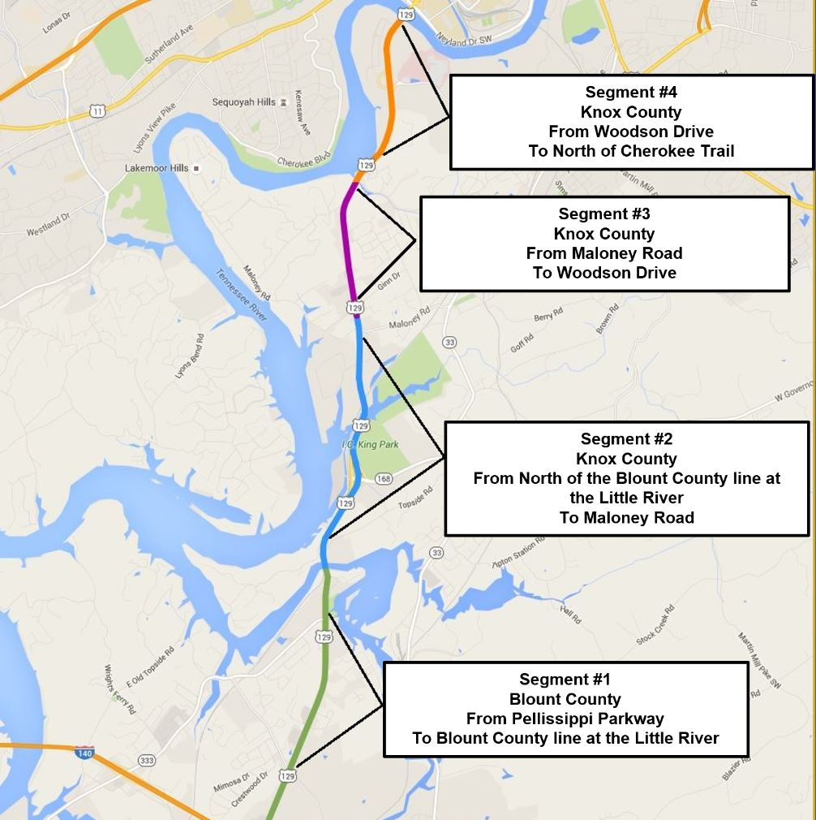

Project History
The preliminary design for this segment of SR 115 has evolved from an extensive review process mandated by the National Environmental Policy Act (NEPA), during which TDOT coordinated with the public, state, federal and local agencies to identify and consider transportation needs and alternatives as well as various environmental factors.
While one Build and a No-Build Alternative were considered during this process, the Build Alternative was selected for development based on its ability to address the defined transportation needs and minimize impacts to the environment.
Upon completion of the NEPA process in March, 2014, TDOT began development of preliminary plans.
Project Description
The improvements follow the existing alignment and consist of widening State Route 115 (Alcoa Highway) to six lanes (three lanes in each direction). A center median barrier will be constructed throughout the project limits and all left turns will be eliminated on SR-115. Traffic desiring to turn left will utilize new interchanges which will be provided at SR-168 (John Sevier Highway) and Topside Road. Right turns will be allowed at all existing locations along the route. Additionally, frontage roads will be provided to carry local traffic adjacent to SR-115 at Topside Road and Power Drive.
A 12 foot wide greenway will also be constructed along the southbound portion of Alcoa Highway from Little River to north of the John Sevier Highway Interchange, providing access to I.C. King Park (located east of Alcoa Highway).

