Harmelink Guide

Roadway Design Division
Website www.tn.gov/tdot/roadway-design/training.html
Email TDOT.RoadwayDesignDivisionTraining@tn.gov

Table of Contents
Left-Turn Storages for Two-Lane Highways 2
Harmelink Charts – 40 mph 3
Harmelink Charts – 50 MPH 6
Harmelink Charts – 60 MPH 9
Left-Turn Storages for Four-Lane Highways 12

Table of Figures
Table 1: Harmelink Table for Two-Lane Highways 2
Figure 1: Warrant for 5% Left-Turn Storage Lanes at 40 mph 3
Figure 2: Warrant for 10% Left-Turn Storage Lanes at 40 mph 3
Figure 3: Warrant for 15% Left-Turn Storage Lanes at 40 mph 4
Figure 4: Warrant for 20% Left-Turn Storage Lanes at 40 mph 4
Figure 5: Warrant for 30% Left-Turn Storage Lanes at 40 mph 5
Figure 6: Warrant for 40% Left-Turn Storage Lanes at 40 mph 5
Figure 7: Warrant for 5% Left-Turn Storage Lanes at 50 mph 6
Figure 8: Warrant for 10% Left-Turn Storage Lanes at 50 mph 6
Figure 9: Warrant for 15% Left-Turn Storage Lanes at 50 mph 7
Figure 10: Warrant for 20% Left-Turn Storage Lanes at 50 mph 7
Figure 11: Warrant for 30% Left-Turn Storage Lanes at 50 mph 8
Figure 12: Warrant for 40% Left-Turn Storage Lanes at 50 mph 8
Figure 13: Warrant for 5% Left-Turn Storage Lanes at 60 mph 9
Figure 14: Warrant for 10% Left-Turn Storage Lanes at 60 mph 9
Figure 15: Warrant for 15% Left-Turn Storage Lanes at 60 mph 10
Figure 16: Warrant for 20% Left-Turn Storage Lanes at 60 mph 10
Figure 17: Warrant for 30% Left-Turn Storage Lanes at 60 mph 11
Figure 18: Warrant for 40% Left-Turn Storage Lanes at 60 mph 11
Figure 19: Warrant for Left-Turn Storage Lanes on Four-Lane Highways 12

Left-Turn Storages for Two-Lane Highways
The Harmelink Table is a table that expresses when there is a warrant or need for a left-turn storage lane based on the following factors: opposing vehicle volume (VPH), approaching vehicle volume (VPH), and the percentage of left-turning vehicles. The following figures shown below are an expansion of this table. Using the same factors, they determine the minimum required storage length that needs to be used for each of the left-turn storage lanes at unsignalized intersections.

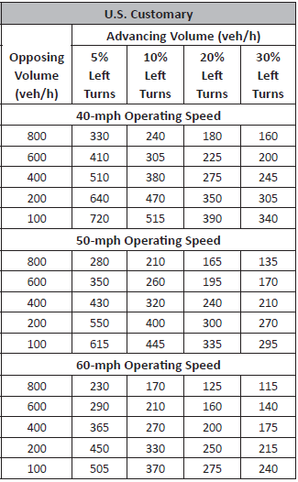
Table 1: Harmelink Table for Two-Lane Highways

Harmelink Charts – 40 mph
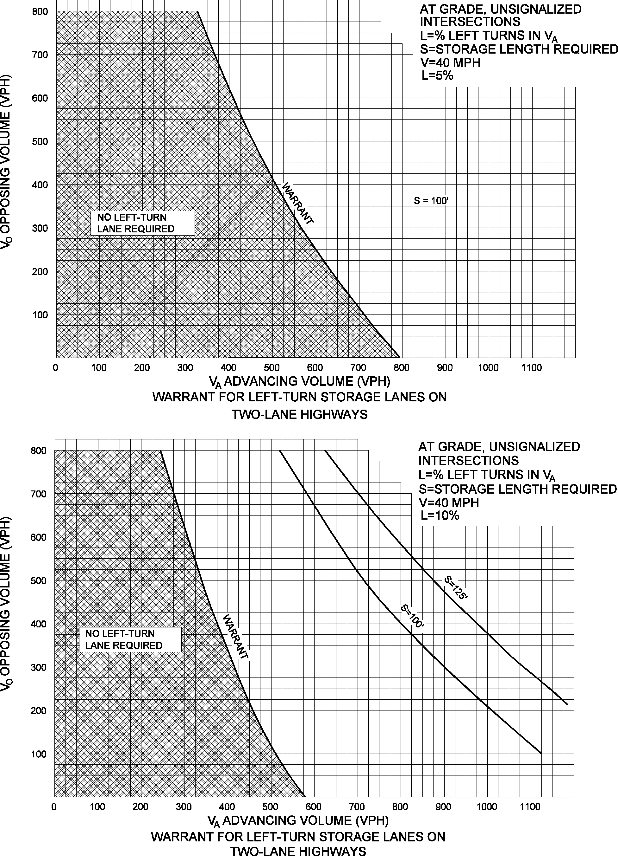
Figure 1
Warrant for 5% Left-Turn Storage Lanes at 40 mph
Figure 2
Warrant for 10% Left-Turn Storage Lanes at 40 mph
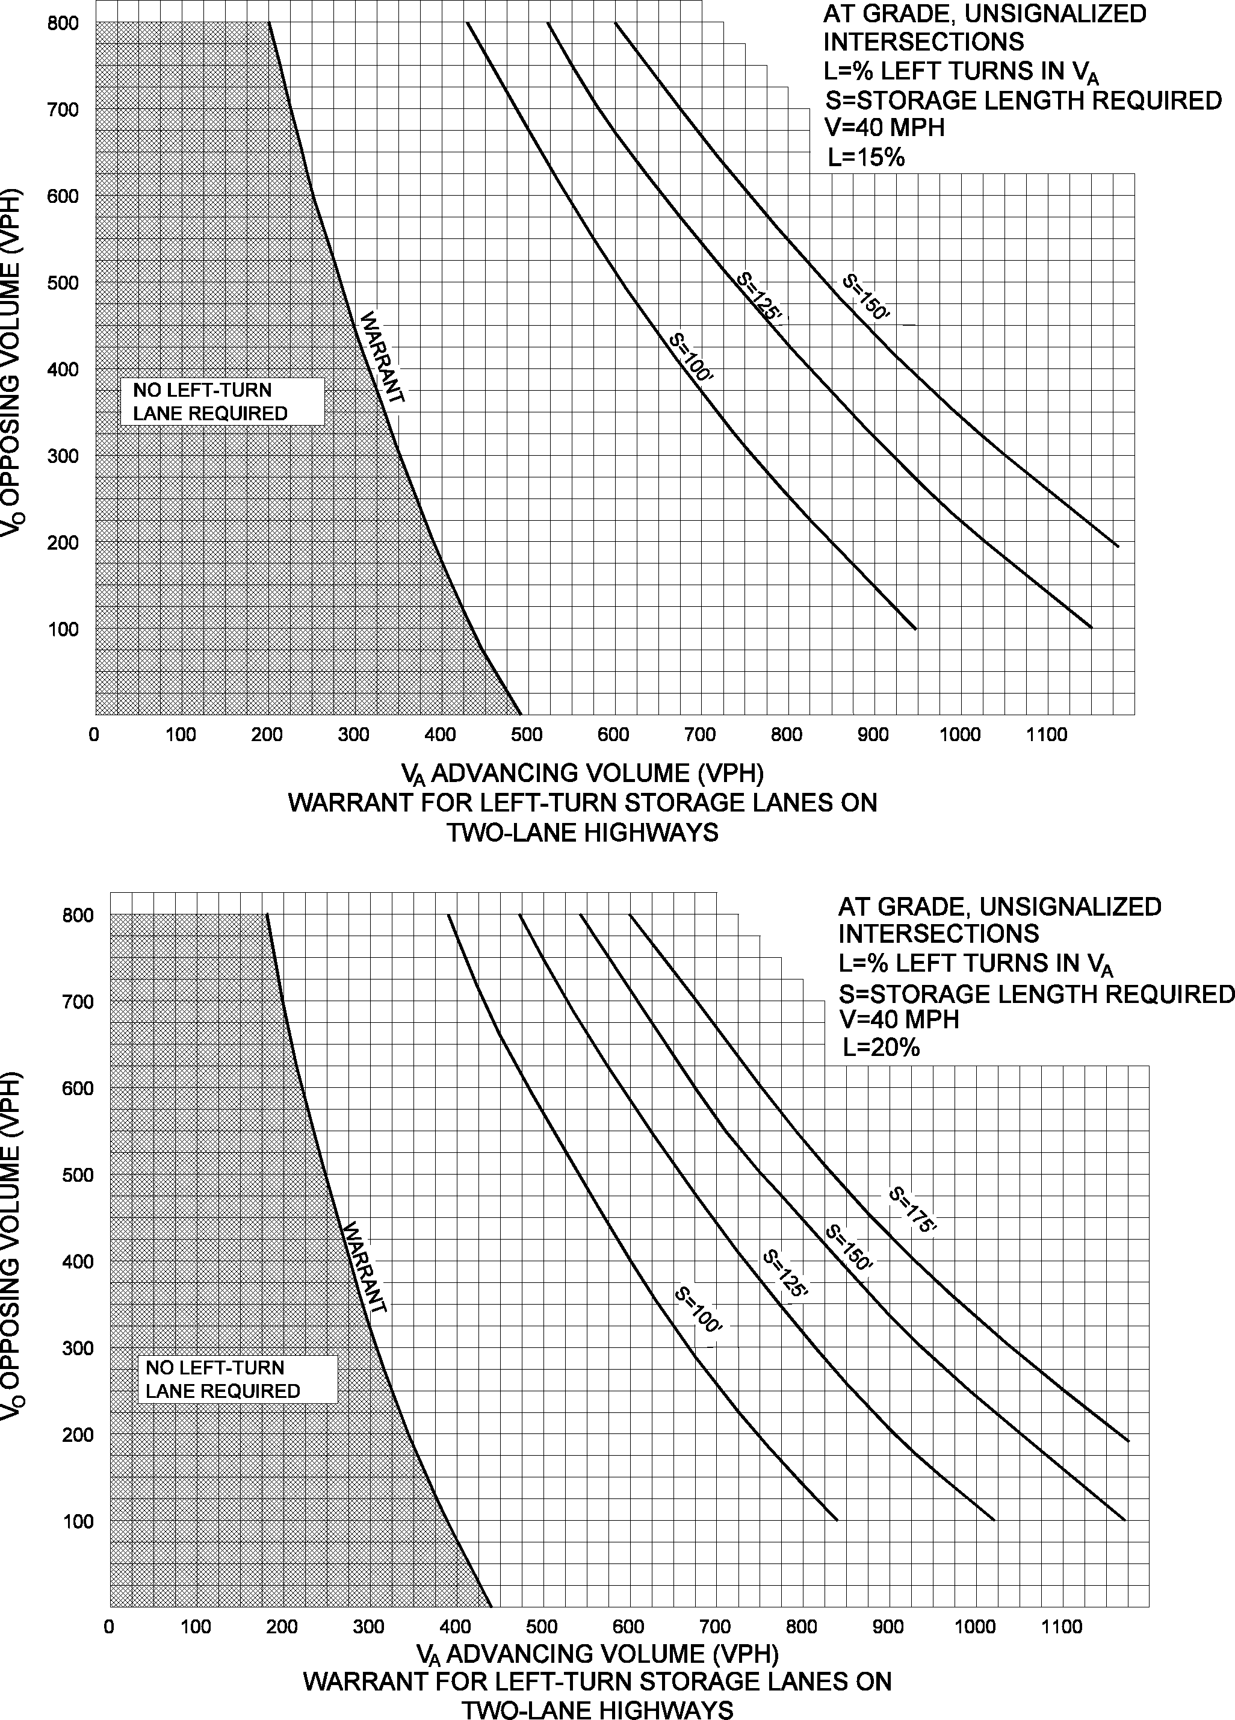
Figure 3
Warrant for 15% Left-Turn Storage Lanes at 40 mph

Figure 4
Warrant for 20% Left-Turn Storage Lanes at 40 mph
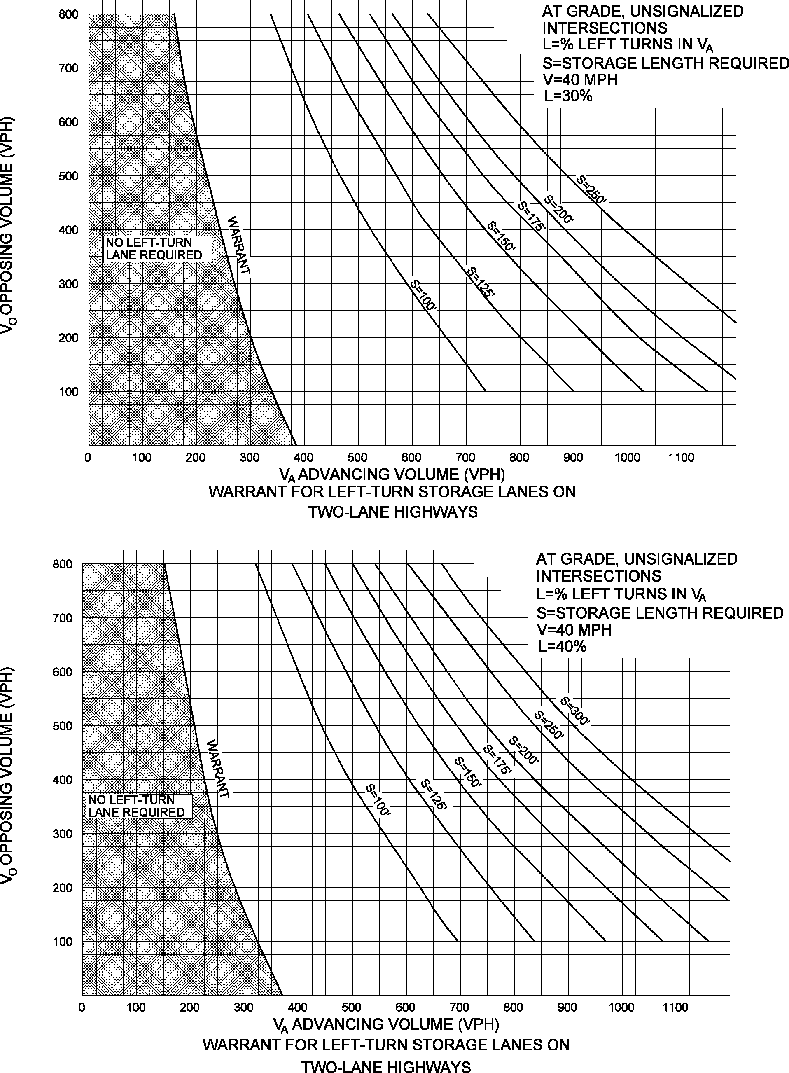
Figure 5
Warrant for 30% Left-Turn Storage Lanes at 40 mph

Figure 6
Warrant for 40% Left-Turn Storage Lanes at 40 mph

Harmelink Charts – 50 MPH
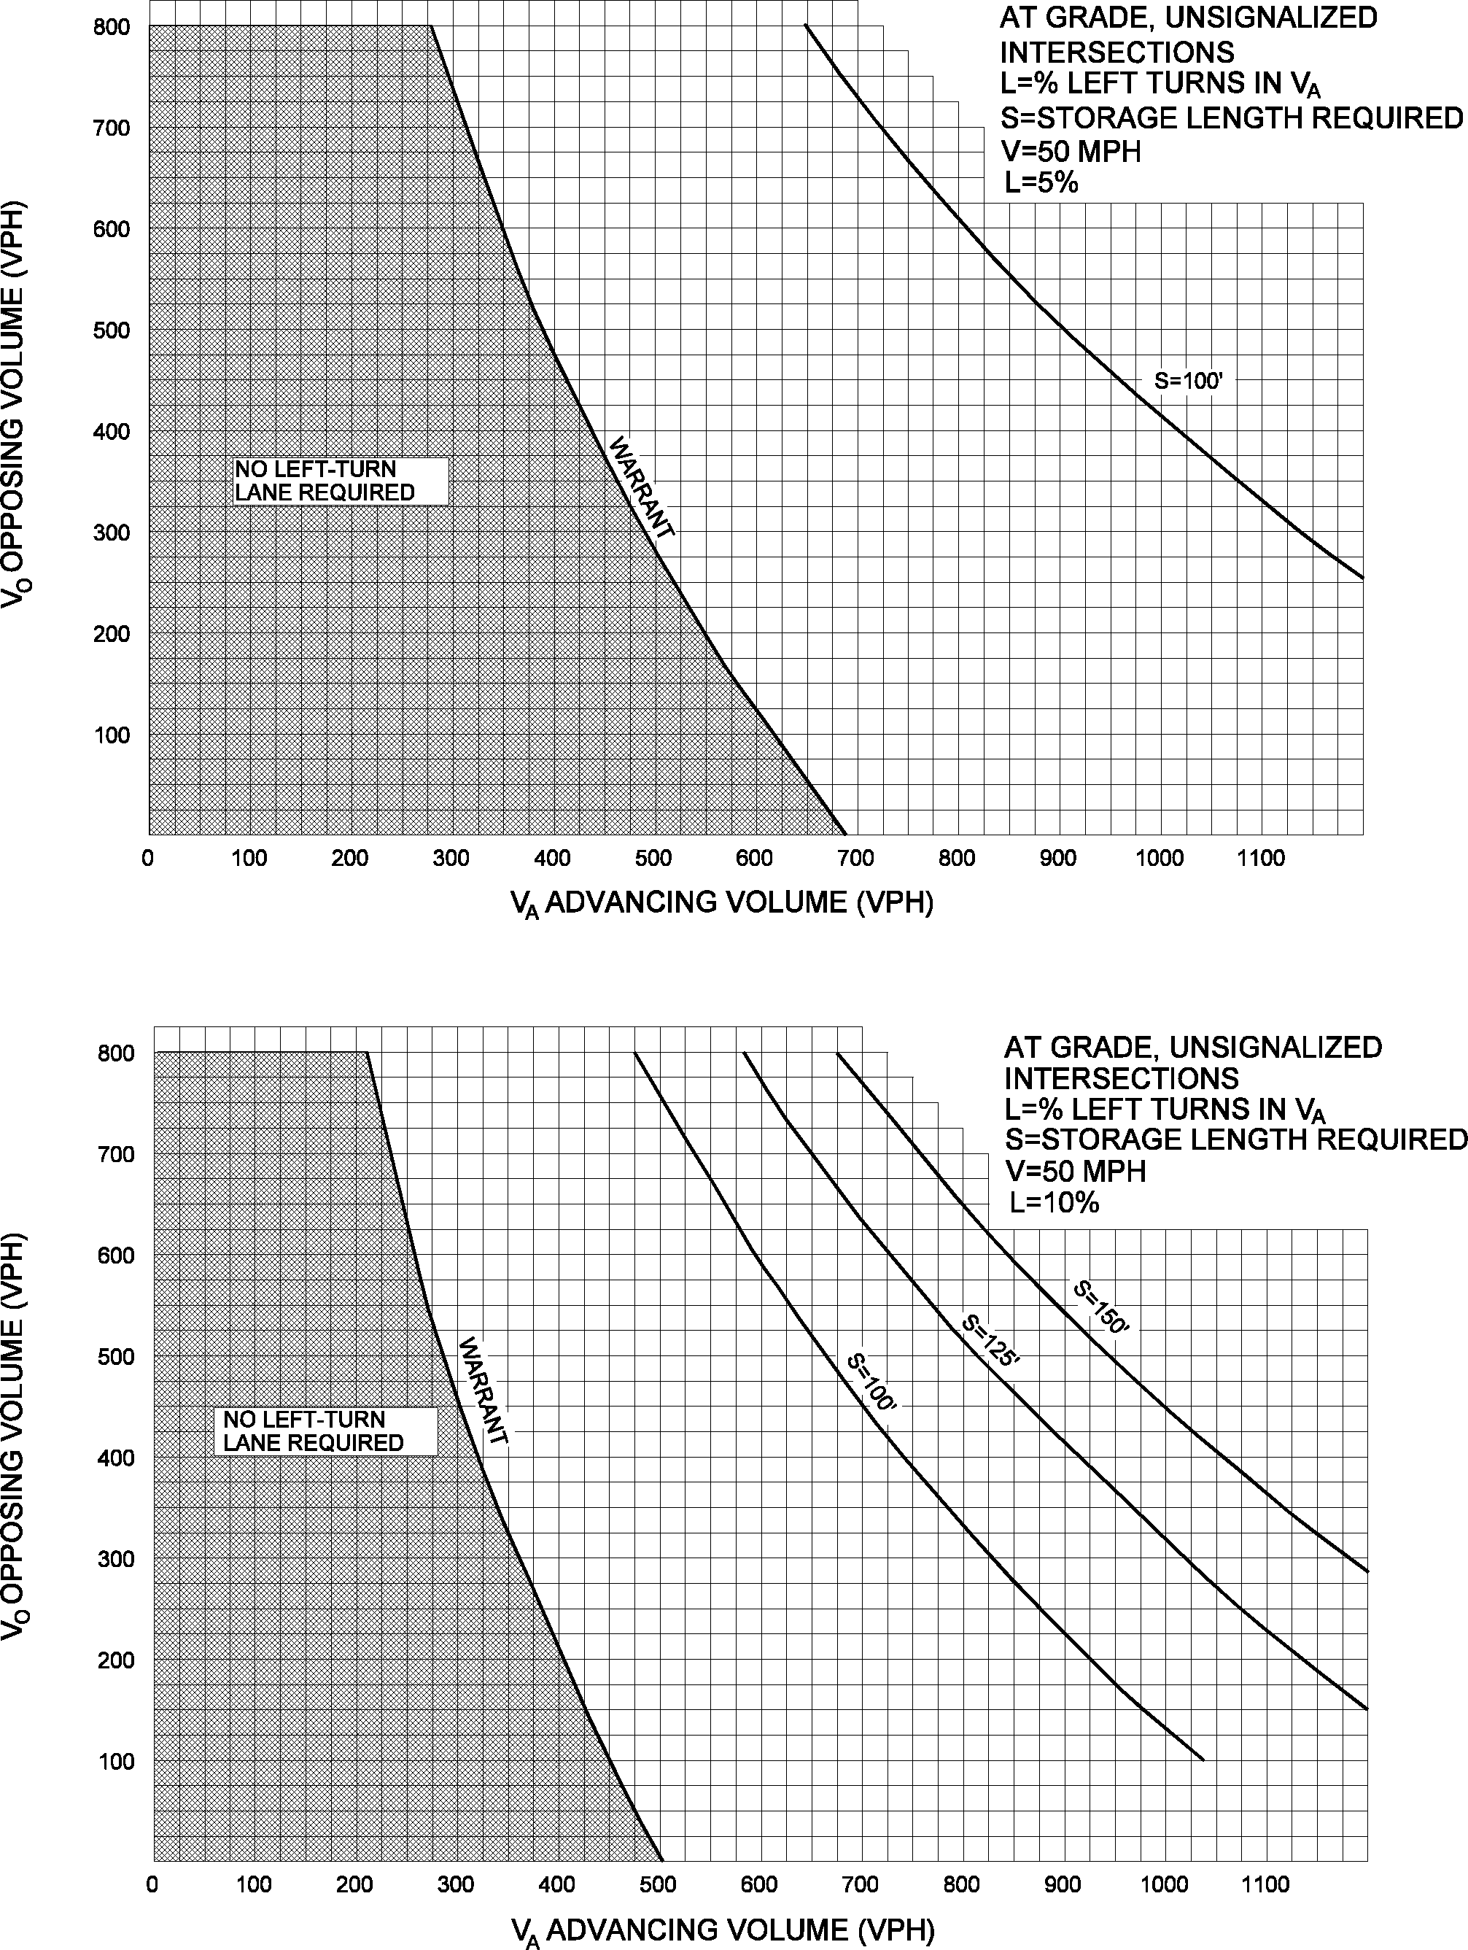
Figure 7
Warrant for 5% Left-Turn Storage Lanes at 50 mph

Figure 8
Warrant for 10% Left-Turn Storage Lanes at 50 mph
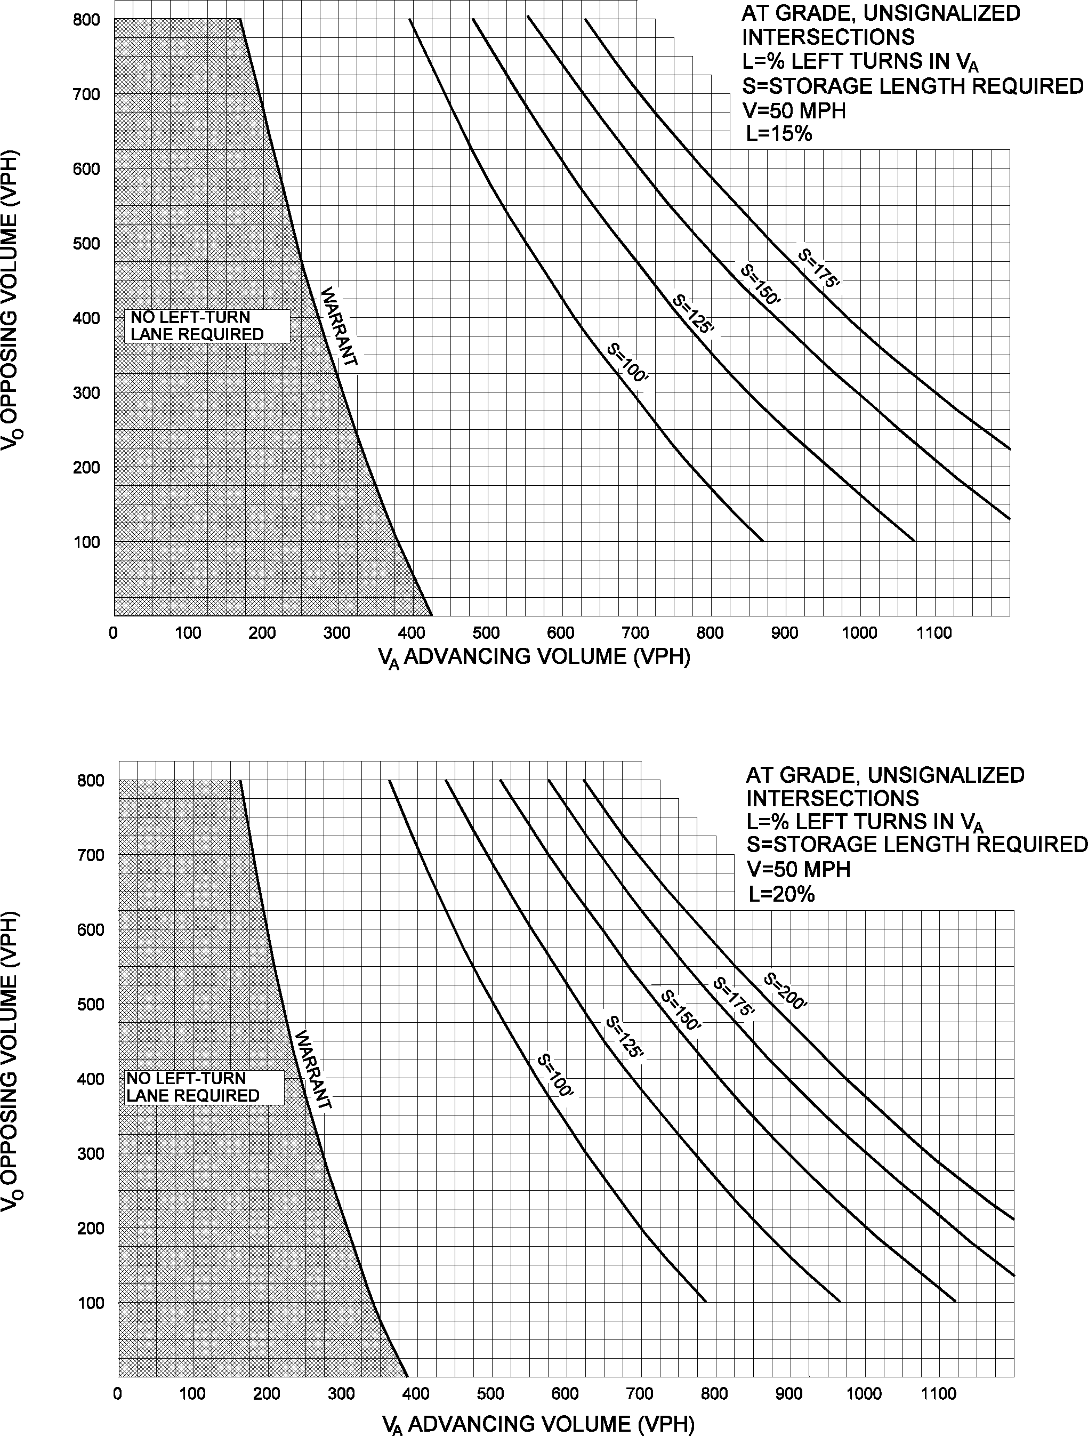
Figure 9
Warrant for 15% Left-Turn Storage Lanes at 50 mph

Figure 10
Warrant for 20% Left-Turn Storage Lanes at 50 mph
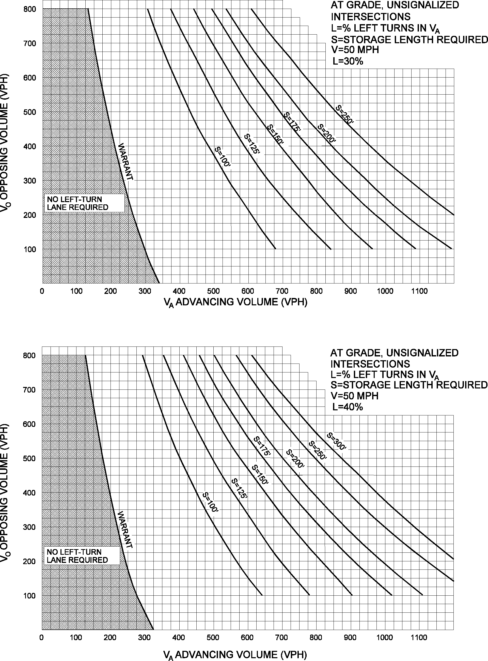
Figure 11
Warrant for 30% Left-Turn Storage Lanes at 50 mph

Figure 12
Warrant for 40% Left-Turn Storage Lanes at 50 mph

Harmelink Charts – 60 MPH
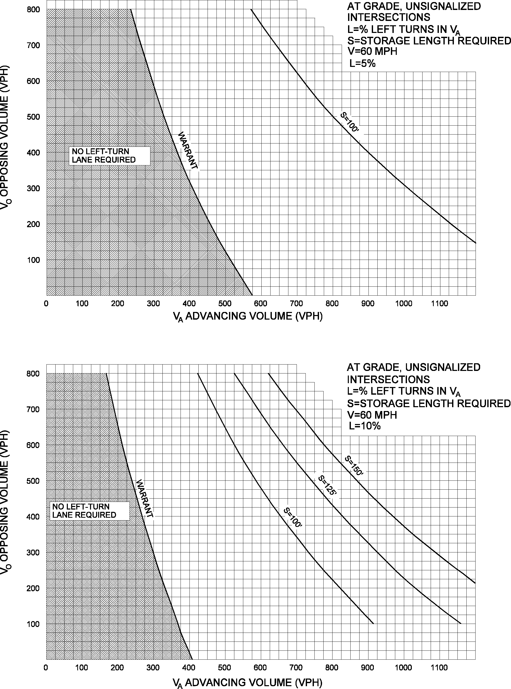
Figure 13
Warrant for 5% Left-Turn Storage Lanes at 60 mph

Figure 14
Warrant for 10% Left-Turn Storage Lanes at 60 mph
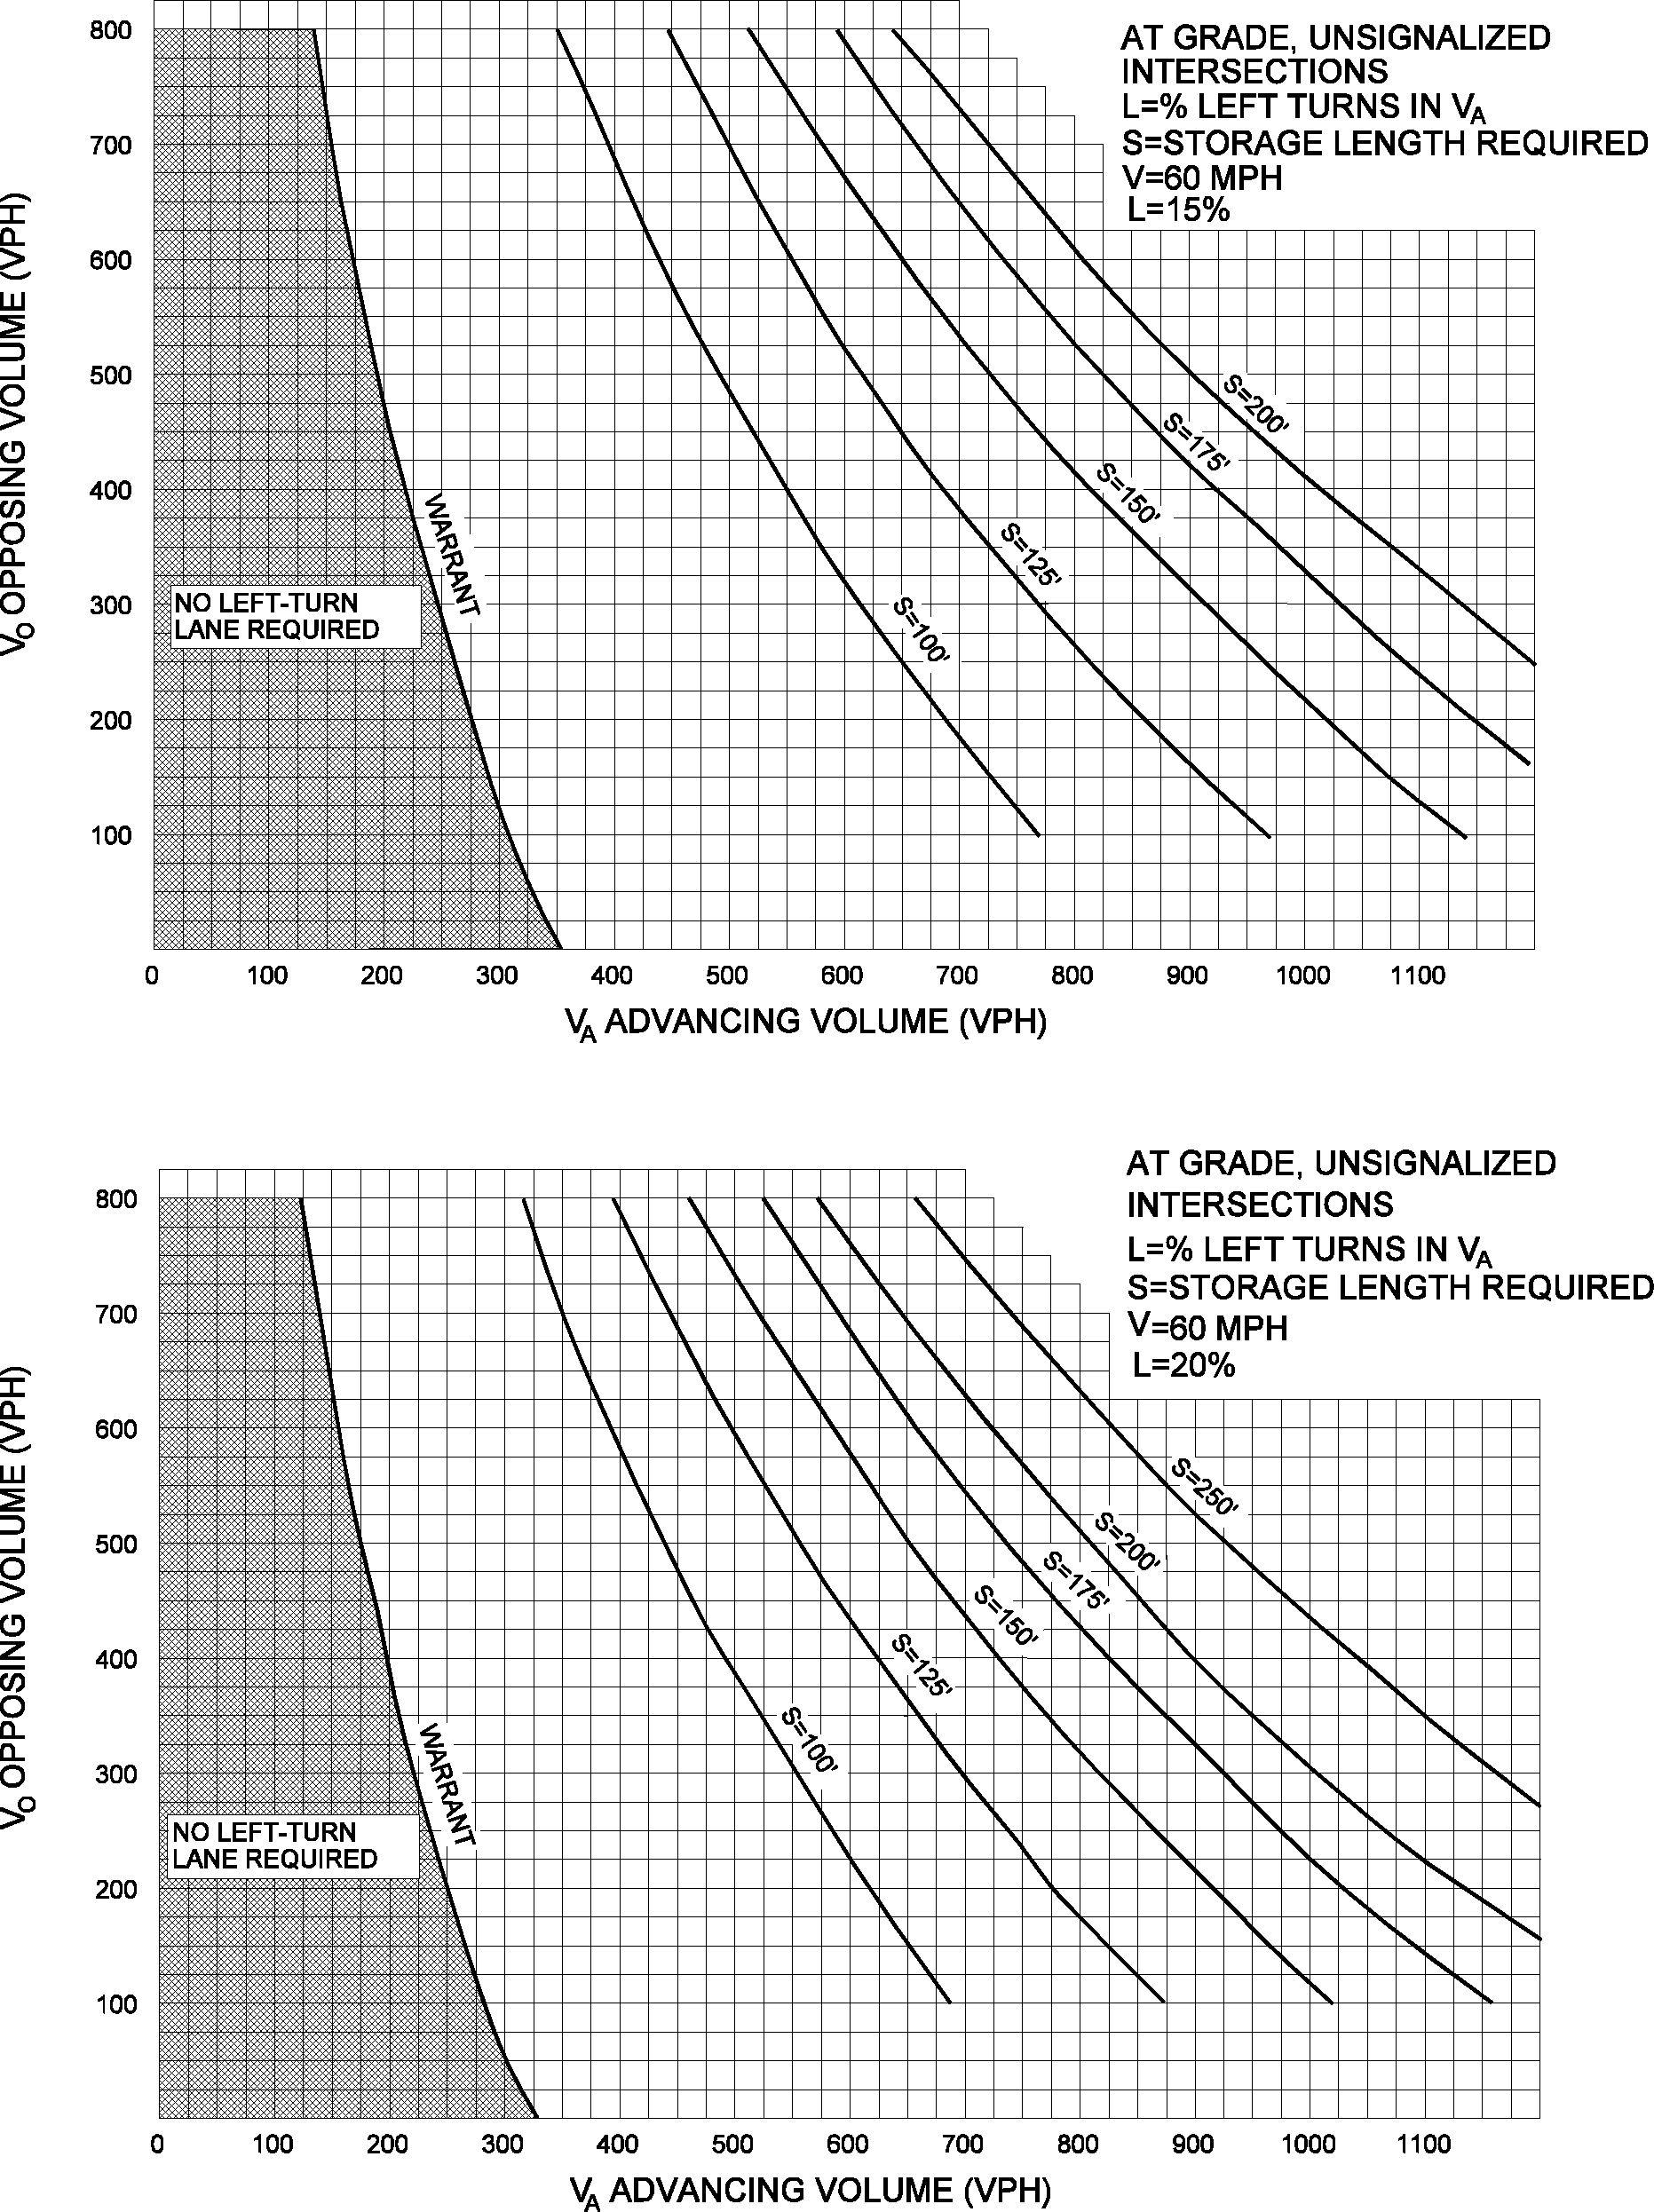
Figure 15
Warrant for 15% Left-Turn Storage Lanes at 60 mph

Figure 16
Warrant for 20% Left-Turn Storage Lanes at 60 mph
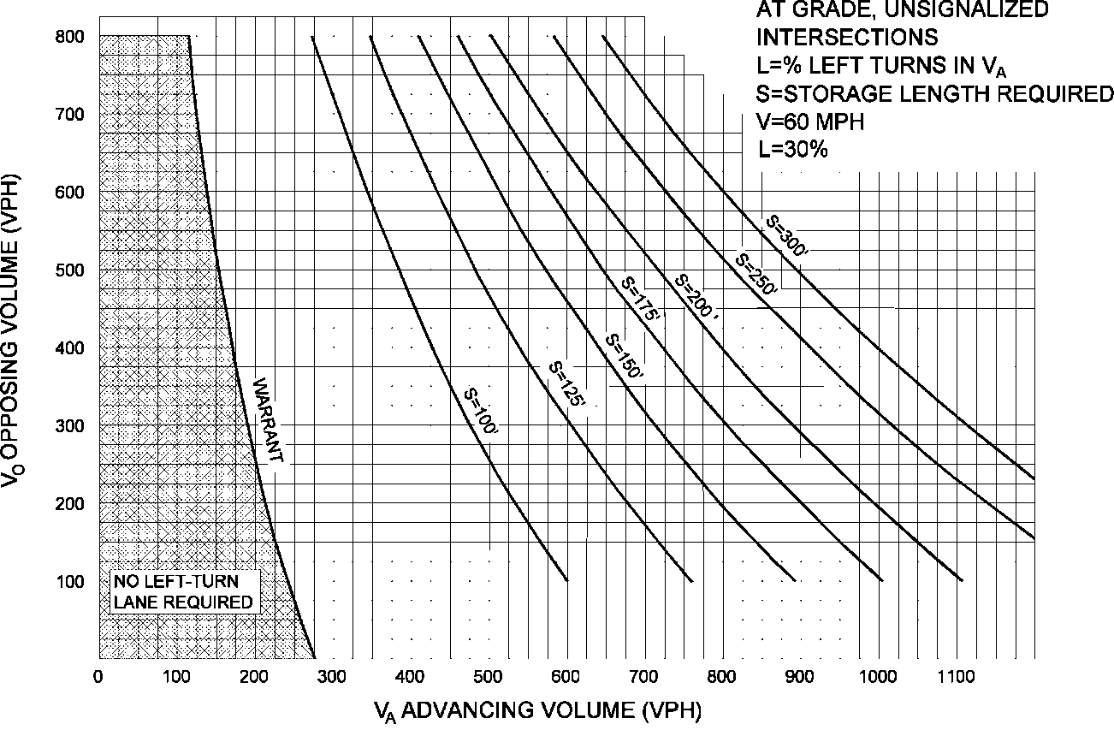
Figure 17
Warrant for 30% Left-Turn Storage Lanes at 60 mph

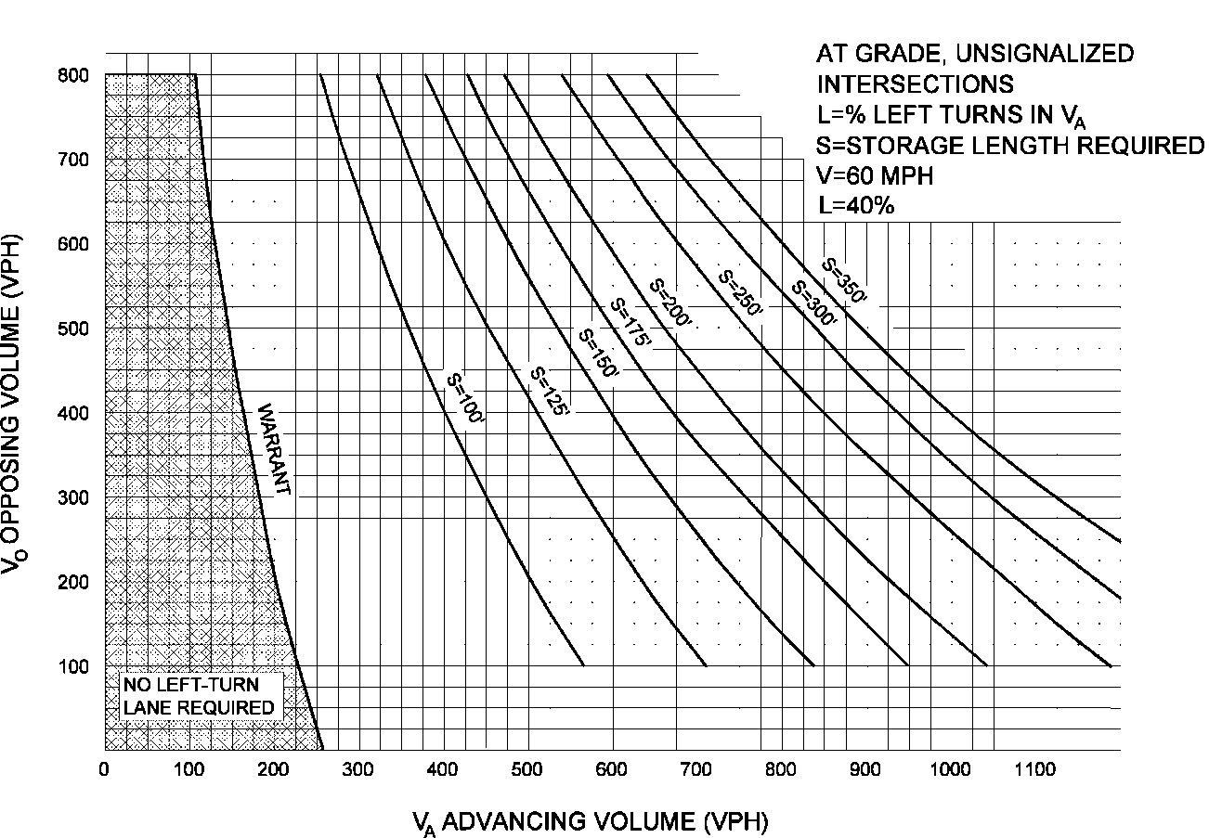
Figure 18
Warrant for 40% Left-Turn Storage Lanes at 60 mph

Left-Turn Storages for Four-Lane Highways
The following figure below shows the warrants and storage lengths for an Undivided and Divided Four-Lane Highway.
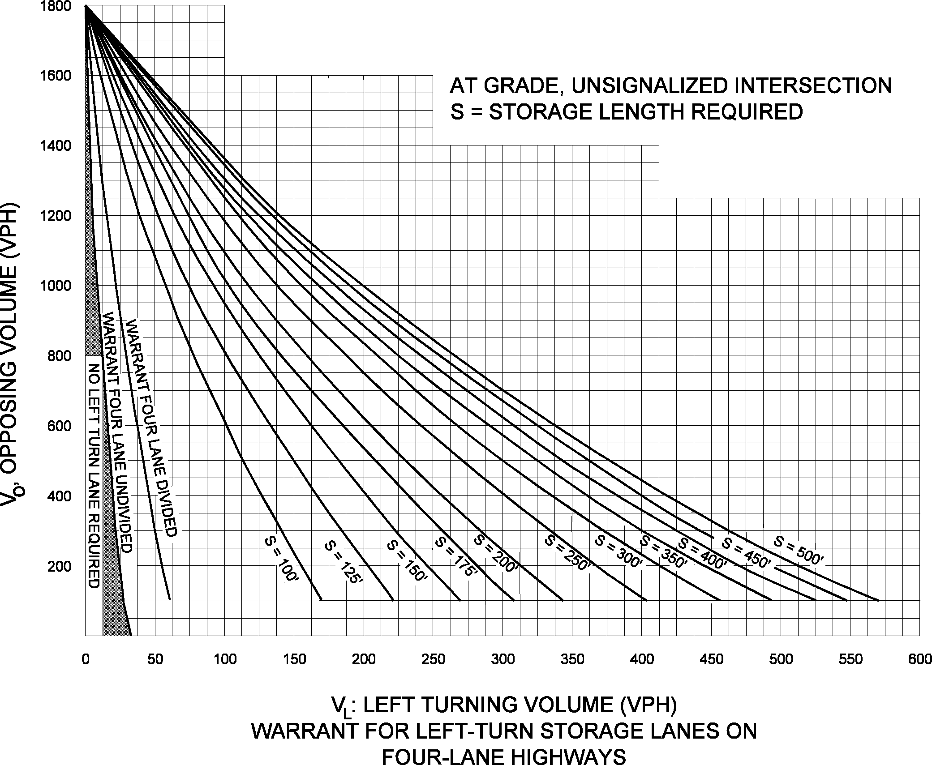
Figure 19
Warrant for Left-Turn Storage Lanes on Four-Lane Highways

References
http://onlinepubs.trb.org/Onlinepubs/hrr/1967/211/211-001.pdf
A Policy of Geometric Design of Highways and Streets 2011

