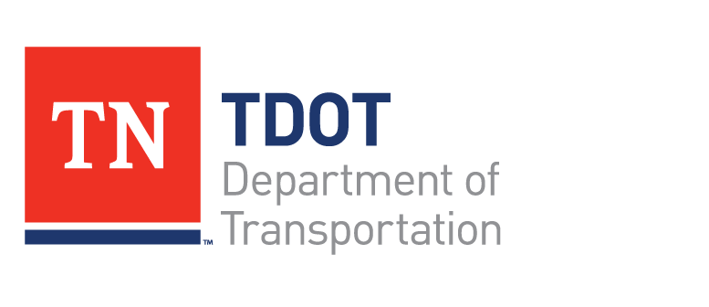

Interested in a Highway Construction Career?
- TDOT is in the process of offering a FREE Highway Construction Certification Program. Graduates would receive 3 months of training in a course designed by highway contractors.
- Included in the program would be a one month paid internship with a contractor on a highway construction project.
- Successful participants may be offered full time employment with the contractor. (Not TDOT) These jobs offer competitive salaries with fringe benefits. Most contractors will also offer advanced training and promotional opportunities.
- Location(s): To be determined.

Requirements:

Must have a valid TN Driver’s License, High School Diploma or GED, be 18 years of age or older, must be legally able to work in Tennessee, Physically able to do construction work and be interested in highway construction.

For more information contact Affirmative Action Program Staff
615-741-5996

