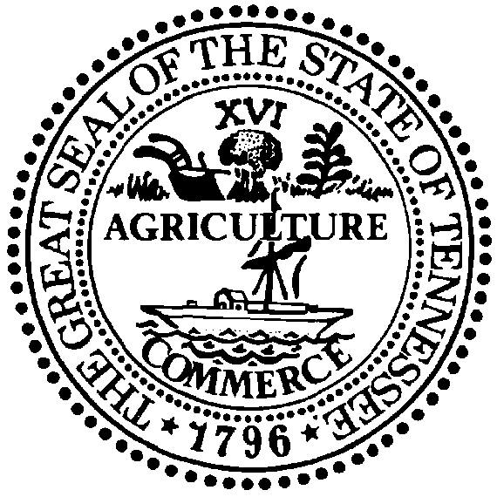

STATE OF TENNESSEE

DEPARTMENT OF TRANSPORTATION
central services division
Overweight & overdimensional permits
suite 300, james k. polk building
505 deaderick street
nashville, tennessee 37243-1402
(615) 741-3821
CLAY BRIGHT BILL LEE
COMMISSIONER GOVERNOR

To whom it may concern:

In response to the national emergency caused the by COVID-19 outbreak, Governor Lee’s Executive Order No. 15, as amended by Executive Order No. 19, suspends state laws and rules governing maximum vehicle size and weight limits for vehicles transporting emergency goods, supplies, equipment, mobile structures, items related to the maintenance of the food supply, disinfectant or sanitizing supplies of any kind, or other items to areas affected by the COVID-19 outbreak. Vehicles participating in this emergency response effort may carry divisible or nondivisible loads up to 95,000 lbs. gross weight, 100 feet long, 14 feet 6 inches wide, and 14 feet 4 inches high on interstate highways (except I-55) or 13 feet 6 inches high on Interstate 55 and other highways on the National Highway System, and subject to other restrictions established in the Executive Orders.

Executive Order Nos. 15 and 19 shall serve as the special permit for vehicles transporting any emergency response load authorized under these Orders. Transporters shall keep a copy of these Executive Orders in their vehicle while transporting any such load. Vehicles transporting emergency response loads that exceed the size and weight limits established in Executive Order No. 15 will need a special permit from the Tennessee Department of Transportation.

