Airport Grant Management and Invoicing supplemental guidelines

IMPORTANT: The TDOT Aeronautics Division has organized comprehensive instructions and guidelines for Airport Sponsor grant management to ensure more efficient project execution and financial oversight. This document provides Airport Sponsors with detailed information referencing grant obligations, invoicing requirements, and processing procedures that support successful project implementation throughout Tennessee's aviation infrastructure network. Please refer to the most recent TN Airport Management Guide for more information on the overall program.
Specifically, we hope you find the list of common invoice rejection reasons and the attached table on required documents for invoice submissions especially helpful. We encourage you to print this out to assist when submitting an invoice reimbursement request to TDOT Aeronautics Division. Example invoice packets to reference are also included with the table. To use this document to its fully intended functionality, please toggle each section below on and off by clicking the [Triangles].

Grant Obligations and Financial Accountability
Not only do FAA Grant Assurances apply to NPIAS Airport Sponsors, but ALL Airport Sponsors that accept a grant from TDOT Aeronautics Division maintain specific grant obligations to ensure all expenditures are necessary, justified, and documented appropriately. With an executed grant agreement in place, the TDOT Aeronautics Division processes payment requests submitted by Airport Sponsors according to established protocols that maintain both fiscal responsibility and operational flexibility. Payment requests may be submitted no more frequently than monthly and must include all necessary supporting documentation to validate the expenditures being claimed. The Aeronautics Division recognizes the diverse categories of invoices that Sponsors could submit and has developed specific guidance regarding required documentation to facilitate timely processing and minimize administrative delays.

It is essential for Airport Sponsors to thoroughly familiarize themselves with the grant language and provisions set forth in the Grant Contract between the State of Tennessee and the Airport Sponsor. These contracts contain critical information regarding Scope of Services, Deliverables, and Contract/Payment/Standard/Special Terms and Conditions that govern the administration of grant funds. Additionally, documentation attached to the grant that was included in the Sponsor's original application dictates the financial breakdown information that will be used throughout the project lifecycle. Understanding these elements before initiating project work can prevent misunderstandings and ensure compliance with all applicable requirements.

Grant Execution Process
The pathway to accessing grant funding begins after your project receives approval through either the TDOT Aeronautics Project Staff Review (PSR) or the Tennessee Aeronautics Commission (TAC), depending on the nature and scope of the proposed work. Once approved, the grant execution process commences with specific administrative requirements that must be fulfilled. Your assigned Grants & Compliance contact will coordinate directly with your organization to obtain the proper grant signatures and Sponsor certifications necessary for your specific project. This collaborative approach ensures all documentation meets state and/or federal requirements while establishing clear lines of communication for the duration of the project.

For projects designated as Match grants, a local share contribution is required as part of the funding structure. Your assigned Grants & Compliance contact will provide more detail on this during the grant execution process.
As of 2025, all local share contributions must be submitted via certified mail to:
TDOT Finance Division
Attn: Accounts Receivable (Lacey Bryant)
505 Deaderick Street
Suite 800, James K. Polk Building
Nashville, TN 37243-0329

The timely submission of local share funding is a prerequisite for invoice processing on Match grants. Once your grant is executed and your local share has been properly submitted (if required), your organization will be fully equipped to begin the invoicing process as project services are rendered according to the approved scope of work. Please see the graphic right below that shows the lifecycle of an invoice at a glance.
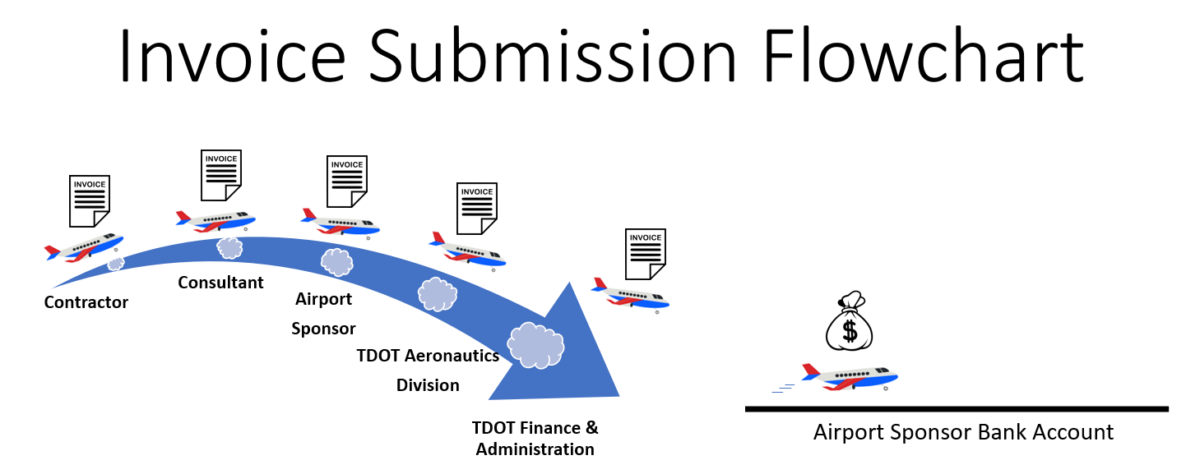
TDOT employees are held to a monitored & practical invoice review timeframe and required to process them promptly. Airport Sponsors can typically expect invoice reimbursement within 45 days of initial submission to TDOT.
Note: Contractor and Consultant invoices only apply for standard development-type projects. Airport Sponsor may submit invoice directly received by vendor. See Table at the end of this document for full comprehension.

Grant Classification and Financial Procedures
The TDOT Aeronautics Division administers two primary categories of grants, each with distinct financial procedures and requirements that Airport Sponsors must understand to ensure smooth project implementation. The most common type is the Match grant, also frequently referred to as a Reimbursement grant. This funding mechanism is primarily utilized for General Aviation airport planning, development projects, land acquisition initiatives, and equipment procurement. The second category is the Participation grant, which serves different purposes including annual airport maintenance funding, Air Carrier projects, and specialized programs such as the Aeronautics Economic Development Fund.

The fundamental difference between these grant categories lies in their financial administration procedures. Under a Match grant structure, the airport must submit a predetermined local share contribution within 15 days to TDOT Finance before any invoices can be processed. This advance payment serves as the airport's committed portion of project funding. When submitting invoices for Match grants, the Sponsor must request reimbursement for the full amount of the pay request, as the local share has already been accounted for through the initial contribution. Conversely, a Participation grant operates on a different financial model where the Sponsor must first pay the entire expense and subsequently request reimbursement for the grant-covered percentage of costs. No upfront local share submittal to the State is required for Participation grants, but proof of payment becomes a primary requirement for reimbursement processing. The specific reimbursement percentage is established in the Financial Breakdown Attachment contained within the executed grant agreement. Please see the graphic right below that can be a quick resource for Match vs. Participation grants.
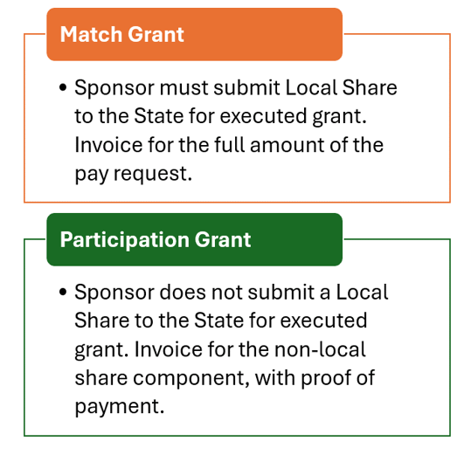

Invoicing System Implementation
The current grant management system for invoice submission and processing is housed within BlackCat Aviation (BCA), the comprehensive grant management platform utilized by TDOT Aeronautics Division. This digital environment streamlines the submission process while maintaining appropriate documentation standards and approval workflows. Airport Sponsors should become familiar with the BlackCat interface and submission requirements to ensure efficient processing of payment requests throughout the project lifecycle. BCA offers a help section at the top right of the screen when logged in. The system provides a secure, transparent mechanism for tracking invoices from submission through approval and payment, offering both the Sponsor and TDOT increased visibility into the financial aspects of project implementation. Contact your assigned Grants & Compliance person for any other questions you may have regarding the grant management system.

Documentation Requirements and Compliance Standards
Supporting documentation requirements vary based on the nature of expenses being claimed through the invoicing process. The TDOT Aeronautics Division has established categorical guidelines for minimum required documentation that must accompany each invoice submission. These requirements ensure proper validation of expenses while maintaining compliance with state and/or federal regulations governing aviation grant administration. Airport Sponsors should reference the comprehensive documentation table provided by TDOT when preparing invoice submissions to ensure all necessary supporting materials are included.

As explicitly stated in the grant contract under Invoice Requirements and Payment provisions, "the State has the right to object to or question any reimbursement, invoice, or related matter." Understanding some common reasons for invoice rejection will help Airport Sponsors avoid processing delays and maintain project momentum. Some frequent issues that result in returned invoices include but are not limited to:

- Insufficient Documentation
  - Use Table below to assist on what is minimally required
  - Utilize the latest website published TAD professional services and construction payform template to satisfy TDOT Finance and Administration office (F&A) requirements
    - Consultant RFQ satisfied, professional services executed Owner/Engineer (O/E) Work Authorization, and construction services executed in Owner/Contractor bonded contract
    - Ensure proper heading information is, undoubtedly, representative of the project services rendered (i.e. Project Number, Contract Number, Dates of Service, Working Days, etc.)
- Improper Scope of Work
  - Project must line up with the approved application and be eligible, appropriate, & justified. Contact TDOT Aeronautics Project manager for scope of work questions, if necessary.
- Services spanning multiple State fiscal years without appropriate separation in documentation (State FY = July 1 - June 30)
  - Split invoices into two (or multiple) packets for reimbursement
- Inconsistent invoice numbering
  - Invoices must be numbered numerically by service type, beginning with number 1 for each service category within a new grant (i.e. Professional Services #1, Construction #1, …etc.)
- Inadequate redaction of sensitive financial information known as Personal or Private Information (PPI)
    - This goes for bank account numbers, routing numbers, credit card numbers, social security numbers, personal addresses, tax identification numbers, etc. All supporting documentation becomes a permanent part of the system and is considered public record.
- Unsigned documents
  - Ensure invoice cover letter and other documents that require a signatory are signed
- Missing or inadequate cover letters
  - Invoice cover letters accompanying invoice submissions must be presented on official Sponsor letterhead and addressed to the appropriate TDOT Aeronautics Division personnel. Please take time to review and write an appropriate letter to ensure information is updated, correct, and sufficient. Ensure date on letter is correct and not before the DOS of the invoice(s).
    - Sample Letter Here (Microsoft Word).
- Duplicate Invoice Submissions
  - If invoice was rejected, please reupload and submit revised documents under the same grant management system number. DO NOT CREATE A NEW INVOICE SUBMISSION!
- Services performed outside the grant period
  - Pay close attention to your grant start and end dates
- Late submissions
  - Invoices must be submitted within 60 days after the end of the calendar month in which the costs were incurred, or services were rendered. All invoices must be submitted within 60 days of the grant end date.
    - Invoice submitted after this period are not eligible for reimbursement. Submit monthly to combat this issue.
- Retainage
  - In accordance with the Tennessee Department of Transportation standard grant terms and conditions, the Grantee [and TDOT] may not withhold retainage on progress payments from the prime contractor and the prime contractor may not withhold retainage from their subcontractors.
- Interest
  - TDOT does not reimburse loan/bond interest
- Illegible documentation
  - Cut down on the number times it is machine-scanned to retain proper document resolution. 300 DPI is minimum scanning resolution required. Sign electronically to combat this issue.
- Incorrect upload and/or submission in BlackCat Aviation
  - Follow the correct steps and fill in the correct information in the system. Make sure it is submitted under the correct project listing.
  - Only mark the last invoice reimbursement request for the grant as final in the grant management system or it will create errors
- Not showing proper decimal places on payforms
  - TDOT Aeronautics recreates the payforms to check for error. The Sponsor is always responsible for submitting correct and accurate information.
  - All invoices must be precise and correct down to the cent.
- Incorrect transcription of information
  - Always double check to ensure critical information like the correct project number or project title or even previous payments is referenced on the documentation

Effective grant management requires ongoing attention to both administrative details and broader compliance requirements throughout the project lifecycle. Airport Sponsors can maximize the efficiency of their grant administration by implementing several best practices developed through TDOT Aeronautics' extensive experience in aviation project oversight. Maintaining a comprehensive project file that includes all grant documents, communications, invoices, and supporting materials creates a valuable reference resource that can expedite issue resolution and support successful project audits if required. Regular communication with assigned TDOT contacts helps identify potential issues before they create processing delays and ensures alignment between Sponsor activities and grant requirements.

Calendar management represents another critical element of successful grant administration. Sponsors should establish internal tracking systems for key grant deadlines, including the grant expiration date, invoice submission timeframes, and project milestones. These tracking mechanisms help prevent situations where valid expenses become ineligible for reimbursement due to missed submission deadlines. Similarly, maintaining awareness of the State fiscal year calendar is essential for proper invoice preparation, particularly for projects that span multiple fiscal years and require segregated documentation.

The quality of documentation submitted through the BlackCat system directly impacts processing efficiency. Sponsors should develop internal quality control procedures to verify that all required documents are included with each submission, information is accurately transcribed from source documents, and all materials meet TDOT's legibility standards. These verification steps, while requiring additional time during the preparation phase, ultimately reduce processing delays by minimizing the need for clarifications or corrections after submission.

Conclusion
Successful implementation of airport development projects through TDOT Aeronautics grant programs requires attention to administrative detail, consistent compliance with established procedures, and clear communication between Airport Sponsors and Division personnel. The procedures outlined in this document are designed to facilitate efficient project execution while maintaining appropriate financial controls and documentation standards. By understanding and adhering to these requirements, Airport Sponsors can streamline the reimbursement process and focus more effectively on the technical and operational aspects of their development initiatives.

The TDOT Aeronautics Division remains committed to supporting Tennessee's aviation infrastructure through responsive grant administration and ongoing procedural refinements. As regulatory requirements or administrative processes evolve, the Division will provide updated guidance to ensure all stakeholders maintain current knowledge of grant management best practices. Through collaborative partnership between the Division and Airport Sponsors, Tennessee's aviation network will continue to develop in ways that enhance safety, expand capacity, and support economic growth throughout the state.

Table & Footnotes (See NEXT PAGE)
Invoice Submission Common Supporting Documentation Requirements
Grant Terms |  | Match (Reimbursement) |  |  |  |  |  |  | Participation
Grant Type |  | Airport Development |  |  |  |  | Airport Sponsor Invoice⁶ | Grounds Maintenance Equipment⁷ | General Aviation (GA) | Air Carrier | AEDF | TAC Policy 170-02
 |  | Airport Planning³ | Capital Project |  | Land/Easement Acquisition |  | Airport Sponsor Invoice⁶ | Grounds Maintenance Equipment⁷ | Airport Maintenance Grants | MEM, BNA, CHA, TYS, TRI | Aeronautics Economic Development Fund | Terminals State Funded
 |  | Professional Services  (Planning) | Professional Services (Design) | Construction^{4,5} | Study Phase | Acquisition Phase
What's Required? | Cover Letter on Letterhead signed by Grant Signatory | x | x | x | x | x | x | x | x | x | x | x
What's Required? | Invoice from Vendor |  |  | x | x | x | x | x | x | x | x | x
What's Required? | Deliverable Obtained | x* | x* |  | x* |  | x* |  |  | x*
What's Required? | Proof of Payment¹ |  |  |  |  | x | x* | x* | x | x | x | x
What's Required? | TAD Professional Services Payform | x | x |  | x* | x* |  |  |  |  | x | x
What's Required? | TAD Contractor Payform |  |  | x |  |  |  |  |  | x* |  | x
What's Required? | AIA -Type Construction Invoice Form |  |  | X⁸ |  |  |  |  |  | X⁸ | X⁸ | X⁸
What's Required? | Invoice Request Summary (Draw Request Summary) |  |  |  |  |  |  |  |  | x*
What's Required? | Warranty Deed² |  |  |  |  | x |  |  |  | x*
What's Required? | Replacement Housing Program (RHP) Docs |  |  |  |  | x* |  |  |  | x*
What's Required? | HUD-1 Settlement Statement² |  |  |  |  | x |  |  |  | x*
What's Required? | Title Opinion or Certificate of Title |  |  |  |  | x |  |  |  | x*
What's Required? | Administrative Settlement Form |  |  |  |  | x*
Example Packet Example Packet Example Packet Example Packet Example Packet Example Packet Example Packet Example Packet
Note: The table is not meant to be all-encompassing and should only be used as a resource. The table covers most common scenarios. Contact TDOT for more Information if your scenario is not listed above.
Table Footnotes:

*As Needed or only required if TDOT Aeronautics is not in receipt of the deliverable obtained.

1. This can be a receipt, bank statement, copy of check, or other document that verifies a payment. Please ensure sensitive TAX ID/Account is redacted.
2. This could also be an avigation or other easement, as applicable.
3. Refer to applicable ALP Pay Provisions on the TAD website for more detail on what is required with your submission.
4. Federal Construction contracts that exceed $2,000 have certified payrolls submitted with the project invoices. Additionally, DBE/Subcontractor commitment is required and submit the Contract Commitments/Awards and Payments Report.
5. For documentation purposes and as applicable, submit the fully executed change order/supplemental agreement(s) with the accompanying invoice(s). If invoice required procedures like, for example, stored materials or bituminous/fuel indexing, attach the supporting documentation.
6. This might be invoices for project advertisements, project legal expenses, Independent Fee Reviews, Audit Fees, or any project invoices that the Airport Sponsor is managing independently. For FAA Reimbursable Agreements (RA), the Sponsor should pay the invoice first and understand that the FAA may give money back or charge more at the end of the project. Sponsor must read the terms of the agreement and work with TAD on proper invoicing procedure. Common RAs are FAA Commissioning Flight Checks and Special Studies (like ATC Siting).
7. This is a specialized grant that is different from the annual FY Maintenance Grants the airport receives. It is commonly used for equipment like tractors, mowers, & bushhogs to maintain airport grounds.
8. Typically used for architectural building projects that have many construction line items (i.e. Terminals, ATC Towers, Multi-component hangar/lean-tos., etc.). NOT A REQUIRED FORM, BUT IT IS ALLOWED TO BE USED IN LIEU OF TAD CONTRACTOR PAYFORM.

