Friday, Aug. 7, 2026

Weekly Agency Benefits Coordinator Update

ABC email content is separated by information for all plans and then by plan:
ALL PLANS
STATE GOVERNMENT
HIGHER EDUCATION
LOCAL EDUCATION
LOCAL GOVERNMENT

Attachments such as flyers or PDFs will be linked on the ABC webpage on the top panel titled Weekly ABC Update and named by plan (all plans, state government, higher education, local education or local government).

Information you can directly share will be listed under the For Members header.
ABC-specific information is listed under the For ABCs header.

ALL PLANS

For ABCs

August ABC Conference Calls
ABC conference calls will take place on Tuesday, Aug. 11.
- Higher education: 8:30-9 a.m. CT
- Local education: 9:30-10 a.m. CT
- Local government: 10:30-11 a.m. CT
- State government: 11:30 a.m.-noon CT
To join the calls, use the Webex login link and instructions in the posted agenda or link below. See the agenda for details on other ways to join the calls.

To join the ABC conference call, click on the link:

https://tn.webex.com/meet/joan.williams

Benefits WorkCenter Update
We’ve added two new shortcuts to the Benefits WorkCenter to provide quicker access to frequently used pages and streamline navigation.
New Shortcuts
Review Benefits Summary
- Located under Employee/Dependent Information
- Provides direct access to the Review Benefits Summary page, allowing you to quickly review an employee's current benefit elections without navigating through multiple menu options.
Review Employee Statements
- Located under Enrollment Administration
- Provides direct access to the Review Employee Statements page, making it easier to view employee benefit statements.
Please see the screenshot below for the location of these new shortcuts.

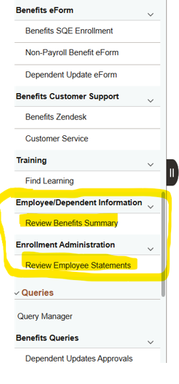
Figure 1 Screenshot of Benefits WorkCenter showing the location of two new shortcuts: Review Benefits Summary and Review Employee Statements.
We hope these enhancements help make your work a little easier. As always, thank you for everything you do to support your employees.

Edison Maintenance
Edison will be down this Sunday, Aug. 9, 2026, from 6 a.m. to noon CT for maintenance. During this time, Edison will be unavailable to all users.

ABC Summer Training
Registration for the ABC summer training is closed due to full capacity. Portions of the training will be available online this fall. In September, please check the ABC summer training webpage for session videos.
ABC Summer Training Information:
- State and higher education: Tuesday, Aug. 25
- Local education and local government: Wednesday, Aug. 26
- Location: Ed Jones Auditorium at Ellington Agricultural Center in Nashville.
- The event is free and designed for ABCs. It covers key updates, important changes and helpful resources to support your role.
- There is no virtual attendance option.
- If you’ve registered to attend, please check the ABC summer training webpage regularly leading up to the event. We’ll post important updates, event information, parking details and other logistics as they become available.

Annual Enrollment for 2027 Benefits
Mark your calendar with the Annual Enrollment dates for 2027 benefits:
- State government and higher education employees: Oct. 1-16, 2026
- Local education and local government employees, and all retirees: Oct. 1-30, 2026
We’ve posted the Annual Enrollment countdown clock on the main Annual Enrollment webpage. More AE information will be coming soon.

## End of all plans message ##

STATE GOVERNMENT

For ABCs (state government)
We don’t have any specific information for state government ABCs.

## End of state government message ##

HIGHER EDUCATION

For ABCs (higher ed)
We don’t have any specific information for higher education ABCs.

## End of higher ed message ##

LOCAL EDUCATION

For ABCs (local ed)
We don’t have any specific information for local education ABCs.

## End of local education message ##

LOCAL GOVERNMENT

For ABCs (local gov)
We don’t have any specific information for local government ABCs.

## End of local gov message ##

