Friday, March 27, 2026

Weekly ABC Update

ABC email content is separated by information for all plans and then by plan:

ALL PLANS
STATE GOVERNMENT
HIGHER EDUCATION
LOCAL EDUCATION
LOCAL GOVERNMENT

Attachments such as flyers or PDFs will be linked on the ABC webpage on the top panel titled Weekly ABC Update and named by plan (all plans, state government, higher education, local education or local government).

Information you can directly share will be listed under the For Members header.
ABC-specific information is listed under the For ABCs header.

ALL PLANS

For ABCs

ADA Compliance Update
The Americans with Disabilities Act compliance deadline for government websites is April 24. Benefits Administration’s deadline is April 1. Materials and videos on the Partners for Health website that are not yet ADA-compliant by this date may be temporarily unavailable online but can still be requested by submitting a Zendesk ticket.

Effective April 1, the Enrollment Change Application will be available through Formstack, our new electronic submission process. With this new process, ABC signatures are no longer required, and submissions will be sent directly to the Benefits Administration Service Center for processing. ABCs will be included on the back end of the request to ensure visibility of member submissions. In April, both the current version and the new Formstack application will be accepted to ensure a smooth transition. Beginning May 1, all enrollment change requests must be submitted via Formstack, as the previous version will no longer be accepted. If you would like to request a copy of the current Enrollment Change Application, we can provide it via email. Please note that this form will no longer be updated by BA and will no longer be accepted after May 1. The eForms in Edison are still available for ABCs to enter for employee elections.

For Newly Issued BlueCross BlueShield ID Cards
Starting March 27, 2026, new BCBST ID cards for new hires and members will look a little different. Below is a brief description of the changes, followed by a picture showing what’s new.

On the front of the card, the Member ID that is above the member’s number will change to Subscriber ID. On the back of the card, in the bottom-right corner, the prior authorization information will change to: Avoid additional costs. Show this card to your provider and ask for a prior authorization check. See your benefit materials for details. This card does not guarantee benefits eligibility.

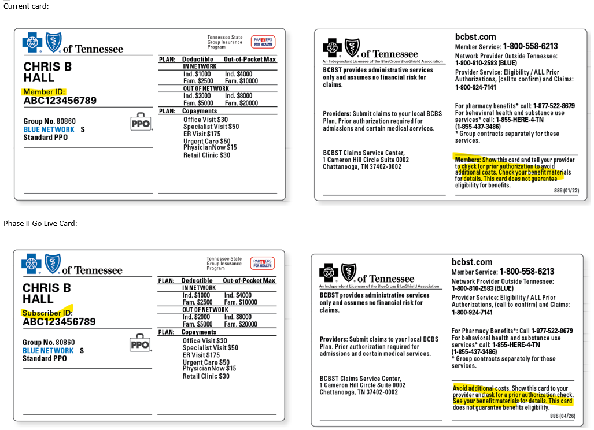

HIPAA Training Announcement
Please see the plan sections for your specific HIPAA training information and deadline.
- The higher education training completion deadline is March 31.

State Offices and the Benefits Administration Service Center Closed
State offices and the BA service center will be closed next Friday, April 3, for Good Friday. We will not post an ABC Update on that date due to the office closure.

## End of all plans message ##

STATE GOVERNMENT

For Members (state government)

April 4Mind4Body Webinar: Simplifying Your Money When Life Gets Busy
Email/subject line: Join Partners for Health for Simplifying Your Money When Life Gets Busy, Wednesday, April 8, starting at 11:30 a.m. CT

Explore practical strategies for maintaining financial health during life’s busiest moments. We’ll address how competing priorities—whether it’s a new job, growing family, caregiving responsibilities or unexpected life changes—can make money management feel overwhelming and lead to putting important financial decisions on hold. You’ll also learn strategies you could deploy to keep progressing toward your goals.

- Preregistration is required. The session will be recorded and sent to those who register.
- Go to this registration page to register.
- Go to the Partners for Health webinar webpage for current and past webinars.

For ABCs (state government)

April 4Mind4Body Webinar: Simplifying Your Money When Life Gets Busy
Optum Behavioral Health and BrightPlan will present the April 4Mind4Body webinar, Simplifying Your Money When Life Gets Busy, on Wednesday, April 8, from 11:30 to 12:30 p.m. CT. You can share the information above and the flyer posted with today’s update with your employees.

HIPAA Training Announcement
The 2026 HIPAA annual classes are open. You can take the class now! There is no need to wait for the assigned month. You must complete the training by the last day of your assigned training month.

Training completion deadline:
State government – June 30

This year, we have registered everyone for the class. You will locate the class in Edison under My Learning. If you were not registered, please sign up for the class using the instructions that follow.

The Health Insurance Portability and Accountability Act of 1996, known as HIPAA, is a federal law that protects the privacy and confidentiality of protected health information. Protected health Information is individually identifiable health information held or maintained by Benefits Administration or our business associates who act on our behalf that is transmitted or maintained in any form or medium. As an ABC, you and your agency are our business associates. The law requires all covered entities and business associates to be trained in HIPAA policies and procedures. All ABCs, backup ABCs and directors with access to Edison must complete the annual training. The HIPAA training exemplifies Benefits Administration’s commitment to educating and promoting a culture that encourages ethical conduct and compliance with state and federal laws.

ABCs, backups and directors must complete the annual HIPAA training every calendar year. Failure to comply with mandatory training requirements may suspend insurance benefits access. Training requirements will not be waived unless the BA HIPAA Compliance Officer approves.

State government will take BA_STATE_HE_HIPAA_2026

Here is the navigation after you log in to Edison at www.edison.tn.gov: NAV BAR > Navigator > ELM > Learning Home > Search for Learning type HIPAA > Annual HIPAA Training (HIPAA 2000) > BA_STATE_HE_HIPAA_2026

Please contact Chanda Rainey for assistance with the HIPAA training at Chanda.rainey@tn.gov.

## End of state government message ##

HIGHER EDUCATION

For ABCs (higher ed)

HIPAA Training Announcement
The 2026 HIPAA annual classes are open. You can take the class now! There is no need to wait for the assigned month. You must complete the training by the last day of your assigned training month.

Training completion deadline:
Higher education – March 31

This year, we have registered everyone for the class. You will locate the class in Edison under My Learning. If you were not registered, please sign up for the class using the instructions that follow.

The Health Insurance Portability and Accountability Act of 1996, known as HIPAA, is a federal law that protects the privacy and confidentiality of protected health information. Protected health Information is individually identifiable health information held or maintained by Benefits Administration or our business associates who act on our behalf that is transmitted or maintained in any form or medium. As an ABC, you and your agency are our business associates. The law requires all covered entities and business associates to be trained in HIPAA policies and procedures. All ABCs, backup ABCs and directors with access to Edison must complete the annual training. The HIPAA training exemplifies Benefits Administration’s commitment to educating and promoting a culture that encourages ethical conduct and compliance with state and federal laws.

ABCs, backups and directors must complete the annual HIPAA training every calendar year. Failure to comply with mandatory training requirements may suspend insurance benefits access. Training requirements will not be waived unless the BA HIPAA Compliance Officer approves.

Higher education will take BA_STATE_HE_HIPAA_2026

Here is the navigation after you log in to Edison at www.edison.tn.gov: NAV BAR > Navigator > ELM > Learning Home > Search for Learning type HIPAA > Annual HIPAA Training (HIPAA 2000) > BA_STATE_HE_HIPAA_2026

Please contact Chanda Rainey for assistance with the HIPAA training at Chanda.rainey@tn.gov.

## End of higher ed message ##

LOCAL EDUCATION

For ABCs (local ed)

HIPAA Training Announcement
The 2026 HIPAA annual classes are open. You can take the class now! There is no need to wait for the assigned month. You must complete the training by the last day of your assigned training month.

Training completion deadline:
Local education – April 30

Our training for local education includes a review of the Memorandum of Understanding.

This year, we have registered everyone for the class. You will locate the class in Edison under My Learning. If you were not registered, please sign up for the class using the instructions that follow.

The Health Insurance Portability and Accountability Act of 1996, known as HIPAA, is a federal law that protects the privacy and confidentiality of protected health information. Protected health Information is individually identifiable health information held or maintained by Benefits Administration or our business associates who act on our behalf that is transmitted or maintained in any form or medium. As an ABC, you and your agency are our business associates. The law requires all covered entities and business associates to be trained in HIPAA policies and procedures. All ABCs, backup ABCs and directors with access to Edison must complete the annual training. The HIPAA training exemplifies Benefits Administration’s commitment to educating and promoting a culture that encourages ethical conduct and compliance with state and federal laws.

ABCs, backups and directors must complete the annual HIPAA training every calendar year. Failure to comply with mandatory training requirements may suspend insurance benefits access. Training requirements will not be waived unless the BA HIPAA Compliance Officer approves.

Local education will take LG_LE_HIPAA_2026

Here is the navigation after you log in to Edison at www.edison.tn.gov: NAV BAR > Navigator > ELM > Learning Home > Search for Learning type HIPAA > Annual HIPAA Training (HIPAA 2000) > LG_LE_HIPAA_2026

Please contact Chanda Rainey for assistance with the HIPAA training at Chanda.rainey@tn.gov.

## End of local education message ##

LOCAL GOVERNMENT

For ABCs (local gov)

HIPAA Training Announcement
The 2026 HIPAA annual classes are open. You can take the class now! There is no need to wait for the assigned month. You must complete the training by the last day of your assigned training month.

Training completion deadline:
Local government – May 30

Our training for local government includes a review of the Memorandum of Understanding.

This year, we have registered everyone for the class. You will locate the class in Edison under My Learning. If you were not registered, please sign up for the class using the instructions that follow.

The Health Insurance Portability and Accountability Act of 1996, known as HIPAA, is a federal law that protects the privacy and confidentiality of protected health information. Protected health Information is individually identifiable health information held or maintained by Benefits Administration or our business associates who act on our behalf that is transmitted or maintained in any form or medium. As an ABC, you and your agency are our business associates. The law requires all covered entities and business associates to be trained in HIPAA policies and procedures. All ABCs, backup ABCs and directors with access to Edison must complete the annual training. The HIPAA training exemplifies Benefits Administration’s commitment to educating and promoting a culture that encourages ethical conduct and compliance with state and federal laws.

ABCs, backups and directors must complete the annual HIPAA training every calendar year. Failure to comply with mandatory training requirements may suspend insurance benefits access. Training requirements will not be waived unless the BA HIPAA Compliance Officer approves.

Local government will take LG_LE_HIPAA_2026

Here is the navigation after you log in to Edison at www.edison.tn.gov: NAV BAR > Navigator > ELM > Learning Home > Search for Learning type HIPAA > Annual HIPAA Training (HIPAA 2000) > LG_LE_HIPAA_2026

Please contact Chanda Rainey for assistance with the HIPAA training at Chanda.rainey@tn.gov.

## End of local gov message ##

