

Opioid Abatement Council

FY2026 Annual Report
Report No. 5 | September 30, 2026
Mary Shelton, Executive Director

Executive Summary
As outlined in Tenn. Code Ann. § 33-11-105(b), the Opioid Abatement Council (OAC) shall create and the Director shall deliver to the Governor, the Speaker of the Senate, the Speaker of the House of Representatives, the Chairs of the Government Operations Committees of the Senate and House of Representatives, and the Chairs of the Finance, Ways, and Means Committees of the Senate and House of Representatives on or before September 30 of each year an annual report for the prior fiscal year that details the following:
- Total funds deposited into the opioid abatement fund,
- The abatement strategies funded, and
- Any disbursement or expenses paid from the opioid abatement fund.

FY2025 (July 1, 2025– June 30, 2026) Key Achievements and Milestones
- The Opioid Abatement Council met a total of five (5) times. Four (4) were Quarterly Meetings, and one (1) was an off-cycle virtual meeting.

- Annual County Payments totaling $16,938,399 were paid out to all 95 counties in April 2026. This is the fourth (4) annual payment the counties have received with the total payments at $103,900,360.

- Community Grant Cycle 3 application portal opened on March 2, 2026, and closed on April 3, 2026. The OAC Office received 301 Cycle 3 Community Grants applications with a total of $536,652,488 in funding requested.

- Paid invoices for Community Grants reached $102,099,077 by June 26, 2026.

- Total paid Opioid Trust Funds to Tennessee’s counties and community agencies since the Opioid Abatement Council began operations in the Fall 2022 is $205,999,437.

FY2026 Annual Report Scope Statement
This report covers only those funds disbursed to the Opioid Abatement Fund Trust which is managed by the Opioid Abatement Council. The Trust Fund, formally named the Tennessee Opioid Abatement Fund Trust, was established by statute in 2021. The Trust Agreement was adopted by the Opioid Abatement Fund Trust Board of Trustees on April 13, 2022.

Gratitude to the Attorney General’s Office
The Opioid Abatement Council would like to acknowledge the years of work by staff of the Tennessee Attorney General’s Office (AGO). The Tennessee AGO negotiated the multiple settlements which are paying dollars now available to prevent and address the misuse and abuse of opioid products and treat or mitigate opioid use or related disorders or other effects of the opioid epidemic. Their office continues to lead future negotiations and offer valuable guidance to the Executive Director and the Opioid Abatement Council.

Council’s Overview
On May 24, 2021, the Tennessee General Assembly passed Public Chapter 491 establishing the Opioid Abatement Council to manage the disbursement of proceeds from lawsuits relating to opioids. The Opioid Abatement Council upholds the responsibility to ensure the disbursements of these funds go toward funding programs, strategies, expenditures, and other actions designed to prevent and address the misuse and abuse of opioid products and treat or mitigate opioid use or related disorders or other effects of the opioid epidemic. The Tennessee Department of Mental Health and Substance Abuse Services (TDMHSAS) staffs the Council and provides administrative support.

Tennessee law establishing the Opioid Abatement Council is found at Tenn. Code Ann. §§ 33-11-101, et seq. Tennessee law establishing the Opioid Abatement Fund Trust is found at Tenn. Code Ann. §§ 9-4-1301, et seq.

Please see https://www.tn.gov/oac/about-us.html for more information.

Council Vision

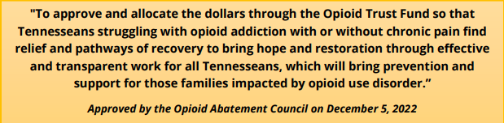

Council Members
As established by the Tennessee General Assembly in statute, the Council is to have 15 members appointed by the Governor, the Lieutenant Governor, the House Speaker, the Tennessee County Services Association, and the Tennessee Municipal League. TDMHSAS Commissioner Marie Williams serves as a non-voting member. Please see https://www.tn.gov/oac/about-us/council-members.html for more information.
There are 15 Council members including the Chair.
Council Chairman
Dr. Stephen Loyd
Dr. Tyler Barrett  Vanderbilt University Medical Center | Brian Buuck  Ridgeview Behavioral Health Services | Dr. Ronald Cowan  West Tennessee Psychiatrist | Thomas Farmer  Tennessee Bureau of Investigation (retired) | Mike Flynn  Blount Co District Attorney General (retired)
Armando Fontes  Cocke County Sheriff,  retired | Dr. Timothy Fournet,  Cookeville Cardiologist | Dr. Clay Jackson  West Tennessee Physician | Dr. Ken Moore  Franklin Mayor | Shayne Sexton  Judge, retired
Lisa Tipton  Families Free | Wayne Wykoff  Knoxville Attorney | Dr. Stephanie G. Vanterpool  UT Medical Center | Marie Williams  TDMHSAS Commissioner  Ex-officio Member

During FY 2026, two (2) members concluded their time on the Council:

- Judge Shayne Sexton ended his first term on June 30, 2026, and was thanked for his time and expertise during the March 5, 2026, OAC Quarterly meeting.

- Dr. Stephen Loyd stepped down as the OAC Council Chair effective June 30, 2026. The OAC thanked Dr. Loyd for his service during the June 2, 2026, OAC quarterly meeting.

Please see https://www.tn.gov/oac/about-us/former-members.html for more information.

Quotes from Council Members

“It is a tremendous honor to serve on the Tennessee Opioid Abatement Council. I am deeply grateful for the opportunity to work alongside such dedicated leaders and community partners who are committed to addressing one of the most significant public health challenges of our time. The Council’s work is making a meaningful difference by investing in prevention, treatment, recovery, and support services across our state. Together, we are helping communities heal, saving lives, and creating a stronger
Dr. Tyler Barrett, Professor of Emergency Medicine and the Associate Chief Medical Officer for Compliance at Vanderbilt Medical Center, quoted:

future for Tennesseans affected by the opioid crisis.”
“Serving on the Tennessee Opioid Abatement Council is an opportunity to help ensure communities across our state have the resources and partnerships they need to address one of our most significant public health challenges. As a retired physician and active mayor, I believe lasting progress comes from thoughtful collaboration, responsible stewardship, and investing in solutions that strengthen the health and well-being of Tennesseans for generations to come."
Dr. Ken Moore, Mayor of Franklin, quoted:


Council Office Staff


Mary Shelton
Executive Director
Shawn Smith  Deputy Director | Mark Carrillo  Grant Analyst
Ella Reding  Project Director | David Sappington  Grant Analyst
Nathan Payne  Program Director | Debbie Bresee  Executive Administrative Assistant
Melissa Gilbert  Audit Director | Sophia Massey  Fiscal Monitor
David Lewis  Quality Director | Marie Magras  Policy Analyst
Sam Boukli  Advising Legal Counsel | Mary Lee  Advising Legal Counsel for Contracts
Please see https://www.tn.gov/oac/about-us/executive-director.html for more information.

Council Responsibilities
The Opioid Abatement Council upholds the responsibility to ensure the disbursements of funds received in accordance with Tenn. Code Ann. § 9-4-1304 go toward funding programs, strategies, expenditures, and other actions designed to prevent and address the misuse and abuse of opioid products and treat or mitigate opioid use or related disorders or other effects of the opioid epidemic. Disbursement directives include:

- Funding and supporting opioid abatement and remediation purposes and related administrative costs
- Creating a list of approved programs for opioid abatement and remediation for use by the council, state, or local government
- Creating a certification process through which government entities verify the use of funds for programs on the council’s list of approved programs
- Incorporating input from the TDMHSAS Statewide Planning and Policy Council’s Need Assessment Process
- Developing policies for stakeholder input
- Reporting annually on funds deposited, strategies funded, and disbursements made

Council Meetings
The Opioid Abatement Council is required by statute under Title 33, Chapter 11, of the Tennessee Code Annotated to meet at least quarterly and move the meetings between the three (3) grand regions of Tennessee.
In FY2026, the Council met six (6) times, five times in-person and once virtually. The virtual meeting was necessary to plan for and vote to approve new policies; create guidelines for contract amendment and modification requests, carryover requests, and next steps to disburse the funds to the counties; and to prepare to disburse the funds to the community.
The Council meetings are held in compliance with the Open Meeting requirements of Title 8, Chapter 44, of Tennessee Code Annotated. The meetings are held in person with a virtual option for attendees to view and listen to the meeting. On average, there are approximately 150 guests at each meeting (including virtual and in-person).
The Opioid Abatement Council hears a brief reflection from the Council Chair at the start of each meeting on “Our Why”, which grounds us and reminds us of our vision.
At the end of each meeting, and in compliance with the Open Meetings Act, the Council Chair reserves time and asks those present, either in-person or virtually, if there is anyone who wishes to make a public comment.
Please see https://www.tn.gov/oac/meeting-schedule.html for more information.

FY2026 Opioid Abatement Council Meetings
*Meeting held in person if not otherwise indicated.
Date of Council Meeting | Location
October 7, 2025 | Collierville, TN
December 1, 2025 | Nashville, TN
March 5, 2026 | Oak Ridge, TN
April 14, 2026 | Virtual
June 2, 2026 | Jackson, TN

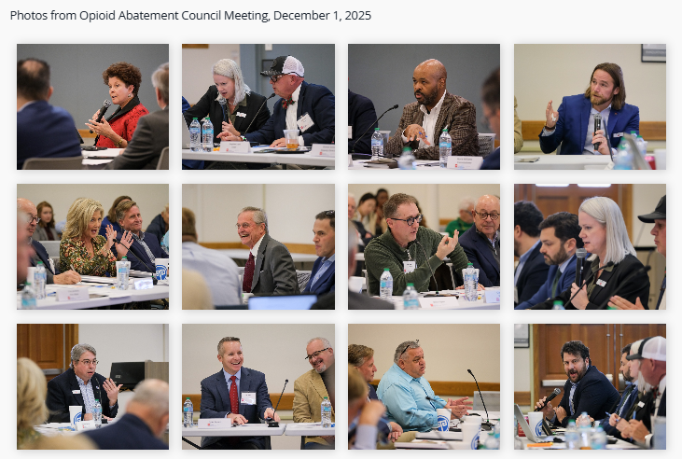

Council Website
The Opioid Abatement Council’s website is the main communication tool with the public.
The OAC Office endeavors to build trust with the community and ensure transparency through updating the website frequently. Please visit the website at https://www.tn.gov/oac.html
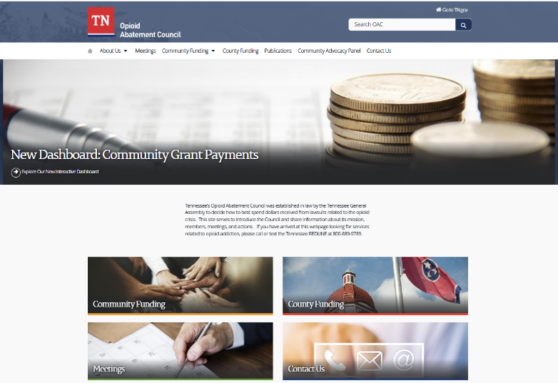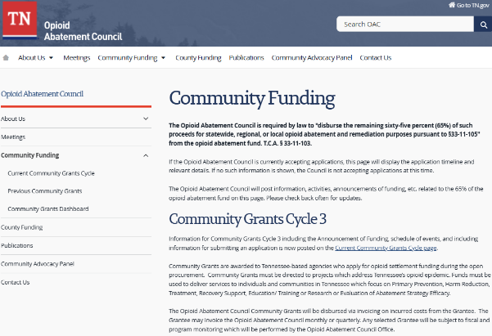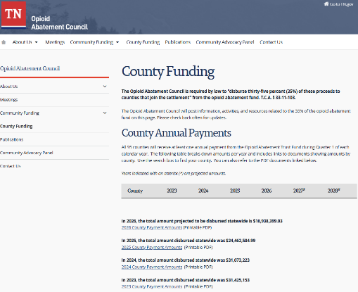
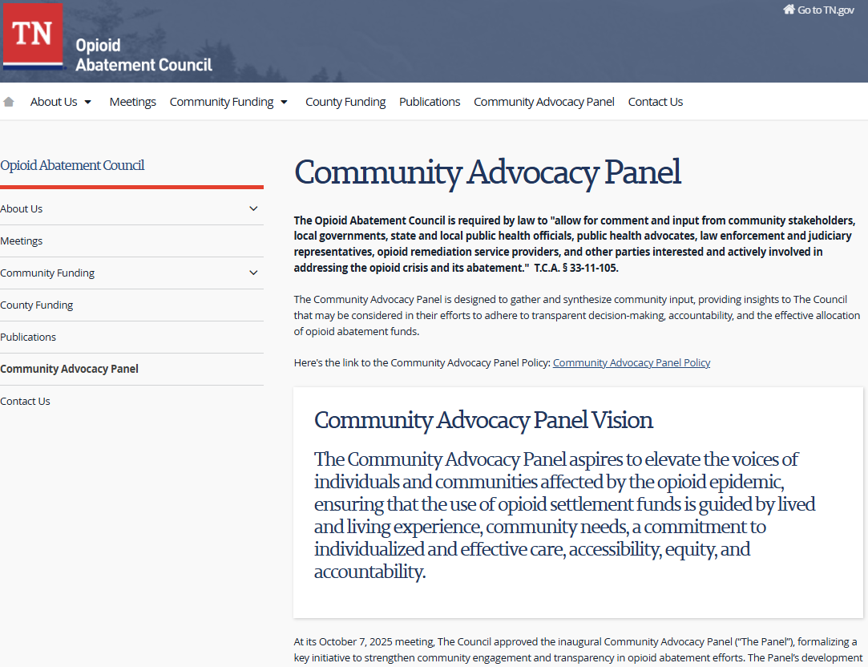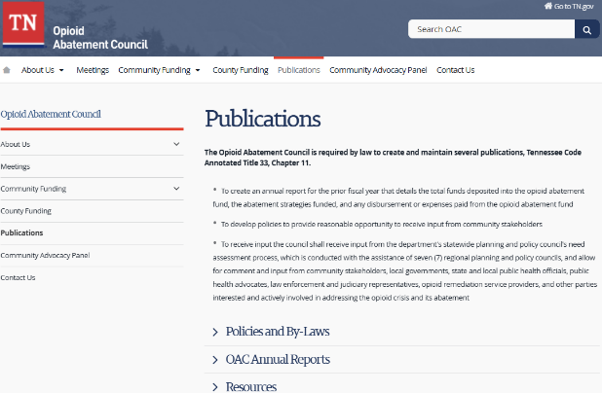

Newsletters
The Opioid Abatement Council Office communicates updates and meeting information on a frequent basis via Community Newsletters.
During FY2026, the OAC Office sent twenty (20) Community newsletters that reached approximately 900 opt-in subscribers. Community newsletters are sent at least monthly and at a greater frequency when there are important updates on applying for funding.
The OAC Office sends monthly newsletters to share important updates and meeting information to OAC Members, OAC Grantees, and County Leaders.


Opioid Abatement Fund Trust
Tennessee Code Annotated § 9-4-1304 makes the Opioid Abatement Fund Trust the designated repository of “funds that are either dedicated to opioid abatement or remediation or are otherwise directed to abatement or remediation and that are received by the state pursuant to a judgment on opioid-related claims, a recovery in bankruptcy on opioid-related claims, or a settlement of opioid-related claims,” as well as “other sources if the funds will be dedicated to abatement.” These payments are placed in the trust, which is separate and distinct from the State’s General Fund, and money in the fund must be spent on opioid abatement and remediation.

Disbursement of Funds based on Public Charter
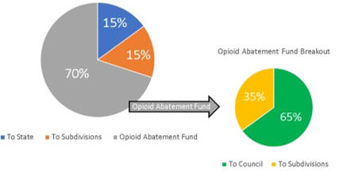

The Opioid Abatement Council is entrusted to manage 70% of the funds received from settlements and bankruptcies. These funds are deposited in the Opioid Abatement Fund Trust. Of the 70%:
- 35% will go to 95 counties (Subdivisions) based on a calculation agreed on by the Attorney General’s Office and all counties. All 95 counties will receive at least one annual payment during Quarter 1 of each calendar year.
- 65% goes to the Council to distribute to the community via grant funding.

Total Funds Deposited into the Opioid Abatement Fund Trust, FY2026
During FY2026, eight (8) deposits were made to the Opioid Abatement Fund Trust.
The Opioid Abatement Fund Board of Trustees and the Tennessee Department of Treasury manage the Opioid Abatement Fund Trust.
Company | Amount
K-V-A-T Food Stores, Inc. | $5,600,000.00
Allergan Limited | $5,733,961.61
Allergan Limited | $5,836,067.13
AmerisourceBergen | 19,618,907.87
CVS | 10,154,011.46
Walgreen | 4,935,462.14
Kroger | 2,734,273.41
Johnson & Johnson, Janssen | 3,011,581.21
Total Deposits | $57,624,264.83

Total Funds Disbursed from the Opioid Abatement Fund Trust, FY2026
Disbursements | Amount
Disbursements to Counties | 16,938,399.07
Departmental Expenses | 2,223,247.36
Disbursement of Community Grants | 79,748,254.63
Total Disbursements | $98,909,901.06

Current Balance of the Opioid Abatement Fund Trust
The Tennessee Department of Mental Health and Substance Abuse Services (TDMHSAS) Fiscal team produces a monthly Opioid Abatement Fund Trust Activity statement for the Opioid Abatement Council.

As of June 30, 2026, the balance in the Opioid Abatement Fund Trust is:
$143,856,221.34

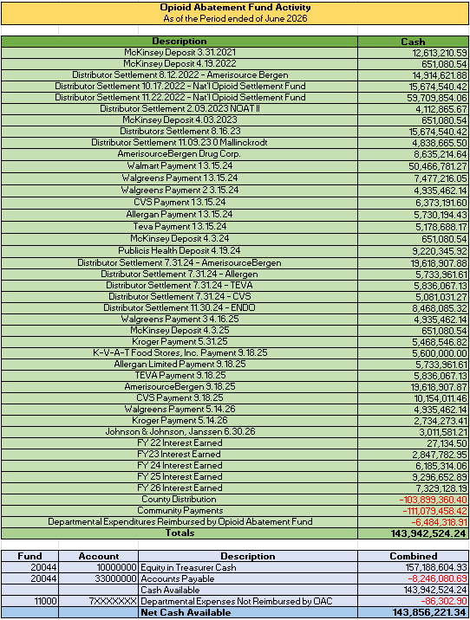

County Annual Payments
The Opioid Abatement Council is required by law to "disburse thirty-five percent (35%) of these proceeds to counties that join the settlement" from the opioid abatement fund trust. Tenn. Code Ann. § 33-11-103.
The illustration below is an overview of the FY2026 activities which expedited the 4th annual payments to all 95 counties in April 2026.

County Letter of Agreement
A Letter of Agreement (LOA) represents the formal document between the Opioid Abatement Council and each county, outlining the terms and conditions for each county’s utilization of Opioid Abatement Funds. Each county is required to execute the LOA prior to disbursement of funds.
- The LOA’s are sent via email.
- Disbursed funds must be spent on opioid abatement and remediation purposes.
- All records shall be maintained in accordance with state law
- The county shall obligate all funds for specific purposes as consistent with the agreement within the initial two-year time period of the four-year time period.
- Counties must report semi-annually on the use of funds received through disbursements from the Opioid Abatement Fund Trust.
  - For this report, the Council will be using Formstack as their report platform.

Tennessee Department of Mental Health and Substance Abuse Services (TDMHSAS) attorney assigned to the Opioid Abatement Council office, will annually review, and approve the LOA’s.

County Revision Report
For FY2026, the Opioid Abatement Council requested an aggregate report of the past 3 years of spending from each county. The intent of the Revision Report was to ensure that the numbers reported by the Counties were checked for accuracy by the county and reviewed for completeness by the OAC Office.

Data included:
- Allocation of the funding received by counties
- Funding amount spent by the counties
- Positive outcomes

County Funding
    - All 95 counties will receive at least one annual payment from the Opioid Abatement Fund Trust during Quarter 1 of each calendar year.
    - Tennessee Abatement Fund Initial County Allocation Percentages
    - The data used to determine the amount each county will receive is based on the Initial County Allocation Percentages (reference is above).
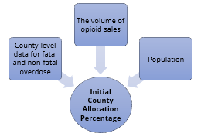
The County Allocation Percentage is based on the data that is updated by the TN Department of Health

The Opioid Abatement Council relies on the data collected by the Department of Health for the County Allocation Percentage which was agreed to under the settlement agreements with the subdivisions.

Below lists the data which is collected and input into a formula to determine the annual payments to the counties.

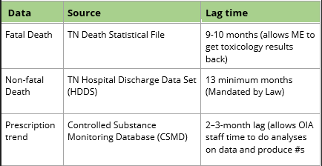

All 95 Counties have received their 4th payments from the Opioid Abatement Fund Trust.
As of April 2026, all 95 counties have received their share of $16,938,399 through their 4th annual payment.
The annual payments will continue for at least 15 years with payments during the 1st quarter of the calendar year.

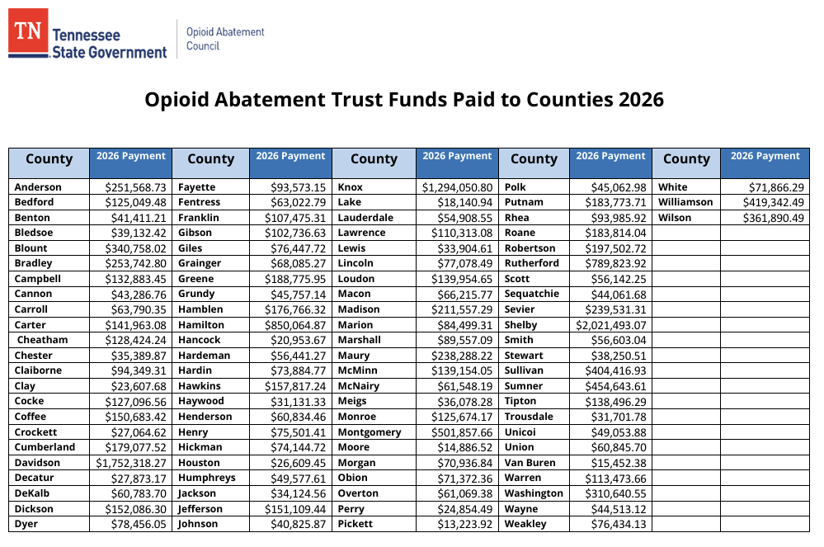

Please see https://www.tn.gov/oac/county.html for more information.

Community Grants
The Opioid Abatement Council is required by law to "disburse the remaining sixty-five percent (65%) of such proceeds for statewide, regional, or local opioid abatement and remediation purposes pursuant to § 33-11-105” from the opioid abatement fund. Tenn. Code Ann. § 33-11-103.
Here is an overview of FY2026 activities which allowed the opening of the Community Grants Cycle 3 application on March 2, 2026

Community Grant Funding Information
Community Grants must be directed to projects which address Tennessee’s opioid epidemic. Community Grant Funds must be used to deliver services to individuals and communities in Tennessee which focus on Primary Prevention, Harm Reduction, Treatment, Recovery Support, Education/ Training or Research or Evaluation of Abatement Strategy Efficacy.
Timing of the program is flexible and based on OAC approval for either 1, 2, or 3 years.
The Opioid Abatement Council set a maximum funding amount for each approved application and Community Grant funding requests are expected to adhere to the following guidance: For applications for a single Project, the proposed total annual budget limit is $1,000,000; For applications from multiple Proposers who are collaborating on the same Project, the total annual budget limit is $3,000,000.
The Opioid Abatement Council has awarded, contracted and is now paying invoices for Community Grants Cycle 1 and Cycle 2.
The Opioid Abatement Council received 301 applications for Community Grants Cycle 3. The OAC is in the process of reviewing Proposer eligibility and ensuring all applications meet qualifications for scoring for the Community Grants Cycle 3.

Grant Application Platform
- SmartSimple
The Opioid Abatement Council is continuously working with Strategic Technology Solutions (STS) with the state-owned, off-the-shelf, customizable grants management platform known as SmartSimple. This platform brings many efficiencies to the Opioid Abatement Council’s Community Grants program, and the Council continues to approve funding for updates and maintenance.
- Community Grant Application Portal
The Community Grants Cycle 3 applications were submitted through the Sub-Recipient Grant Management Enterprise Solution, State of Tennessee Portal. A total of 301 applications were submitted by Tennessee agencies for the Community Grants Cycle 3.

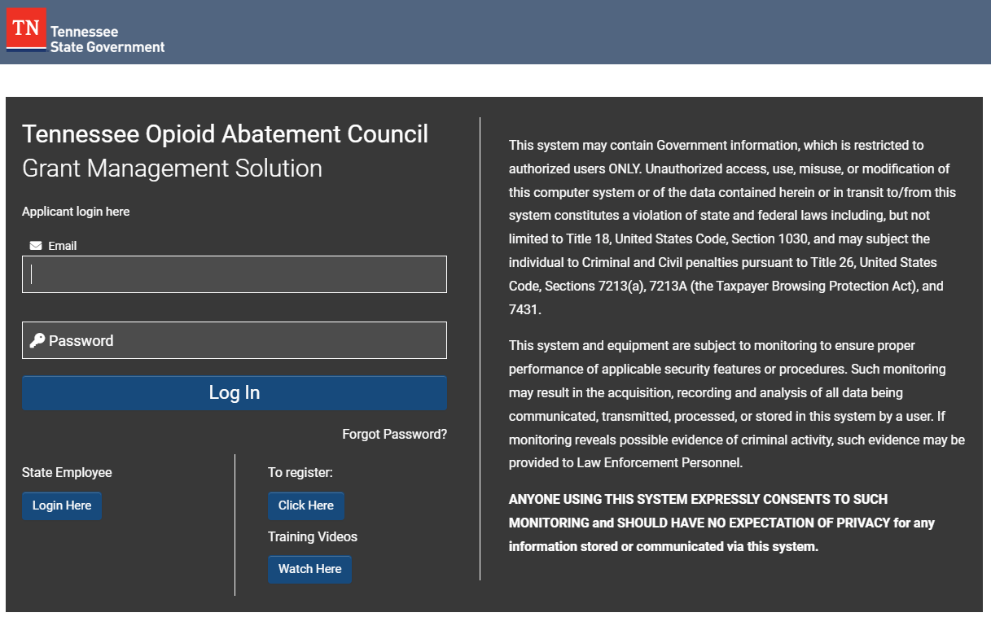

Community Grants Cycle 1 and Cycle 2
The Opioid Abatement Council is currently contracted with 138 Community Grant recipients. These Grantees are providing services, programs and projects across the state from Memphis, Johnson City, Chattanooga to Nashville.
The Awardees for Community Grants Cycle 1: TN_OAC_Community_Grant_Awards_March24.pdf | The Awardees for Community Grants Cycle 2: Cycle_2_Awarded_Community_Grants_FINAL_v.2.pdf
Paid Invoices
The Opioid Abatement Council reimburses for costs incurred by the contracted Grantees. The Grantees submit invoices to the OAC Office on a monthly basis.

Total Community Grant Invoices
Received Invoices | 2372
Pending Invoices | 40
Paid Invoices | 2332
Received Payments | $113,502,289.59
Pending Payments | $2,422,831.17
Paid Payments | $111,079,458.42

Community Grant Monitoring
The OAC Office, Community Grants Management Division provides Fiscal and Program Monitoring of the contracted Community Grant recipients.

Fiscal Monitoring
In FY2026, there were 66 Fiscal Monitoring site visits completed. The results are below.
Number of Recommendations | Number of Discrepancies | Number of Concerns | Number of Findings | Unallowed Costs
245 | 16 | 11 | 27 | $296,458.40

Program Monitoring
In FY2026, there were 22 Program Monitoring site visits completed. The results are below.
Number of Recommendations | Number of Discrepancies | Number of Concerns | Number of Findings
0 | 1 | 0 | 7

Community Grants Dashboard
In September 2025, the Opioid Abatement Council published the Community Grants Dashboard.
By making this information public, the Tennessee Opioid Abatement Council is ensuring accountability and transparency of the funds disbursed to the contracted Grantees.
This Community Grants Dashboard is to inform Tennesseans how the Tennessee Opioid Abatement Council is using funds from the Tennessee Opioid Abatement Fund Trust to support communities through Community Grants.
The Community Grants Dashboard currently highlights Community Grants awarded in Cycle 1 and will expand to include future cycles, showing where funds are going and what types of programs are being supported.
The Community Grants Dashboard reflects this line from the Council’s vision: "To bring hope and recovery to Tennesseans impacted by opioid addiction — through effective, transparent work that supports prevention, treatment, and family support."

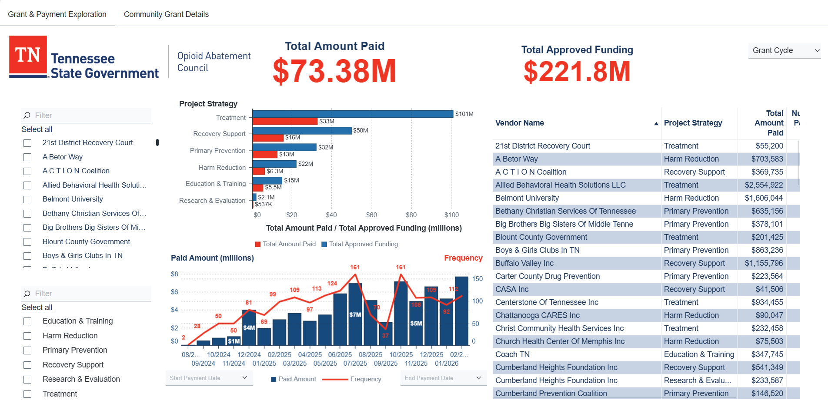

Please see https://www.tn.gov/oac/community/dashboard.html for more information.

OAC Office Discretionary Fund
On April 28, 2025, the OAC approved a $10,000/ year discretionary fund for the Executive Director to spend on OAC Office expenses. The Fund is calculated on a calendar year basis.
Discretionary Fund
Current Reimbursements for 07/01/2025 – 06/30/2026
Date | Description | Amount Paid
8/7/2025 | Community Grants Monitoring Kick Off Training | $40.03
8/26/2025 | OAC Office Team Luncheon/Volunteer Event (IOAD) | $104.24
09/11/2025 | OAC Office Team Meeting (Process Sheets/Team Building) | $254.01
11/5/2025 | OAC Office Team Shirts | $865.78
3/11/2026 | OAC Office Team Meeting - Volunteer Event | $131.86
3/20/2026 | 1 Acrylic Award | $120.50
3/30/2026 | OAC Office Team Meeting - Strategic Planning | $308.65
4/7/2026 | OAC Office Team Meeting - Team Updates/RX Summit | $285.20
4/23/2026 | 1 Acrylic Award | $117.36
TOTAL |  | $2,227.63

Community Advocacy Panel
The Opioid Abatement Council is required by law to "allow for comment and input from community stakeholders, local governments, state and local public health officials, public health advocates, law enforcement and judiciary representatives, opioid remediation service providers, and other parties interested and actively involved in addressing the opioid crisis and its abatement." Tenn. Code Ann. § 33-11-105.
During the June 18, 2024, OAC meeting, the Council approved the motion giving the Executive Director the authority to begin developing a process for a Community Advocacy Panel to fulfil this requirement.
Panel members will work to develop a consensus based on input received from the community and report ideas on possible solutions to the Executive Director, for the purpose of improving transparency, establish accountability, and informing the OAC decisions for the implementation of funding programs, strategies, expenditures, and all other actions designed to prevent and address the effects of the opioid epidemic.
The Panel consists of sixteen (16) members, including two (2) representatives from each of Tennessee's seven (7) regions with an additional two (2) members who will serve as Chair and Vice-Chair.
The OAC Office reviewed applications and compiled a slate of candidates to serve on the Community Advocacy Panel which represents all seven (7) regions. At the October 25, 2025, Opioid Abatement Council meeting, the Council approved the inaugural Panel members.

During FY2026, the Community Advocacy Panel met two (2) times:
- February 3, 2026
- April 2, 2026

Quote from Panel Member
"Recovery gave me a second chance, and being part of this panel gives that second chance a greater purpose. Serving on the Community Advocacy Panel is both a great honor and a meaningful opportunity to represent my region and help ensure the voices of those most affected by the opioid crisis are at the table. I believe the most effective solutions come from listening to the people they impact, and I am grateful to work alongside such dedicated panel members who are committed to creating meaningful change across Tennessee."
Cassidy Newman, Region 3, is a dedicated Certified Peer Recovery Specialist in recovery since 2016, quoted:


Please see https://www.tn.gov/oac/community-advocacy-panel.html for more information.

Summary

The Opioid Abatement Council is honored to lead the disbursement of opioid settlement funds to the counties and the community. We remain mindful of those who have lost loved ones and who are on the path of recovery, and we will continue to steward the Opioid Trust Fund with focus and care, approving and allocating the dollars, so Tennesseans impacted by opioid addiction can get the support they need and a direct path toward recovery.

Contact Information
Please visit the Tennessee Opioid Abatement Council’s website to stay updated: www.tn.gov/oac.html or, email the Opioid Abatement Council at Opioid.Abatement@tn.gov for any additional information or if there are questions.

