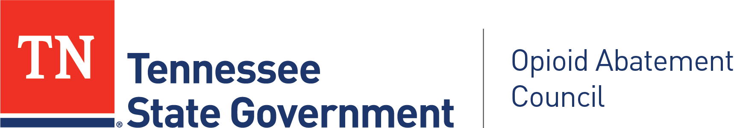

Tennessee OAC Community Advocacy Panel

DATE & TIME
July 7, 2026
3:00 PM CT/4:00PM ET: Meeting Begins
5:00 PM CT/6:00PM ET: Meeting Ends

LOCATION
OAC Community Advocacy Panel, Third Quarter Meeting
Tuesday, July 7, 2026
4:00-6:00 PM ET/ 3:00-5:00 PM CT
100% Virtual

Webinar topic:
OAC, Community Advocacy Panel, Third Quarter Meeting

Date and time:
Tuesday, July 7, 2026 3:00 PM | (UTC-05:00) Central Time (US & Canada)

Join link:
https://tn.webex.com/tn/j.php?MTID=m5e4b952e88b5a7934916337fe58a7d3e

Webinar number:
2300 340 0401

Webinar password:
WRpyJxPD458 (97795973 when dialing from a phone or video system)
Join by phone
+1 615-747-4911 Webex Call-In
+1-415-655-0001 US Toll
Access code: 230 034 00401

CONVENED BY
Betty Mason, Panel Chair

Tennessee OAC Community Advocacy Panel
OAC Office
Nathan Payne, Program Director

For more information, please visit the Community Advocacy Panel Webpage at:
https://www.tn.gov/oac/community-advocacy-panel.html

Please contact Opioid.Abatement@tn.gov for information about the Community Advocacy Panel meetings.

AGENDA

3:00 Roll Call and Welcome
(Betty Mason, Panel Chair)

3:05 April 2, 2026 Meeting Minutes Approval
(Betty Mason)

3:10 Remarks and Update from OAC Program Director
(Nathan Payne)
    - Introduce Marissa Kluk as Region 1 Representative
    - Reminder of Panel Member Formstack Link
    - Thank you for Panel Input
    - Reminder about By-Laws
    - Panel Meeting Focus Moving Forward

3:20 OAC Opioid Settlement Overview
(Melissa Gilbert)

Panel members will hear from OAC Office Audit Director who will provide a brief description of the Opioid Settlements which the OAC manages.

3:35 OAC Remediation List
(Mary Shelton)
Panel Members will hear from OAC Office Executive Director on a brief overview of the approved OAC Remediation List.

3:45 Input Document
(Betty Mason)

Panel Members review input document and discuss and draft edits.

Potential Discussion Prompts:

- Do these regional observations accurately reflect the most significant opioid-related service gaps in your area?
  - Are there critical needs that are missing or understated?

- Of the Identified Service Gaps, is there agreement on which would be considered of the highest priority/priorities?
  - What would have the greatest impact if addressed?

- Considering the gaps in service discussed both in this document and in this meeting. Do you know of evidence-based practices happening in our state or elsewhere that address these gaps?
  - Do these practices or programs fall within the OAC Remediation List?

4:45 Presenting Panel Input
(Betty Mason)

After thorough discussion around the input document and prompts above, please be prepared to indicate how you would like the OAC Office to consider presenting this panel input to the Council.

5:00 Meeting Adjourns
(Betty Mason)

Next Community Advocacy Panel Meeting, 100% Virtual
October 1, 2026 4:00PM – 6:00PM ET/ 3:00PM – 5:00PM CT

OAC Quarterly Meeting - Middle Tennessee
Thursday, September 3, 2026
12:00 - 3:00 PM CT
Meeting location: TBD

