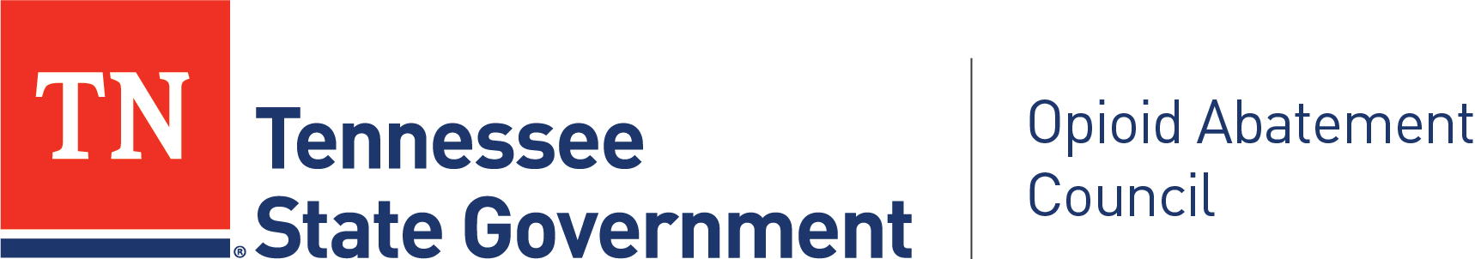

Tennessee OAC Community Advocacy Panel

DATE & TIME
February 3, 2026
3:00 PM CT/4:00PM ET: Meeting Begins
5:00 PM CT/6:00PM ET: Meeting Ends

LOCATION
100% Virtual

Webinar topic:
OAC, Community Advocacy Panel, First Quarter Meeting

Date and time:
Tuesday, February 3, 2026 3:00 PM | (UTC-06:00) Central Time (US & Canada)

Join link:
https://tn.webex.com/tn/j.php?MTID=mc1036d289ed7354b22770ecb96e4d757

Webinar number:
2301 780 8061

Webinar password:
yGPJWG3Rj38 (94759437 when dialing from a phone or video system)

Join by phone
+1 615-747-4911 Webex Call-In
+1-415-655-0001 US Toll

Access code: 230 178 08061

CONVENED BY
Betty Mason, Panel Chair

Tennessee OAC Community Advocacy Panel Office
Nathan Payne, Program Director

For more information, please visit the Community Advocacy Panel Webpage at:
https://www.tn.gov/oac/community-advocacy-panel.html

Please contact Opioid.Abatement@tn.gov for information about the Community Advocacy Panel meetings.

AGENDA

3:00 Roll Call
(Betty Mason, Panel Chair)

3:05 Vote to approve Secretary
(Patti van Eys, Panel Co-Chair)

3:10 Welcome and OAC Overview from Executive Director
(Mary Shelton, OAC Executive Director)

3:15 Welcome from OAC Program Director
[Nathan Payne, OAC Program Director]

3:20 Welcome from OAC Chair
[Dr. Stephen Loyd, OAC Chair]

3:25 Introductions of Panel Members (1-2 minutes each)
[Patti]
  - Name
  - What region do you represent? How long have you lived in TN?
  - High level info about you professionally (e.g., lawyer in X-ville) and personally (e.g., hobby or what keeps you grounded)
  - Your “why” for being on this advocacy panel

4:00 Input and Vote on Panel Vision Statement
[Betty]
"The Community Advocacy Panel aspires to elevate the voices of individuals and communities affected by the opioid epidemic, ensuring that opioid settlement funds are guided by lived experience, community needs, and a commitment to healing, equity, and accountability."

4:15 Panel Training
[Nathan]

4:20 Expectations – Charge to Panel Members
[Nathan, Betty, and Patti]
- Review of the Community Advocacy Panel Expectations – Nathan
- Request for agenda items prior to Panel Quarterly meetings; Betty or Patti will send you an email asking for items a few weeks ahead of the meeting - Betty Mason
- Panel Member volunteers to attend the OAC Quarterly Meetings (need regional reps to attend in person)- Betty
  - Designated volunteers will be introduced at each OAC Quarterly Meeting
  - Encourage all Panel Members to attend each OAC Quarterly Meeting (in person for regional reps if possible; virtual if not- OAC Quarterly Meeting links posted on website)
  - 2026 OAC Quarterly Meetings: March 5 (East), June 2 (West), September 3 (Middle), December 1 (East)
- Create relationships and get a pulse on your region; make visits, talk with leaders and constituents- Patti

4:35 Questions/Discussion around Panel Responsibilities
[Betty]

4:50 General Questions or Comments from Panel Members
[Patti]

5:00 Meeting Adjourns
(Betty)

Next Community Advocacy Panel Meeting, 100% Virtual
April 2, 2026 4:00PM – 6:00PM ET/ 3:00PM – 5:00PM CT

