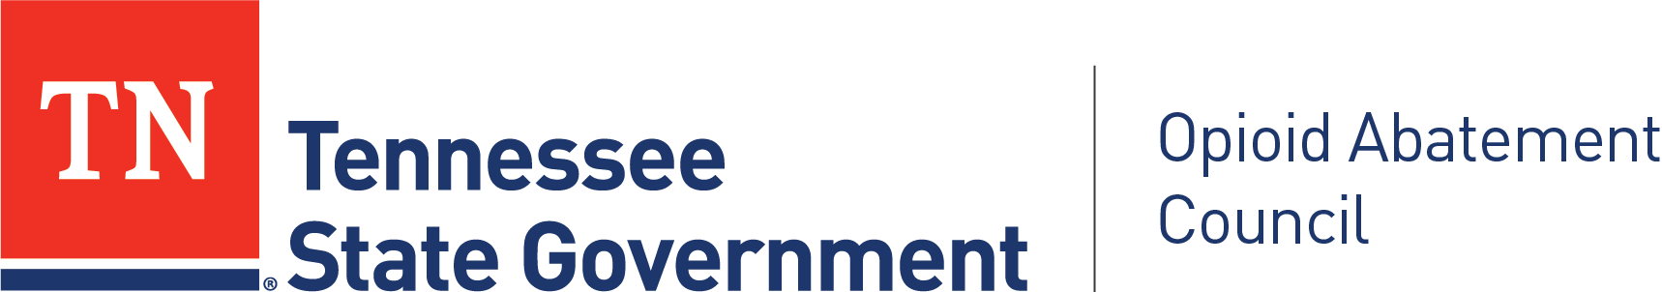

Tennessee OAC Community Advocacy Panel

DATE & TIME
April 2, 2026
3:00 PM CT/4:00PM ET: Meeting Begins
5:00 PM CT/6:00PM ET: Meeting Ends

LOCATION
Webinar topic:
OAC Community Advocacy Panel, Second Quarter

Date and time:
Thursday, April 2, 2026 3:00 PM | (UTC-05:00) Central Time (US & Canada)

Join link:
https://tn.webex.com/tn/j.php?MTID=m1f2f00fe31f22168dc09c47bed12abe9

Webinar number:
2311 538 2829

Panelist password:
jGNBG3aZi42 (54624329 when dialing from a phone or video system)

Join by video system
Dial 23115382829@tn.webex.com
You can also dial 173.243.2.68 and enter your meeting number.

Join by phone
+1 615-747-4911 Webex Call-In
+1-415-655-0001 US Toll

Access code: 231 153 82829

CONVENED BY
Betty Mason, Panel Chair

Tennessee OAC Community Advocacy Panel
OAC Office
Nathan Payne, Program Director

For more information, please visit the Community Advocacy Panel Webpage at:
https://www.tn.gov/oac/community-advocacy-panel.html

Please contact Opioid.Abatement@tn.gov for information about the Community Advocacy Panel meetings.

AGENDA

3:00 Roll Call and Welcome
(Betty Mason, Panel Chair)

3:05 February 3, 2026 Meeting Minutes Approval
(Betty Mason)

3:10 State Opioid Response Prevention
(Cate Faulkner)

Panel members will hear about overdose prevention and response efforts in Tennessee.

3:25 Remarks and Update from OAC Program Director
(Nathan Payne)
    - Panel Member Formstack Link
    - Region 1 Vacancy
    - Community Grants Dashboard
    - OAC Website Walkthrough
    - Questions or Discussion around Panel Responsibilities

3:45 Panel By-Laws
(Betty Mason)

Panel Members discuss and draft.

4:15 Staying Up to Date on Current Trends in Opioid Misuse (guided discussion)
(Betty Mason)

Please be prepared to provide source information/ reference when applicable and feasible during this discussion.

Discussion prompts:
- Successful abatement strategies in your area?
- Are new substances emerging in your area?
- Notable shifts in overdoses?
- Populations being disproportionately affected or underserved?

4:35 Open Discussion/Regional Report Out
(Betty Mason)

5:00 Meeting Adjourns
(Betty Mason)

Next Community Advocacy Panel Meeting, 100% Virtual
July 7, 2026 4:00PM – 6:00PM ET/ 3:00PM – 5:00PM CT

