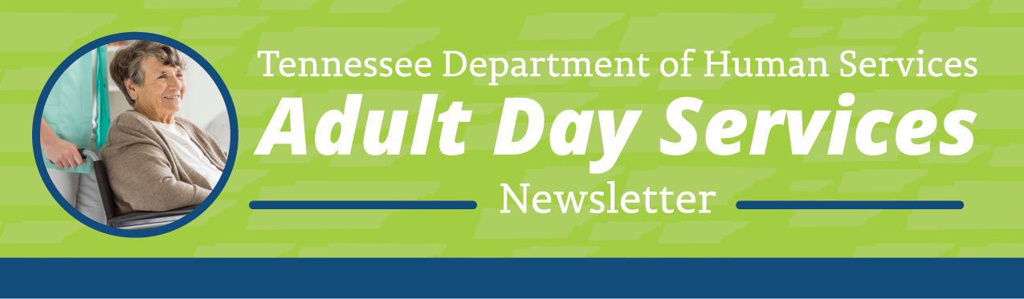
Greetings from your partners at the Tennessee Department of Human Services (TDHS), Adult Day Services Team!
Welcome to the Adult Day Services (ADS) Quarterly Newsletter. This newsletter shares information on topics related to your day-to-day operations as a licensed Adult Day Services (ADS) provider.
In this edition of the newsletter, we would like to provide information on the new rules, introduce new opportunities for trainings, and welcome two new agencies.

Updates on ADS Rules Revisions

The new rules are officially in effect as of September 22nd. Thank you to all that participated in the revisions process and that attended our rules training on the 24th. We had to remove all the proposed revisions for section 1240-07-10-.12 Staffing and Supervision in order to get them through. You can find the link to the new rules on our DHS ADS website under the Rules and Regulations tab or on the Secretary of State’s website at https://publications.tnsosfiles.com/rules/1240/1240-07/1240-07-10.20260922.pdf.

State Fire Consults for New or Expanding Agencies
DHS has contracted with the State Fire Marshall’s office to provide FREE fire consultation services to new or expanding Adult and Child Care agencies. If you are looking to add a new location or expand your current location, State Fire will come in to discuss with you any potential costs or barriers to obtaining an approved fire inspection for that location. Our Pre-Licensure unit is handling the scheduling of those consults. Anyone interested should reach out to them at (615) 906-0517 or ChildCarePreLicensure.DHS@tn.gov.
Welcome to ADS Licensing!
DHS would like to welcome three new Adult Day Services licensed providers. We are so happy to have you join the team!
Fifty Forward opened a second location in Nashville in August. They serve the 50 and older population by providing social and recreational activities, caregiver support, and transportation for community outings.
Auxilium Health Services, in Memphis, opened in September. Their program is designed to promote participants' independence, dignity, health, safety, and quality of life. They use a person-centered approach that encourages participant choice, independence, social interaction, and community involvement.
S&L Adult Day Center, in Chattanooga, also opened in September. They offer social and recreational activities, along with health and medical services such as medication reminders and specialized care.
Training Resources
There are two resources for trainings we would like to pass along. The first one is a new transportation training on our DHS Adult Day Services Website that was designed by our People Ops team. This training will satisfy the requirement in the rules for the annual transportation training required by the Department. The link is: https://www.tn.gov/humanservices/adults/adult-day-services/adult-day-services-training.html
The second resource is sponsored by the Department of Health and offers a variety of trainings. You will need to register for an account to view them. The link to the Tennessee Train website is www.train.org/tn/home.
Licensing Violations or Illegal Operations
To report suspected adult day services licensing violations or possible illegal operations call the Child and Adult Care Complaint Hotline at 1-800-462-8261 or email AdultDayServices.DHS@tn.gov.

Reminders
We will feature existing and newly opened ADS agencies in the Program Spotlight section of each issue. If you wish to be featured, have ideas about potential topics or general feedback please reach out to us by email at, AdultDayServices.DHS@tn.gov.

Quarterly ADS Newsletters are posted at the ADS webpage of the TDHS website for your reference at, https://www.tn.gov/humanservices/adults/adult-day-services.html.

