2026 CARES Conference Speaker Bios

Amanda Actor, Assistant Professor at Vanderbilt University Medical Center
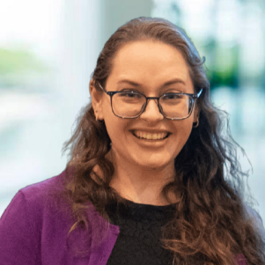
Amanda Actor is an Assistant Professor at Vanderbilt University Medical Center, seeing patients in the geriatric psychiatry memory and aging clinic. She also serves as the Assistant Training Director for Vanderbilt’s Geriatric Psychiatry Fellowship program. She obtained her BA in Biology from Bryn Mawr College in Pennsylvania in 2016 and MD from McGovern Medical School, The University of Texas Health Science Center at Houston in 2020. She graduated from her Adult Psychiatry Residency Program at the University of Texas Health Science Center at Houston in 2024 until moving to Tennessee to complete specialized training via the Geriatric Psychiatry Fellowship at Vanderbilt University Medical Center in Nashville in 2025. Her clinical interests include late-life depression, neurocognitive disorders, academic medicine, electroconvulsive therapy/neuromodulation, and medical humanities and ethics.

Jason Allen, Director of Event Management, Department of Disability and Aging (DDA)
Jason began his career with DDA in 2015, as a Protection from Harm (PFH) Investigator. In 2017, Jason accepted the position of Investigation Training Coordinator, training Provider staff and State Investigators on Investigative procedure. In 2018, Jason became the Assistant Director of Investigations and then Director of Investigations for DDA. In 2021, Jason became the Director of Event Management and helped to over see the implementation of the Reportable Event Management (REM) system, which replaced the Protection From Harm system. REM became a partnership between TennCare, DDA, and the three Managed Care Organizations (United Health, Blue Care, and WellPoint), and introduced the CHOICES program to the Event Management and Investigations process for DDA.

Shelli Allison, Manager | Compliance, Fraud, Vendor Management, Knoxville TVA Employees Credit Union
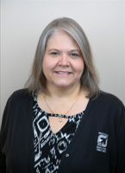
With more than 20 years in the financial industry including the past 17 years serving in the credit union movement, Shelli Allison brings both expertise and a genuine heart for helping others. She is especially passionate about protecting older adults from financial exploitation and believes financial institutions play an important role in recognizing, preventing, and responding to abuse. She is honored to represent the financial industry at the CARES Conference and to be part of this important conversation around safeguarding our most vulnerable adults.

William “Bill” Benson, National Policy Advisor, NAPSA

William F. Benson is co-founder, with Dave Baldridge (Cherokee), and President of the International Association for Indigenous Aging (IA²), a national organization representing the interests of American Indian and Alaska Native elders, with particular focus on elder justice and Alzheimer’s disease and brain health. IA ² operates national initiatives funded by ACL (the Native American Elder Justice Initiate National Resource Center or NAEJI), as well as the CDC’s Healthy Brain Initiative, and the U.S. Department of Justice. Benson is also President of Health Benefits ABCs, a policy consulting practice. He has spent 5 decades advocating for older adults, holding senior leadership positions in California state government, the U.S. Congress and the U.S. Administration on Aging (now ACL). Benson played a major role in amendments to the Older Americans Act, nursing home reform legislation, establishment of the SHIP Program, the Elder Justice Act, and other notable legislative initiatives. He serves as National Policy Advisor for the National Adult Protective Services Association and American Association of Service Coordinators, among others. From 2000-2025, Benson hosted First Person, a series of conversations with Holocaust Survivors for the U.S Holocaust Memorial Museum. Contact him at bbenson@iasquared.org.

Dan Buchanan, Felony Prosecutor/VAPIT Coordinator, Shelby County District Attorney General’s Office
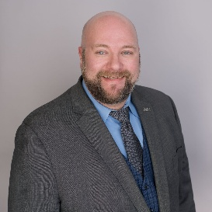
A native Memphian and a lifelong advocate for social justice; Buchanan attended the University of Memphis where he earned Bachelor of Arts degrees in both Anthropology and History, and his Juris Doctorate from the Cecil C. Humphreys School of Law. As a founding partner of the Ralston Buchanan Consumer Law Group, Buchanan practiced consumer advocacy law with focuses in consumer bankruptcy, fair debt collection, and auto fraud. Buchanan now serves the community in a dual role at the Shelby County District Attorney General’s Office as a Felony Prosecutor and as the VAPIT (Vulnerable Adult Protection & Investigation Team) Coordinator for Shelby County. In these roles General Buchanan pursues justice for the most vulnerable citizens in Shelby County by prosecuting criminal cases in the courtroom, working with dedicated partners throughout the community to strengthen public policy, and educating the public about the abuse, neglect, and financial exploitation of vulnerable adults.

Cherrell Campbell Street | Deputy Commissioner, Tennessee Department of Human Services

Cherrell Campbell Street has been with the Tennessee Department of Human Services since November 2011, serving now as the Deputy Commissioner of Programs and Services. She has over 20 years of experience in the Human Services sector, with an emphasis on employment services for persons with disabilities and public safety net programs. Over the expanse of her career, Cherrell has had a proven record of accomplishments in leading and driving several federal and state programs in meeting and exceeding standards of compliance and goals. She has expertise in administering programs for persons with disabilities, community/social programs, and Social Security Administration's disability claims. She manages large budgets, capital projects, develops policies, establishes effective teams, and secures partnerships with private and public stakeholders.

Clarence H. Carter, Commissioner, Human Services
Clarence H. Carter was appointed to serve as a member of Governor Bill Lee’s Cabinet as the Commissioner of the Tennessee Department of Human Services (TDHS) in January 2021. Mr. Carter oversees the state's second-largest agency, with an operating budget of more than $3 billion and nearly 4,000 employees across 95 counties. TDHS provides more than 17 programs and services, including nutrition programs, employment assistance, vocational training, and protective services, aiming to strengthen Tennessee by strengthening Tennesseans.
A chair of multiple state task forces, a Fellow of the National Academy of Public Administration, and a published author, Mr. Carter is recognized for his leadership and innovation in public administration. With over 30 years of experience, including roles under four Governors, two Presidents, and a Mayor, Mr. Carter has significantly contributed to public service, focusing on improving the safety net for socially and economically vulnerable citizens.

Zandra Carter-Mann, Team Coordinator, Adult Protective Services

Hello, my name is Zandra Carter‑Mann. I hold an associate degree from Dyersburg State Community College and a bachelor’s degree in health education from the University of Tennessee at Martin. I am a wife, a mother of three adult children, and an active advocate within my community and church.
I enjoy coordinating activities and planning events, and I bring that same enthusiasm to my work. This year marks my 20th year in Tennessee State Government. I have served in Adult Protective Services for the past eight years. I have worked as in investigator specialist and now my current role is a Team Coordinator. My career in public service began in 2005 with the Tennessee Department of Children’s Services, where I spent twelve years as an investigator. I later served with the Tennessee Department of Intellectual and Developmental Disabilities in the Protection from Harm Unit.
My guiding motto is: “Teamwork makes the dream work.”

Detective Kendra Cowper, Metropolitan Nashville Police Department

I have a bachelor’s degree from Northen Michigan University in Criminal Justice. I have worked for MNPD for 11 years and have been a part of the VAPIT team since 2021.

Liz Dayton, Vice President of Home Health Services, GUIDE Model (Dementia Care) & Coordinated Response to Elder Abuse (CREA)

Liz Dayton joined Meritan in the spring of 2016 as a Registered Nurse in Meritan’s Home Health program. Since then, she became Meritan’s Associate Director of Home Health and was then promoted to Meritan’s Associate Vice President of Home Health Services. In addition, she serves as Meritan’s CREA Coordinator for the Memphis/Shelby County Coordinated Response to Elder Abuse cohort.
Liz holds many years of experience in nursing care and is well known for her deep compassion and support for patients and victims of elder abuse. In 2017, Liz was named the Outstanding Home Care Direct Service Provider by the Tennessee Association for Home Care. In 2017, she was a finalist in the Memphis Business Journal’s Health Care Heroes. In 2023, she was a Volunteer Memphis Healthcare Humanitarian of the Year finalist.

Cara Lowe, Special Agent, TBI
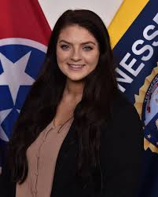
My name is Cara Lowe, and I am a Special Agent with the Tennessee Bureau of Investigation. I have a law enforcement background and served five years at a local department in East Tennessee before coming to TBI. Between 2023-2025, I served as a Special Agent Criminal Investigator in TBI's Medicaid Fraud Division and primarily investigated abuse and neglect of elderly and vulnerable adults within facilities and group home settings. I now serve in the Criminal Investigation Division and investigate a variety of offenses, with a primary focus on crimes against children. I am also a forensic interviewer and support the use of advocacy centers across the state by child and adult welfare agencies. I enjoy serving and working with vulnerable populations and strive to fight for their protection within our legal system.

Caitlin Rogers, Deputy Director of LTSS Quality and Innovation, TennCare
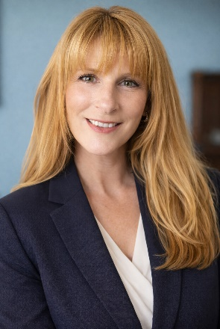
Caitlin Rogers is a Medicaid leader with more than two decades of experience spanning direct service delivery, statewide program design, quality oversight, and managed care innovation. She currently serves as the Deputy Director of LTSS Quality and Innovation at TennCare, where she leads Value-Based Purchasing, Quality and Evaluation, and System Transformation.
Since joining TennCare, Caitlin has helped strengthen internal alignment, connect siloed efforts, and develop evaluation frameworks that now guide the LTSS Quality Strategy. She works collaboratively with staff, partners, and leadership to encourage data-informed decision-making, improve processes, and build organizational capacity.
Caitlin’s leadership approach is grounded in empathy, curiosity, and commitment to relationship-driven work. She believes that high-quality care should be efficient, equitable, and centered on the people served. Contact: Caitlin.v.rogers@tn.gov

Dr. Raymond Romano, Family Nurse Practitioner, Vanderbilt Memory and Alzheimer’s Center

Raymond Romano is a family nurse practitioner with experience in research and quality improvement. His focus is on the detection, diagnosis and care of dementia in the primary care setting. He currently works at the Vanderbilt Memory and Alzheimer’s Center where he conducts clinical assessments for the Center’s longitudinal studies and supports outreach and recruitment activities across the Center. He is the director of the Tennessee Dementia ECHO program a telementoring program aimed at bringing quality dementia care to every corner of Tennessee.

Chantelle Smith, JD | Consultant, US DOJ Elder Justice Initiative

Chantelle Smith is an attorney and advocate for justice and the wellbeing of older persons, with a focus on preventing abuse and exploitation. Over her 23 years as an assistant attorney general in the Iowa Attorney General’s Office, she prosecuted criminal and civil cases involving elder abuse and worked closely with state agencies to enhance services and strengthen safeguards for older persons. She has built networks of professionals, shared effective practices, and supported efforts to improve the investigation and prosecution of elder abuse cases. As a consultant for the U.S. Department of Justice’s Elder Justice Initiative, she assists in developing training programs and resources to support prosecutors, law enforcement, and other professionals in achieving a more effective response to elder abuse.

Rae Anne Smith, Senior Attorney, Legal Aid Society of Middle Tennessee and the Cumberlands’ Tullahoma office
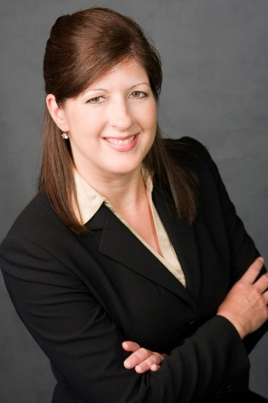
Rae Anne Smith is a Senior Attorney at the Legal Aid Society of Middle Tennessee and the Cumberlands’ Tullahoma office. In addition to her law degree, she has Bachelor of Social Work and Master of Science in Social Work degrees and worked in the child welfare field for ten years prior to beginning law school. Rae Anne has had a general civil law practice during her 16+ years with the Legal Aid Society and currently focuses on cases involving financial exploitation of older adults, consumer protection, federal income tax, and assistance to nonprofit organizations.

Dr. Rodney E. Stanley, Dean of the College of Public Service, Tennessee State University
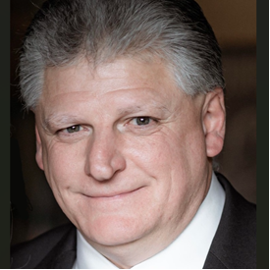
Dr. Stanley previously served as the Department Chair for Public Administration for 14 years. Dr. Stanley’s research has focused on gaming policy and its impact on funding education across the fifty states. Dr. Stanley received his Ph.D. in Public Policy and Administration from Mississippi State University and his master’s degree in Public Administration from the University of Tennessee at Chattanooga. Dr. Stanley enjoys the outdoors where he spends much of his leisure time with his two sons James and Mark and his wife Lisa.

Teresa Strickland, Investigative Specialist, Adult Protective Services
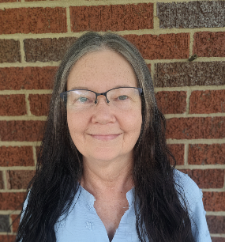
Teresa Strickland is an APS Investigative Specialist with decades of experience in long-term care assisting vulnerable adults and their families in finding the right care at the right time. Ms. Strickland is a strong advocate for her clients and believes in leaving no stone unturned in locating resources for them. Outside of work, Ms. Strickland enjoys spending time with family, fur babies and friends, photography, reading and movies.

Telesa Taylor, Senior Associate Counsel and Litigation Team Leader, Tennessee Department of Human Services
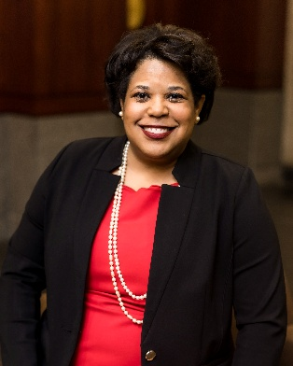
Telesa received her B.A. from Vanderbilt University in 1997, and a J.D. from Vanderbilt University Law School in 2000. Upon graduating from law school, she served as a judicial law clerk for the Honorable Holly M. Kirby, former Tennessee Court of Appeals Judge and current Tennessee Supreme Court Justice.
Prior to joining the Department of Human Services, Telesa worked in private practice, where she handled a variety of legal matters including personal injury, medical malpractice, employment discrimination, and class action litigation. Since 2005, Telesa has represented the Department in family assistance issues, adult protective services matters, childcare licensing and assessment matters, vocational rehabilitation matters, employment and disciplinary matters, rule-making hearings, as well as other areas/litigation. In January 2023, Telesa was appointed to Tennessee Lawyers’ Fund for Client Protection by the Tennessee Supreme Court. She currently serves as Vice Chair.
Telesa resides in Memphis, Tennessee where she is an active member of her community, barbecue aficionado, and avid fan of the Memphis Grizzlies and UofM Tigers.

Patti Tosti, Director of Interagency Collaboration and Research, Adult Protective Services
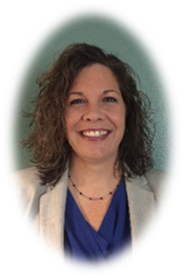
Patti Tosti is the Director of Interagency Collaboration and Research for the TN Department of Human Services, Adult Protective Services where she manages a variety of projects, including the State Coordinated Community Response (CCR) team, a group of over twenty state agencies that collaborate to create more efficient and system improvement processes to protect older and vulnerable adults. With over 20 years of project management experience and 15 years of social work practice, Patti has worked with a variety of stakeholders, locally and nationally, to address gaps, create solutions and build new programs, including the Coordinated Response to Elder Abuse (CREA) in Memphis and Shelby County, a 24/7 response to elder abuse.
A social worker at heart, she began her career as a homemaker for older adults, worked at a group home for teenage girls and then for the CT Dept. of Children and Families before moving to Memphis in 2004. Patti has served on several committees and board of directors with a focus on leadership, race relations and mentoring. Patti received her undergraduate degree from Saint Joseph’s College in Maine and an Executive MBA at the University of Memphis. In 2016, she received her Project Management Professional (PMP) certification.

Jude White, Assistant Commissioner for Child Care and Community Services
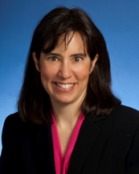
In this role, Ms. White oversees licensing and subsidy support for childcare, the adult protective services program, child/adult care and summer food programs, and administration of the community services block grant. Previously, Ms. White served as Executive Director of the Children’s Cabinet for Governor and First Lady Haslam. With a law degree from Vanderbilt University, Ms. White brings a mixture of experience in judicial and private law practice, non-profit management, and state government service. Ms. White previously served as the executive director of Renewal House, a local non-profit agency in the Nashville community serving families in recovery from addiction. She worked formerly as an assistant general counsel for the Tennessee Department of Children’s Services, after practicing law and holding a judicial clerkship.
Ms. White has served on multiple boards in her capacity as a non-profit leader and attorney such as: Hands on Nashville, the Center for Non-profit Management; the Nashville Bar Association; and is a past-president of the Lawyer’s Association for Women.

