Dear Sir or Madam,
You’re invited to join the Tennessee Department of Health and partners across the state in celebrating the 5th annual Tennessee Quit Week, February 3-7, 2020. This year’s theme is “Seeing 2020 Tobacco-Free”. The goal is to inspire Tennesseans to live healthier lives by taking advantage of the state’s free resource, the Tennessee Tobacco QuitLine to quit using tobacco.
In Tennessee, 31 people die each day from smoking. Yet one in ten 18-24 year olds report being current smokers, and three in ten use e-cigarettes daily. Tobacco use is a risk factor for heart disease, stroke, diabetes, cancer and other chronic diseases, but quitting greatly reduces these risks.
College students and faculty members are leading the way in tobacco-free advocacy, and you too can be a powerful resource in reducing the toll of tobacco and vaping on the community. We hope you will join the movement by spreading the critical message of quitting tobacco and vaping.
Quitting is hard, but the good news is most tobacco users say they want to quit, and more than half try to quit each year. Tennesseans who are ready to quit can call the Tennessee Tobacco QuitLine at 1-800-QUIT-NOW or access web-based services at www.tnquitline.com for free coaching and nicotine patches (if eligible). These effective services are free to Tennesseans and can double a tobacco user’s chance of quitting successfully.
If you are interested in an opportunity to partner with us during Tennessee Quit Week or other strategies to reduce student and employee tobacco use, please contact [local health department rep]. We look forward to partnering with you to create a tobacco-free Tennessee!
Respectfully,

[Local Health Department Representative]
XXX-XXX-XXXX
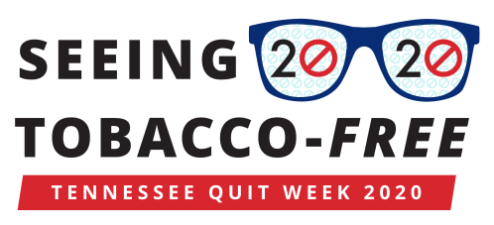
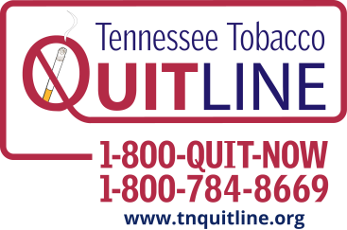
yourname@youragency.gov

Tennessee Behavior Risk Factor Surveillance System, 2018

