Dear Business Leader,
You’re invited to join the Tennessee Department of Health and partners across the state in celebrating the 5th annual Tennessee Quit Week February 3-7, 2020. This year’s theme is “Seeing 2020 Tobacco-Free”. The goal is to inspire Tennesseans to live healthier lives by taking advantage of the state’s free resource, the Tennessee Tobacco QuitLine, to quit using tobacco.
In Tennessee, 31 people die each day and thousands more live with diseases from smoking. Yet, one in five Tennesseans continues to smoke. As a business leader, you have a great opportunity to reach employees with the important message of quitting. Quitting tobacco use isn’t only good for the individual; it’s also good for your workplace. Helping employees quit can have several benefits, including:
- Increased productivity and decreased medical expenses (saving an employer up to $6,000 per tobacco user, per year)
- Lower absenteeism rates
- Decreased worker’s compensation costs ($2,189 for smokers vs. $176 for nonsmokers)
- Savings on maintenance costs (cigarette butts are the most littered item in the US)
Quitting is hard, but the good news is that most tobacco users say they want to quit, and more than half try to quit each year. Tennesseans who are ready to quit can call the Tennessee Tobacco QuitLine at 1-800-QUIT-NOW or access web-based services at www.tnquitline.com for free coaching and nicotine patches (if eligible). These effective services can double a tobacco user’s chance of quitting successfully.
If you are interested in an opportunity to partner with us during Tennessee Quit Week or other strategies to reduce employee tobacco use, please contact [local health department rep]. We look forward to partnering with you to create a tobacco-free Tennessee!
Respectfully,

[Local Health Department Representative]
XXX-XXX-XXXX
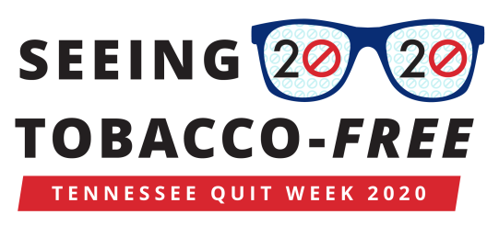
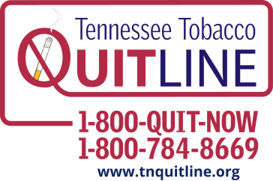
yourname@youragency.gov

