Inclement Weather Policy
The (Insert League Name) is committed to keeping all student-athletes, staff, guests and fans safe, including from the dangers of the weather and environment. It is important to know the harms, risks, and appropriate ways to react to a weather emergency or situation. Knowing when to seek shelter and recognizing a potential weather hazard is essential, especially for sports that do not have a certified athletic trainer present at practices and games. The following are the policies and procedures that should be followed in the event of inclement weather:
WEATHER RESOURCES: (Insert Weather Service Name) Weather Service shall be utilized as the determining source for temperature, relative humidity and wind chill factor verification.
Weather Service website and Phone #
Monitoring Personnel: The Certified Athletic Trainer covering the practice/event or the Head Coach in the occurrence that a Certified Athletic Trainer is not present, shall be the individual(s) responsible for weather observation and current conditions. The Certified Athletic Trainer and/or Head Coach shall check the (Weather Service) and utilize available lightning detectors, sling psychomotor/ hand held heat index for current weather conditions. Current conditions shall be monitored minimally 1 hour before, at the time of, and midway through practices/events.
Lightning Safety Policy
The following Emergency Lightning Safety plan is based on current recommendations given by the National Weather Service, the National Lightning Safety Institute, and the current NCAA Sports Medicine handbook. The Certified Athletic Trainer covering the practice/event or the Head Coach in the occurrence that a Certified Athletic Trainer is not present, shall be the individual(s) responsible for weather observation, including using available lightning detectors and evacuation plan implementation. In the situation where an observation of 30 seconds (or less) between seeing the lightning flash and hearing its associated thunder, the following shall occur:
1. Leave site immediately and seek safe shelter which is considered any fully enclosed building that involves plumbing and/or electrical wires that act to electrically ground the structure. Equipment should be left on the field and retrieved once deemed safe.
2. If such a shelter cannot be found, take shelter in any vehicle with a hard metal roof and closed windows.
3. While indoors, stay away from any of the walls, windows, plumbing and electronic devices attached to the walls (including landline telephones). If in a vehicle, avoid contact with the metal frame and avoid radio use.
4. Designate a weather watcher to monitor the weather from a safe location.
5. No outdoor activities are to be resumed until 30 minutes after the last sign of lightning/thunder. For every sign observed, the 30 minute timer is reset.
6. The Lightning Safety Statement shall be read to aid with fan and staff evacuation during events.
Management of Lightning Storm-Induced Injuries
Individuals that are struck by lightning do not carry residual charge and may be handled without danger to the medical or assisting personnel. The medical or assisting personnel should:
1. Evaluate whether the scene is safe. On-going lightning may still be a threat.
2. Safely move the injured individual to a safe shelter.
3. Activate emergency medical response systems if deemed necessary.
4. Apply any first aid necessary.
Call 911.
The following should be considered when developing a strategy of safety during a lightning storm:
1. Multiple means of monitoring weather are encouraged for large outdoor athletic events. A longer time to clear the venue should be anticipated due to congestion.
2. Avoid being near the highest point of the venue.
3. Individuals who feel their hair stand on end should assume the lightning safety position crouched on ground, weight on balls of their feet, head lowered, and ears covered. Avoid lying flat on the ground.
Hot Weather Policy
All outdoor athletic events for (Insert League) operate under guidelines highlighted in the following table. The certified athletic trainer is responsible for communicating to all athletic personnel and employing these guidelines. In the event a Certified Athletic Trainer is not present, it is the responsibility of the coaches and student-athletes to adhere to the following table to determine the guidelines recommended for your practice conditions.
Under 95 degrees Heat Index | Provide ample amounts of water. This means that water should always be available, and athletes should be able to take in as much water as they desire. Optional water breaks every 30 minutes for 10 minutes in duration. Ice-down towels for cooling. Watch/monitor athletes carefully for necessary action.
95 degrees to 99 degrees Heat Index | Provide ample amounts of water. This means that water should always be available, and athletes should be able to take in as much water as they desire. Mandatory water breaks every 30 minutes for 10 minutes in duration. Ice-down towels for cooling. Watch/monitor athletes carefully for necessary action. Contact sports and activities with additional equipment. Helmets and other possible equipment removed if not involved in contact. Reduce time of outside activity. Consider postponing practice to later in the day, Re-check temperature and humidity every 30 minutes to monitor for increased Heat Index.
100 degrees to 104 degrees Heat Index | All sports- provide ample amounts of water. This means that water should always be available, and athletes should be able to take in as much water as they desire. Mandatory water breaks every 30 minutes for 10 minutes in duration. Ice-down towels for cooling. Watch/monitor athletes carefully for necessary action. Alter uniform by removing items if possible. Allow for changes to dry t-shirts and shorts. Reduce time of outside activity as well as indoor activity if air conditioning is unavailable. Postpone practice to later in day. Contact sports and activities with additional equipment. Helmets and other possible equipment removed if not involved in contact or necessary for safety. If necessary for safety, suspend activity. Re-check temperature and humidity every 30 minutes to monitor for increased Heat Index.
Above 104 degrees Heat Index | Stop all outside activity in practice and/or play, and stop all inside activity if air conditioning is unavailable.

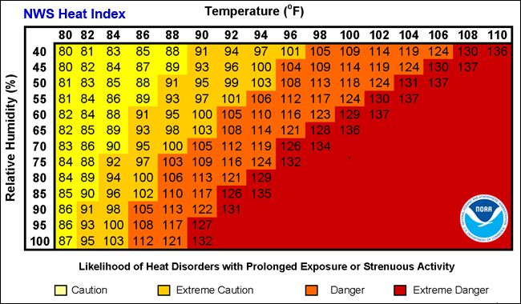
Recognition: Signs and Symptoms of Common Heat Injuries
Heat Cramps  - Dehydration  - Thirst  - Sweating  - Transient muscle cramps  - Fatigue | Heat Syncope  - Dehydration  - Fatigue and Dizziness  - Lightheadedness  - Pale/sweaty skin  - Tunnel vision

Exercise (heat) exhaustion  - Core temp (97.0 -104.0°F)  - Dehydration  - Dizziness  - Lightheadedness  - Syncope  - Headache  - Nausea  - Intestinal cramps/diarrhea  - Pallor  - Profuse sweating  - Cool, clammy skin  - Weakness  - Hyperventilation | Exertional heat stroke  - Core temp (> 104.0°F)  - Dizziness  - Drowsiness  - Irrational behavior  - Confusion/disorientation/irritability  - Loss of consciousness  - Dehydration  - Weakness  - Hot and wet/dry skin  - Tachycardia (100-120 bpm)  - Hypotension  - Hyperventilation  - Vomiting  - Diarrhea

Exertional hyponatremia
(Over-hydration/insufficient sodium level)
- Core temp (<104.0°F)
- Nausea
- Vomiting
- Swelling of extremities
- Low sodium level
- Progressive headache
- Confusion
- Lethargy
- Seizures/coma

If a certified athletic trainer is NOT PRESENT:
1. Call 911. The athlete should be sent to (Insert Hospital) Emergency Room or comparable emergency room for immediate care.
Unsafe Conditions Scheduled practices and games shall be continually evaluated. Should conditions be deemed unsafe (due to temperature/heat index or lightning, etc.) a collaborative decision for cancellation/postponement shall be made between the Head Coach, Certified Athletic Trainer, Game officials when applicable and when necessary, the specific Administrative Sports Supervisor.

