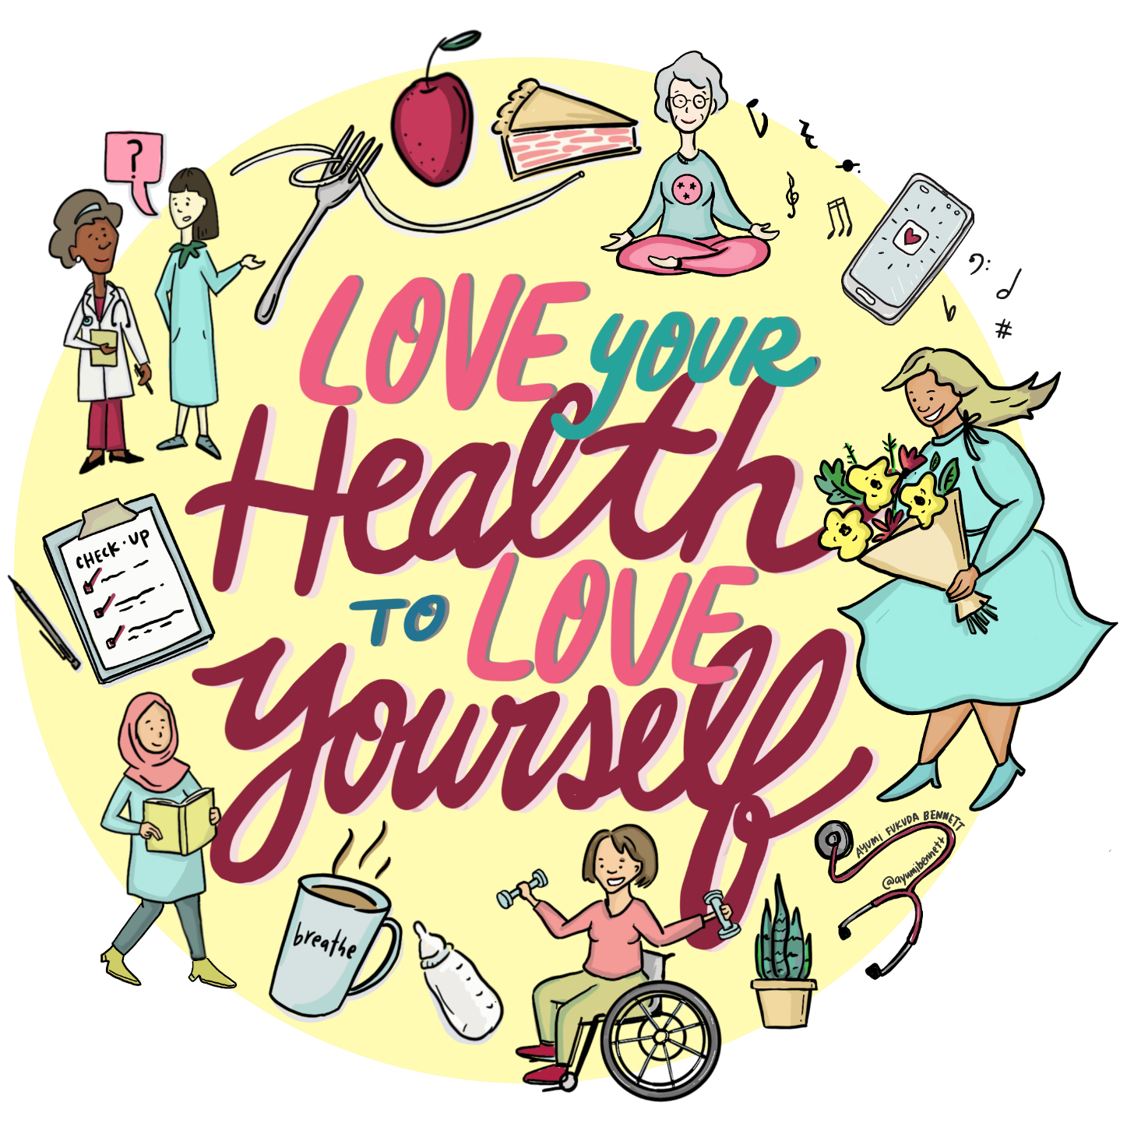

National Women’s Health Week
2021 Toolkit

Contents
ABOUT THIS TOOLKIT 4
WHAT IS NATIONAL WOMEN’S HEALTH WEEK? 4
WHAT IS THE REPRODUCTIVE & WOMEN’S HEALTH SECTION? 4
TOPICS 4
RWH Section Identified Priorities for 2021 4
OWH – Previous Identified Priorities 5
SOCIAL MEDIA 5
Sample Posts 5
Sample Posts for Specific Programs 10
Hashtags 11
Webpage 11
STRATEGIES 12
Facebook Live Events 12
Planning an Event 12
Day of Event Tips 12
Cooking a Healthy Recipe 12
Physical Activity (Dancing, Yoga, etc.) 12
Stress Reduction Techniques 13
Video on Benefits of Exercise 13
Resources 13
Free Cervical Cancer Screening Day 13
Sample Posts 13
Sample Hashtags 14
Promotional Material 14
ADDITIONAL MATERIALS 14
Bookmark 14
Flyer 14
Images 14
PARTNERS 15
ADDITIONAL RESOURCES 15
Tobacco Resources 15
Youth and Young Adult Resources 15
Parent and Guardian Resources 15
Educator and Community Resources 16
Mental Health, Substance Abuse and Human Trafficking Resources 16
STD/HIV 16
Misc 16
APPENDIX 17
A – Free Cervical Cancer Screening Day Flyer (English) 18
B – Free Cervical Cancer Screening Day Flyer (Spanish) 19
C – Free Cervical Cancer Screening Day Flyer (Arabic) 20
D – WHW Bookmark 21
E – WHW Priority Topic Flyer 22

ABOUT THIS TOOLKIT
Due to the emergence of COVID-19 in 2020, many individuals have put preventative health screenings on hold. Women are often the caregivers of the family be it children, spouses, parents, siblings, or other family members. They often take care of others first and put themselves last. For National Women’s Health Week 2021, the Reproductive & Women’s Health (RWH) section is urging women to make their health, and themselves, a priority.
This toolkit is designed to help women’s health stakeholders implement evidence-based practices and unique strategies when communicating about women’s health.

WHAT IS NATIONAL WOMEN’S HEALTH WEEK?
About National Women's Health Week | womenshealth.gov
National Women’s Health Week (NWHW) is a weeklong health observance led by the Department of Health and Human Services’ Office of Women’s Health (OWH). It occurs in the month of May and begins on Mother’s Day. It is intended to raise awareness of the importance of women’s health and to remind women and girls, especially during the outbreak of COVID-19, to make their health a priority and take care of themselves.

WHAT IS THE REPRODUCTIVE & WOMEN’S HEALTH SECTION?
Reproductive & Women's Health (tn.gov)
The Reproductive & Women’s Health (RWH) section is a group of programs within the Tennessee Department of Health (TDH) division of Family Health and Wellness (FHW). The programs that make up the RWH section include the Family Planning Program (FPP), the Tennessee Breast and Cervical Screening Program (TBCSP), Teenage and Adolescent Pregnancy Prevention Program (TAPPP), Rape Prevention & Education (RPE) program, and the Presumptive Eligibility (PE) TennCare program. Specific information about each program can be located on the RWH Homepage at the link above.

TOPICS

RWH Section Identified Priorities for 2021
Preventative Health
Stress Reduction
Healthy Eating/Nutrition
Healthy Weight
Talk to Your Healthcare Provider

OWH – Previous Identified Priorities
Talk to Your Healthcare Provider
Maintain a Healthy Weight
Get and Stay Active
Eat Heart-Healthy
Take Care of your Mental Health
Find Healthy Ways to Manage Stress
Practice Good Sleep Habits
Monitor Alcohol Intake
Look Out for your Lungs

SOCIAL MEDIA

Sample Posts
Post | WHW Topic | Special Program
Annual wellness exams are important for maintaining good health. Annual visits start conversations with your healthcare provider to help you understand your risks for certain diseases and detect any problems early. Encourage the women in your life to get their annual wellness exams and be an example by getting yours as well. | Preventative Health | N/A
Did you know that May 9-15, 2021 is National Women’s Health Week? Encourage the women in your life to make their health a priority and be an example by getting your annual wellness exam. | Preventative Health | N/A
Becoming more physically active may seem overwhelming when you don’t know where to start. Walking is a great way to start simple. Start slow and work your way up. Make sure to talk to your healthcare provider about appropriate activities for you. Getting Started with Physical Activity for a Healthy Weight | Healthy Weight, Nutrition, and Physical Activity | CDC | Healthy Weight | N/A
Taking care of yourself can help you take better care of others. If you are struggling to cope, there are many ways to get help. Call your healthcare provider if stress gets in the way of your daily activities for several days in a row. There are free and confidential crisis resources that connect you to a skilled, trained counselor if you or a loved one are under extreme stress. Mental Health and Coping During COVID-19 | CDC | Stress Reduction / Talk to your Healthcare Provider | N/A
Self-care helps to reduce stress and it can look different for everyone. Some techniques to practice self-care include getting enough sleep every night, doing something every day to get your heart pumping, eating your fruits and veggies, saying no when you are overworked, or cooking a meal that has fresh ingredients. Find what helps to reduce your stress to keep you healthy and happy. Self-Care: 12 Ways to Take Better Care of Yourself | Psychology Today | Stress Reduction | N/A
It’s important to take good care of your body, mind and soul every day, not just when you get sick. Practicing self-care isn’t always easy. Most of us are busy, we may have a stressful job or prioritize others over ourselves. Learning how to eat right, reduce stress, and exercise regularly are all important parts of self-care and can help you stay healthy and happy. Self-Care: 12 Ways to Take Better Care of Yourself | Psychology Today | Stress Reduction | N/A
Did you know that cervical cancer is one of the few cancers that can be prevented? More than 90% of all cervical cancers are caused by the Human Papillomavirus (HPV) and there is a vaccine to prevent infection. Cervical cancer screening can find pre-cancerous cells (cells that are not yet cancerous) and early treatment can prevent the development of cervical cancer. Ensuring that children in your life are vaccinated against HPV and encouraging those with a cervix to get screened regularly can prevent cervical cancer. Cervical Cancer | TDH | Preventative Health | TBCSP/FP
Did you know that Hispanics and Blacks are more likely to be diagnosed with and die from cervical cancer? Encouraging those in your life with a cervix to get regularly screened can prevent cervical cancer. Cervical Cancer | TDH | Preventative Health | TBCSP/FP
While you can’t prevent breast cancer, you can understand your risks and take steps to reduce your chance of developing breast cancer. Eating healthy, quitting smoking, and exercising regularly are things you can do to reduce your risk. Understanding your family history can also help you and your healthcare provider determine how often you should get screened. Encourage those in your life to find out their risks and to get regular breast cancer screenings. What Are the Risk Factors for Breast Cancer? | CDC | Preventative Health | TBCSP
Did you know that in Tennessee, white women and black women are almost equally as likely to get breast cancer, but black women are more likely to die from breast cancer? Encourage those in your life to find out their risks and to get regular breast cancer screenings. What Are the Risk Factors for Breast Cancer? | CDC | Preventative Health | TBCSP
While there is no clear evidence that stress can increase your risk of developing cancer, there is some evidence that appropriately dealing with stress after a cancer diagnosis leads to better cancer treatment outcomes. Additionally, reducing your stress can improve your overall wellness and may prevent other chronic diseases. | Stress Reduction | TBCSP
While there is no clear evidence that certain foods affect your risk of developing cancers, healthy eating and good nutrition can improve your overall wellness, help you maintain a healthy weight, and may prevent other chronic diseases. | Healthy Eating/Nutrition | TBCSP
Maintaining a healthy weight is one way to reduce your risk of developing many cancers and chronic diseases. A healthy weight reduces the risk for breast cancer. Increasing physical activity and eating healthy can help maintain a healthy weight. Talk to your healthcare provider to understand more ways to achieve and maintain a healthy weight and how certain health conditions may play a part. | Healthy Weight | TBCSP
Did you know that women who have gone through menopause and are obese can have a 20%-40% increased risk of developing breast cancer compared to normal-weight women? A healthy weight is a specific risk factor for breast cancer that an individual can change. Talk to your healthcare provider to how a healthy weight can lower your risk for breast cancer and other chronic diseases. | Healthy Weight | TBCSP
Screening is important in the prevention and early detection of breast and cervical cancers. It is also important to understand your risks, including ones you can change, such as being physically active, and ones that you can’t change, like getting older and family history. Talk with your healthcare provider about your risks and the screening that is right for you. | Talk to your Healthcare Provider | TBCSP
Stress can affect our bodies in so many different ways. Did you know it can impact a couple’s ability to get pregnant? Make sure you are taking time for yourself to relax, take some deep breaths, and do something special for yourself. | Stress Reduction | FP
When it comes to planning a healthy pregnancy, there are so many things to consider beforehand. There some things you can control and others that you cannot control. Take control of your health and the health of any further pregnancies by seeing a provider annually for your wellness exam. During this appointment, you should discuss any risk factors and ways to reduce your risk such as maintaining a healthy weight. | Preventative Health/ Healthy Weight | FP
Women of reproductive age (typically ages 15-44) should talk with their provider annually about whether they want children. Planned pregnancies can lead to a healthier mom and baby and allow women to achieve life goals that are important to them. | Talk to your Healthcare Provider/ Preventative Health | FP
It’s never too early to focus on your health before pregnancy. Once pregnant, individuals should seek care immediately. If you need assistance with healthcare and are pregnant, contact your local health department and ask about Prenatal Presumptive Eligibility. | Preventative Health | Prenatal - PE
We can’t eliminate stress but learning to manage stress will benefit you and your baby. Did you know that stress can also affect your body physically? Practicing stress reduction techniques is one way to help improve your health and the health of your unborn child. TennCare Presumptive Eligibility has resources to help you with stress reduction techniques and providers who can help you better manage stress. | Stress Reduction | Prenatal - PE
The foods you choose affects your health; the food you eat will provide the nutrients that your baby needs to grow. If you need assistance with nutrition, contact your local health department and ask about Presumptive Eligibility. Presumptive Eligibility TennCare can provide services related too nutrition. You may also qualify for the WIC/SNAP program. | Healthy Eating/Nutrition | Prenatal - PE
Being overweight is one of the biggest risk factors for women undergoing breast or cervical cancer treatment. Maintaining a healthy weight is also something that can be managed throughout your treatment. Speaking to your provider about ways to achieve a healthy weight is one of the easiest and most controllable ways to achieve better health outcomes. | Healthy Weight | PE
Being overweight is one of the biggest risk factors for pregnant women. Maintaining a healthy weight is also something that can be managed throughout your pregnancy. Speaking to your provider about ways to achieve a healthy weight is one of the easiest and most controllable ways to achieve better health outcomes. | Healthy Weight | PE
Honest and consistent communication with your healthcare provider is important for good health outcomes. This is especially true when you are pregnant. If you are uninsured, you can enroll in Presumptive Eligibility for TennCare so you can communicate regularly with your healthcare provider. | Talk to your Healthcare Provider | Prenatal - PE
Talk to your teen about the importance of taking care of their physical and mental health. Set an example by scheduling your annual physical as well as theirs. | Preventative Health | TAPPP
Have you had your physical this year? Has your mom been to the doctor lately? Work with your mom to get both of your appointments scheduled as we celebrate Women’s Health Week. | Preventative Health | TAPPP
Hey teens, listen up! Did you know it’s Women’s Health Week? You know your mom is always working so hard to take care of you, well now is your chance to encourage her to take care of herself. Offer her some extra help this week so she can relax and focus on herself. | Stress Reduction | TAPPP
What brings you joy? What makes you smile? Have you ever tried: journaling, dancing, reading, working puzzles, walking, jogging, writing, meditating, yoga, crafting, or just sitting in silence? Each of these activities can help reduce your stress level. | Stress Reduction | TAPPP
The food we eat, fuels our day. You can help your mom today by planning a healthy meal for the family. Have fun and ensure that the meal is colorful. | Healthy Eating/Nutrition | TAPPP
Have you checked on your “Mom” today? Check on a woman in your life and let her know how much you care. Share with her that it is Women’s Health Week. Let her know that you care about her health. | Preventative Health | TAPPP
For many women, it takes a lot of courage to simply seek our healthcare. Find someone you feel comfortable with and be sure to be honest with them so they can provide you with the care you need. | Talk to your Healthcare Provider | RPE
During Women’s Health Week we encourage women to take a look at their relationships. The health of our relationships directly impacts our health. To learn more about healthy relationships visit Everyone deserves a healthy relationship - is yours? | love is respect | Preventative Health | RPE

Sample Posts for Specific Programs
Post | Program
If you have been impacted by COVID, you may be eligible for breast and/or cervical cancer screenings through the Tennessee Breast and Cervical Screening Program (TBCSP). If you are low income, do not have insurance or have insurance that does not cover screening services, you may qualify. Contact your local health department or go to Tennessee Breast & Cervical Screening Program (tn.gov) to find out more. | TBCSP
Family Planning clinics play a critical role in ensuring access to a broad range of family planning and preventive health services. Learn more about the services offered by going to Family Planning Program (tn.gov) | FP
The TN Adolescent Pregnancy Prevention Program (TAPPP) provides education to youth and teens across the state. We encourage continuing conversations with a trusted and caring adult. Need tips for talking to your teen about pregnancy prevention? To learn more, go to Adolescent Pregnancy Prevention Program (tn.gov). | TAPPP
The Rape Prevention Education Program at the Tennessee Department of Health seeks to prevent sexual violence in TN through the primary prevention programs: Safe Dates, Coaching Boys into Men, Safe Bar, and Shifting Boundaries. To learn more about these programs, go to Rape Prevention and Education (tn.gov). | RPE
If you are pregnant and need insurance assistance, you may be eligible for Presumptive Eligibility through TennCare. Presumptive Eligibility is a special type of TennCare that allows you to see medical providers sooner than regular TennCare. Contact your local health department for information about this program and how to apply for Presumptive Eligibility (tn.gov). | PE

Hashtags
#NWHW #FindYourHealth
#WHWTN

Webpage
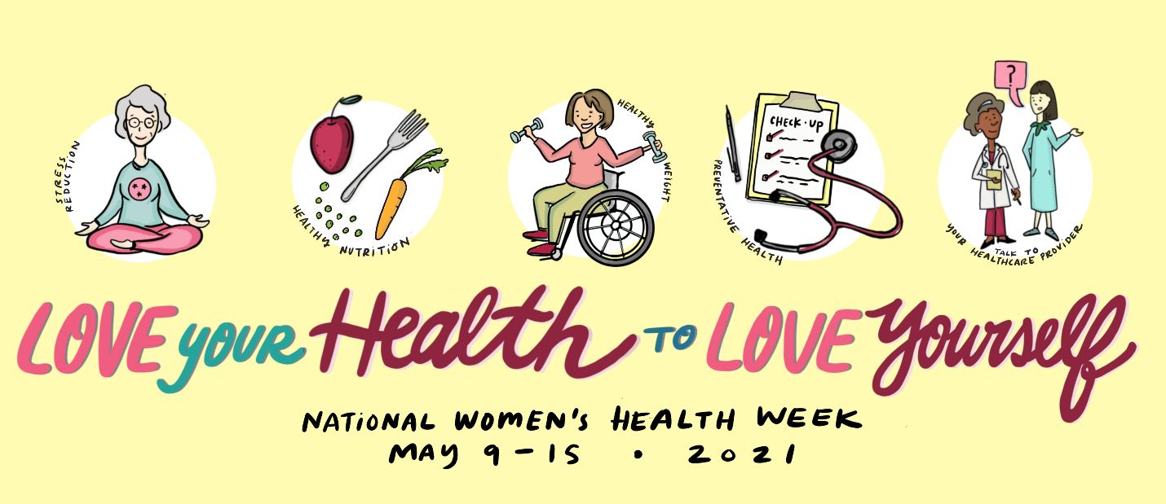

STRATEGIES

Facebook Live Events

Planning an Event
- Identify and contact community partners to help host an event
- Set a date and time to host your event
- Contact speakers or instructors
- Identify which Facebook page to host the event on
- Create a flyer about your event with your Facebook page information
- Create a Facebook live event by selecting schedule a live video
- Identify someone to answer questions in the comment box during the event
- Select what type of equipment to use laptop, smartphone or tablet, webcam
- You can also stream your webinar on zoom Live streaming meetings or webinars on Facebook – Zoom Help Center

Day of Event Tips
- Login a few minutes early to make sure everything is working properly
- On the Facebook page, select the live video option and start your event
- Welcome everyone and introduce your speaker and host
- Share the agenda and start the program
- Track the number of views at the bottom of the live video
- Once you do a live event, people can view your video on your Facebook page

Cooking a Healthy Recipe
One type of Facebook Live activity that could be hosted during WHW is cooking. Showing viewers how to appropriately cook a nutritious, simple meal can increase their understanding and/or awareness of nutrition and how to eat healthy.

Physical Activity (Dancing, Yoga, etc.)
Another type of Facebook Live activity that could be hosted is a physical activity. Inviting viewers to participate in a physical activity such as learning a specific dance, yoga or a walk-and-talk can educate them on new or fun activities that can help get them moving.

Stress Reduction Techniques

Video on Benefits of Exercise
23 and 1/2 hours: What is the single best thing we can do for our health? (Video)

Resources
TDH Wellness Council (mailchi.mp)

Free Cervical Cancer Screening Day
Together with TBCSP, external clinics and metro health departments can provide a day/partial day of cervical cancer screenings. TBCSP has opened up screening to allow patients who meet general eligibility guidelines that are 21 and older to receive cervical cancer screenings through partnered clinics.
Clinics can pre-screen patients registering to determine if the patient is eligible.
Preference for extended hours to reduce structural or scheduling barriers is preferred but not mandatory. Healthcare providers completing a full wellness exam is preferred but not mandatory.

Sample Posts
Annual wellness exams are a very important piece of your health. Annual visits start conversations with your healthcare provider to help you understand your risks for certain diseases and detect any problems early. Encourage the women in your life to get their annual wellness exams and be an example by getting yours as well.
Did you know that cervical cancer is one of the few cancers that can be prevented? More than 90% of all cervical cancers are caused by the Human Papillomavirus (HPV) and there is a vaccine to prevent infection. Also, there are pre-cancerous cells (cells that are not yet cancerous) that be detected early and treated to prevent the development of cervical cancer. Ensuring that children in your life are vaccinated against HPV and encouraging those with a cervix to get screening regularly can increase their chance of preventing cervical cancer. Cervical Cancer | TDH
Did you know that Hispanics and Blacks are more likely to be diagnosed with and die from cervical cancer? Encouraging those in your life with a cervix to get regularly screened can increase their chance of preventing cervical cancer. Cervical Cancer | TDH
Did you know that May 9-15, 2021 is National Women’s Health Week? Encourage the women in your life to make their health a priority and be the example by getting your annual wellness exam. You may be eligible for a free cervical cancer screening. Contact [clinic] at [clinic number]. [Include website if applicable]
Did you know that May 9-15, 2021 is National Women’s Health Week? [Clinic] is offering a Free Cervical Cancer Screening Day on [date]. Call [clinic number] to see if you are eligible. [Include website if applicable]

Sample Hashtags
#FCCSTN
#CervicalCancerScreeningTN

Promotional Material
For flyers promoting the event in English, Spanish and Arabic, please see Appendix A, B and C.

ADDITIONAL MATERIALS

Bookmark
For a bookmark promoting the RWH WHW priority topics, please see Appendix D.

Flyer
For a flyer promoting the RWH WHW priority topics, please see Appendix E.

Images
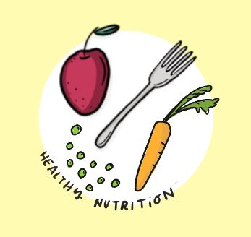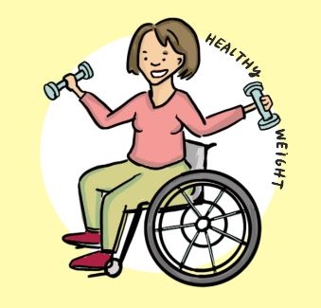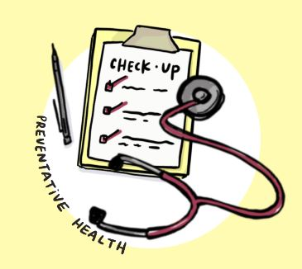
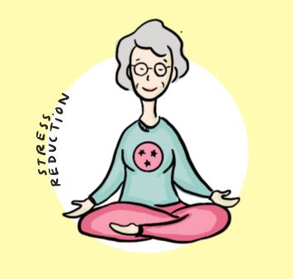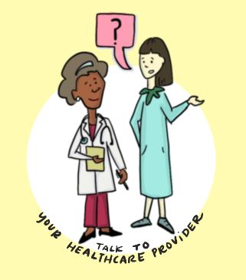

PARTNERS
Office of Minority Health and Disparities Elimination (tn.gov)
Johnson City Community Health Center (East Tennessee State University)
Mid-Cumberland Community Action Agency
Tennessee Cancer Coalition (TC2)
A Step Ahead Foundation
Division of TennCare
Metro Health Departments
Davidson County
Knox County
Shelby County
Hamilton County
Sullivan County
Madison County
Tennessee Coalition to End Domestic & Sexual Violence

ADDITIONAL RESOURCES

Tobacco Resources
- TN QuitLine (tn.gov)
- Baby & Me Tobacco Free (tn.gov)
- Tennessee Tobacco Program - Quit Week (tn.gov)

Youth and Young Adult Resources
- Power to Decide: The Campaign to Prevent Unplanned Pregnancy
- Bedsider
- Stay Teen: Birth Control Explorer

Parent and Guardian Resources
- American Academy of Pediatrics Healthy Children: Teen Dating and Sex
- KidsHealth: Growth and Development
- Talking Is Power | Power to Decide
- KidCentral TN
- CDC - COVID-19 Parental Resource Kit - Adolescence
- CDC - Helping Children Cope

Educator and Community Resources
- CDC- Reproductive Health: Contraception
- Healthy Teen Network: Center for Evidence and Innovation for Communities
- Amaze
- Evidence-Based Teen Pregnancy Prevention Program at a Glance
- Guttmacher Institute: United States: State Policies on Pregnancy

Mental Health, Substance Abuse and Human Trafficking Resources
- Department of Mental Health & Substance Abuse Services (tn.gov)
- Tennessee Human Trafficking Hotline: 1-855-55-TNHTH
- National Human Trafficking Hotline: 1-888-373-7888
- TN REDLINE (substance abuse treatment): 1-800-889-9789 (call or text)
- National Suicide Prevention Lifeline: 1-800-273-TALK
- Domestic & Sexual Violence Hotline: 1-800-356-6767
- Sexual Assault Center: 1-866-811-RISE

STD/HIV
- End the Syndemic TN
- Get PrEP TN

Misc
- TennCare Connect (Creating your Profile)
- Nutrition (tn.gov)
- HealthyBrainToolkit_42419.pdf (tn.gov)

APPENDIX
For original materials, please reach out to Elizabeth Berardi at Elizabeth.Berardi@tn.gov .

A – Free Cervical Cancer Screening Day Flyer (English)
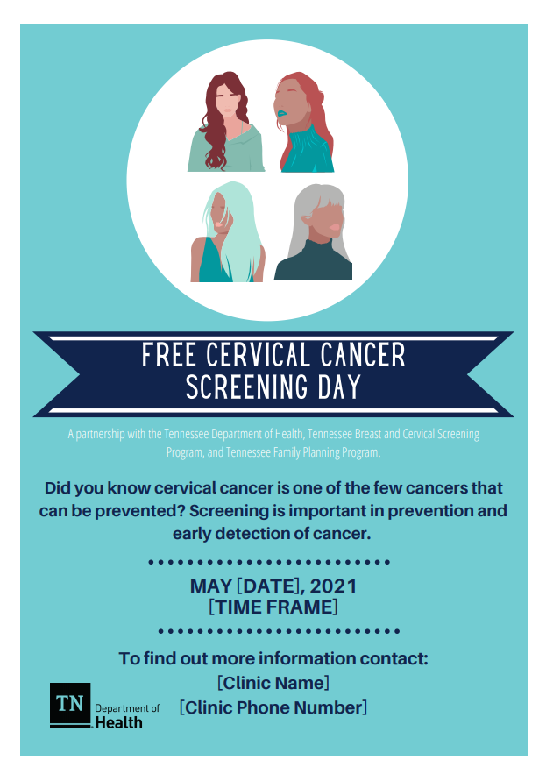

B – Free Cervical Cancer Screening Day Flyer (Spanish)
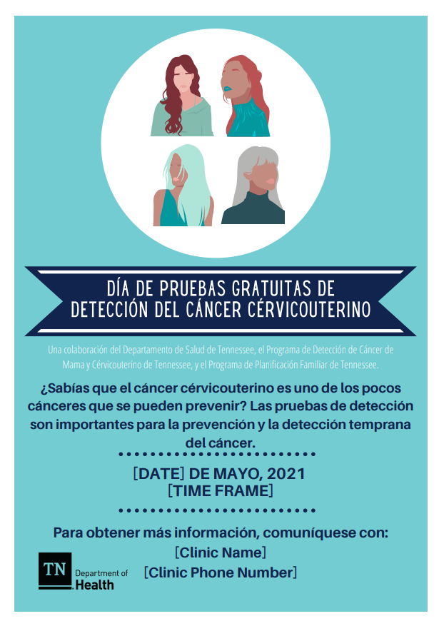

C – Free Cervical Cancer Screening Day Flyer (Arabic)
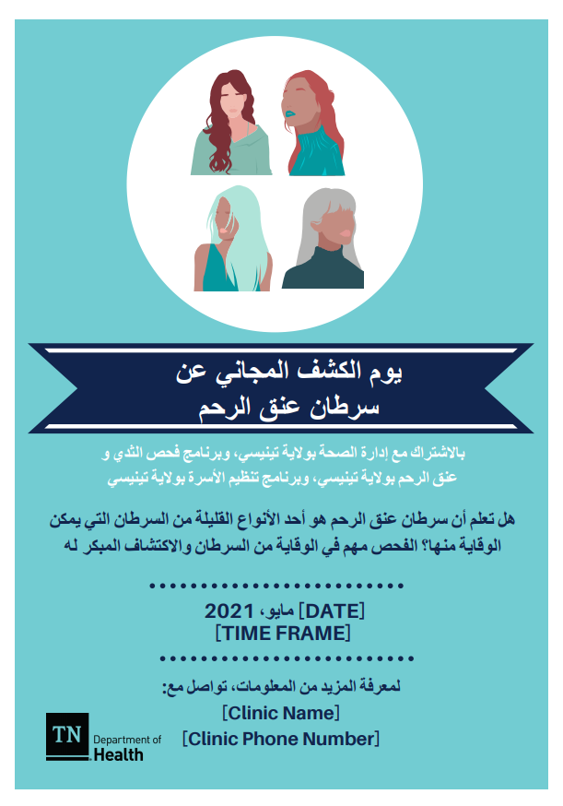

D – WHW Bookmark
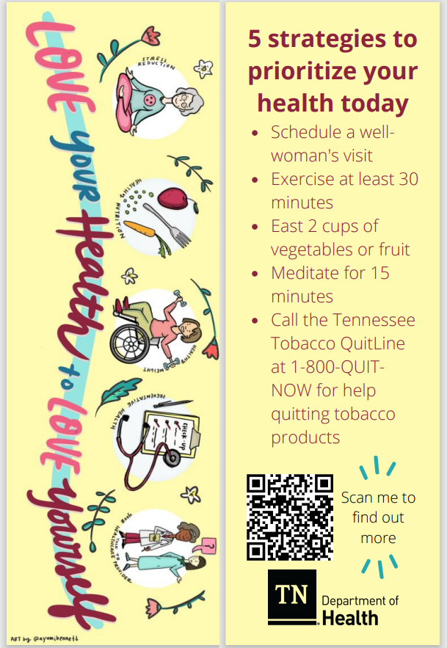

E – WHW Priority Topic Flyer
