State of Tennessee Dept. of Health Newborn Screening shipping steps for Primary Care Providers & Midwives via FedEx
The Tennessee State Lab wants Newborn Screening blood samples sent via FedEx for a reliable and trackable service. Below are steps to use to send the State Lab dried blood spot samples:
- Use the FedEx Billable Stamp that was provided to you and affix to envelope exterior. FedEx will not bill you for this service.
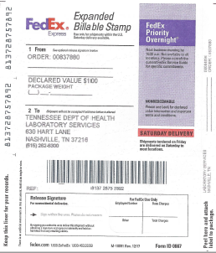
- Place dried blood spot samples in a FedEx Envelope or similar container/mailer. Do not place in a biohazard bag or any plastic or poly bag before placing in envelope.
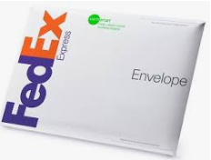
- Here are two ways to ship via FedEx to the State Lab:
  - Call 800.463.3339 for a pickup at your location.
  - Drop package off at a FedEx Office location, Authorized Ship Center.
  - For the best preservation of your sample DO NOT USE A DROP BOX.
  - To find the nearest FedEx location, go to www.fedex.com and search for FIND A LOCATION:
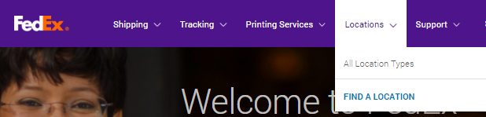
  - If your location has an automatic daily FedEx pickup, just place package with your outgoing shipments.

- Track your package to the State Lab via the tracking number of the Billable Stamp. See left side for a peel off tracking number sticker. Track your package at www.fedex.com.

