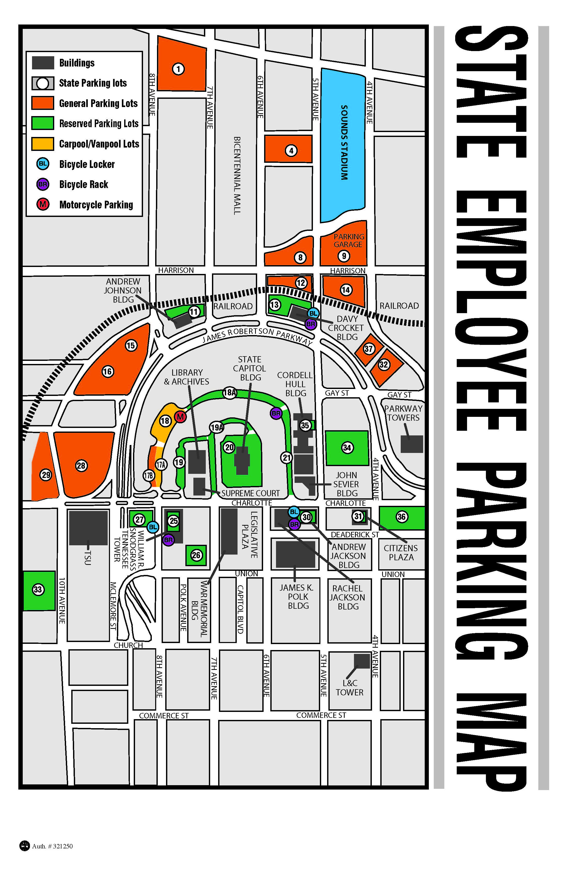
General Parking Options

State Owned Parking Lots
Lot 1
Lot 4
Lot 8 (limited availability)
Lot 12 (disabled ONLY lot)
Lot 14
Lot 15
Lot 16
Lot 17B
Lot 28
Lot 29
Lot 32
Lot 37

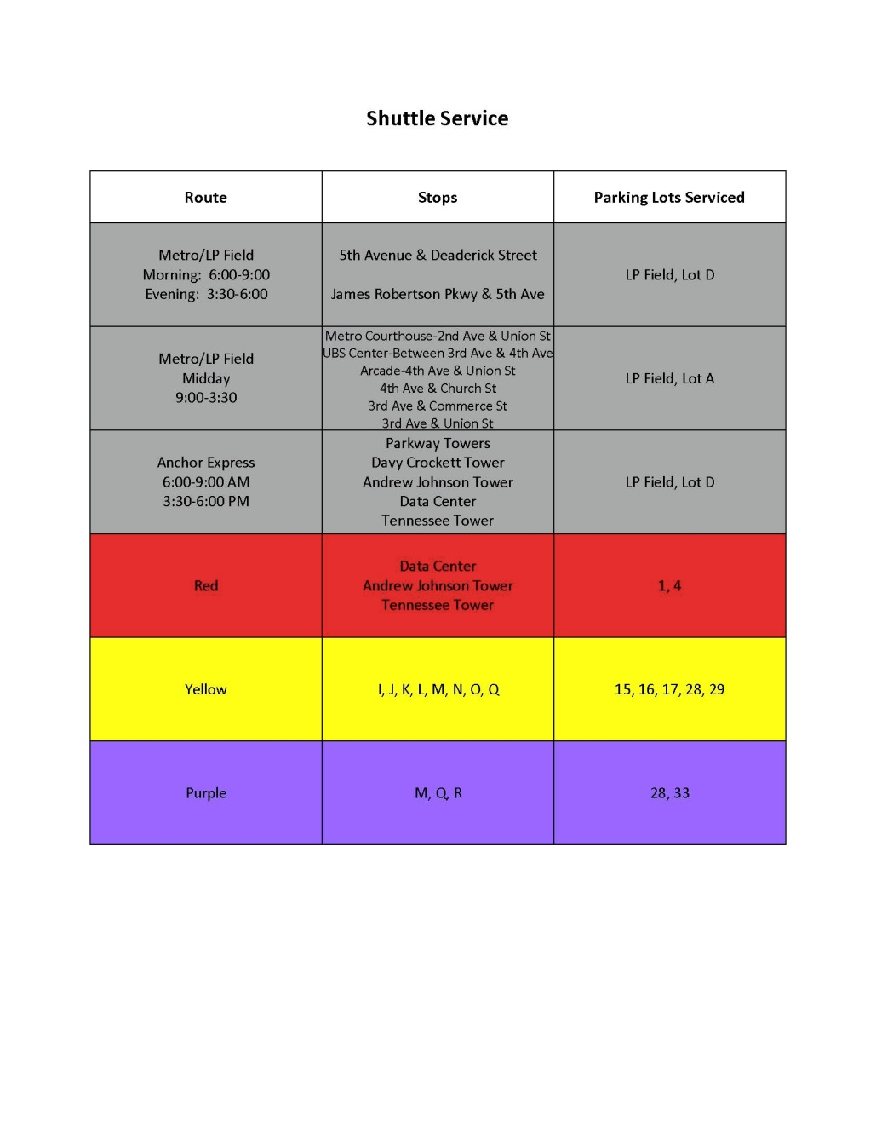
Shuttle Service to the above mentioned lots
Red Route
Yellow Route
Purple Route

Other Parking Options:

DGS currently has access to 1,000 parking spaces at LP Field in Lot D. Please see the Shuttle Service Guide above for LP Field Shuttle Service. There are also mid-day shuttles to and from LP Field.
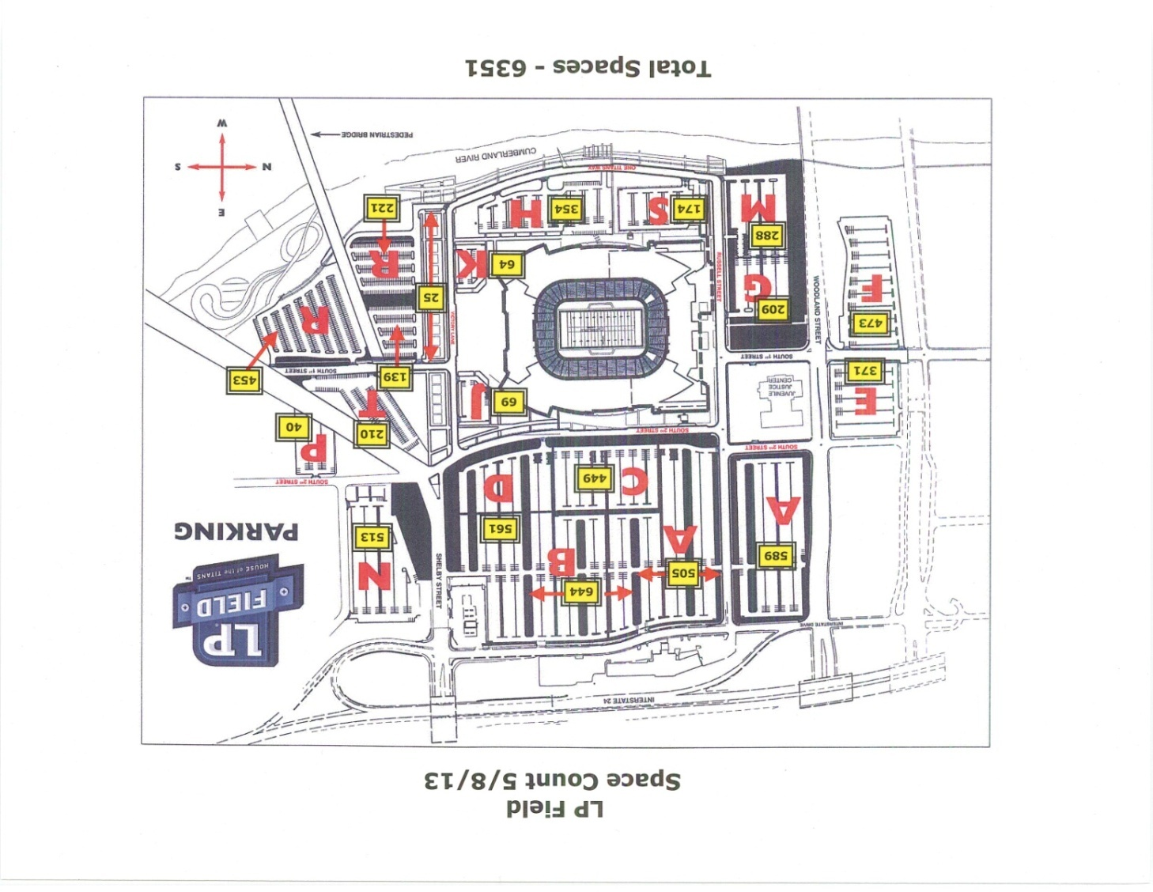

Other Transit Options:
- Apply for a Swipe-N-Ride card with HR to commute via Express Bus from the following Counties:
  - Davidson
  - Sumner
  - Rutherford
  - Robertson
  - Williamson
  - Wilson
  - Dickson
  - Montgomery
- With your Swipe-N-Ride Card, you can catch a MTA Bus to LP Field as well. Bus 43 from Bay 24 will go to LP Field.
- You can use your Swipe-N-Ride Card for the Music City Star.
- Regional Transit Authority has a Rideshare Program where you can find someone to ride a vanpool or carpool.
- Vanpool Options:
  - State Vanpool Program
  - Regional Transit Authority
  - TMA (Transit Management Association)

Important Websites:
- State of Tennessee Parking Website - http://www.intranet.state.tn.us/generalserv/mvm/parking.html
- MTA Nashville - http://www.nashvillemta.org/
- Swipe-N-Ride Program - http://www.tdot.state.tn.us/smartcommute/swipenride.htm
- RTA Nashville - http://www.musiccitystar.org/
- TMA Nashville - http://www.tmagroup.org/

