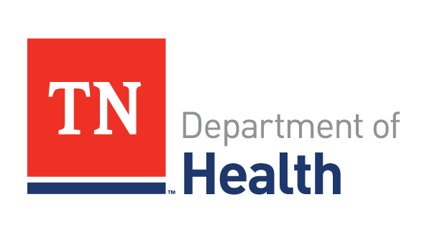
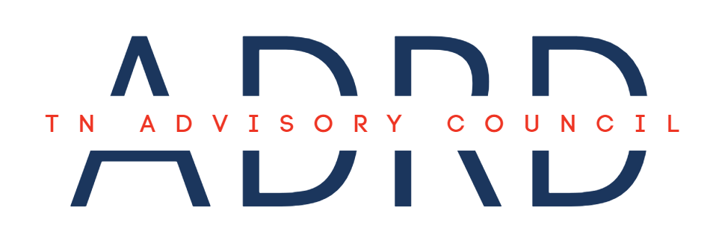
Meeting Agenda

Date: | August 21, 2025 | Time: | 1:00 – 3:00 PM CST
Location: | Cordell Hull Building  425 Rep. John Lewis Way N, 8D  Nashville, TN 37243 | Virtual: | NA

- Call to Order

Bunn called the meeting to order and requested that Rochelle Roberts, TN ADRD Advisory Council Facilitator and TDH State Dementia Director, complete Roll Call.

- Roll Call (1:05 – 1:10)

Roberts introduced herself and read the hybrid meeting script which established that the meeting had established a physical quorum, allowing the meeting to move forward.

Each Council Member introduced themselves to Representative Sabi Kumar during Roll Call.

Council Member Name: | Classification: | Present: | Absent:
Senator Rusty Crowe  (Non-voting) | TN General Assembly | ☐ In-Person  ☐ Virtual | ☒
Representative Sabi Kumar (Non-voting) | TN House of Representatives | ☒ In-Person  ☐ Virtual | ☐
Keita Cole | TN Department of Disability and Aging | ☒ In-Person  ☐ Virtual | ☐
Kirk Mason | Stones River Manor | ☒ In-Person  ☐ Virtual | ☐
Angela Jefferson | Vanderbilt University Medical Center | ☐ In-Person  ☐ Virtual | ☒
Bart Brammer | Person Living with ADRD | ☐ In-Person  ☐ Virtual | ☒
Janice Wade-Whitehead | Alzheimer’s TN, Inc. | ☒ In-Person  ☐ Virtual | ☐
Dawne Bunn | Alzheimer’s Association, TN Chapter | ☒ In-Person  ☐ Virtual | ☐
Anna Lea Cothron | TennCare | ☒ In-Person  ☐ Virtual | ☐
Nina Monroe | TN Health Care Association | ☒ In-Person  ☐ Virtual | ☐
Gwyn Earl | LeadingAge TN | ☒ In-Person  ☐ Virtual | ☐
VACANT | TN Nurses Association | ☐ In-Person  ☐ Virtual | ☒
Alicia Robeson | TN Department of Mental Health and Substance Abuse Services | ☒ In-Person  ☐ Virtual | ☐
Sally Pitt | TN Department of Health | ☒ In-Person  ☐ Virtual | ☐
Laura Musgrave | Family Caregiver Representative | ☒ In-Person  ☐ Virtual | ☐
Ray Romano | Vanderbilt University Medical Center | ☒ In-Person  ☐ Virtual | ☐
Non-Council Attendees: | Rochelle Roberts  Cheryl Blanchard  Amber Barlow Leitch

- Old Business (1:10 – 1:15)
  - Approval of July Meeting Minutes
Cothran proposed a motion to approve the minutes; seconded by Laura. A quorum was maintained with unanimous approval.

- New Business (1:15 – 2:10)
  - Goal #3: Ensure an Adequately Prepared Workforce (1:15 – 2:00)
    - Members will present on current workforce initiatives within their offices/divisions.

Alzheimer’s Tennessee – Wade-Whitehead
- Reiterated about the Alzheimer’s ACT (Alzheimer’s Care Training), 8-hour, -in-person curriculum delivered statewide.
- Distributed a copy of the 39th Annual Alzheimer’s Disease Management & Research Symposium for clinicians on November 13th - 14th, 8:30 – 3:30. She stated that this is all virtual, but next year it will be hybrid.
  - Wade-Whitehead to send copy of flyer to Roberts.
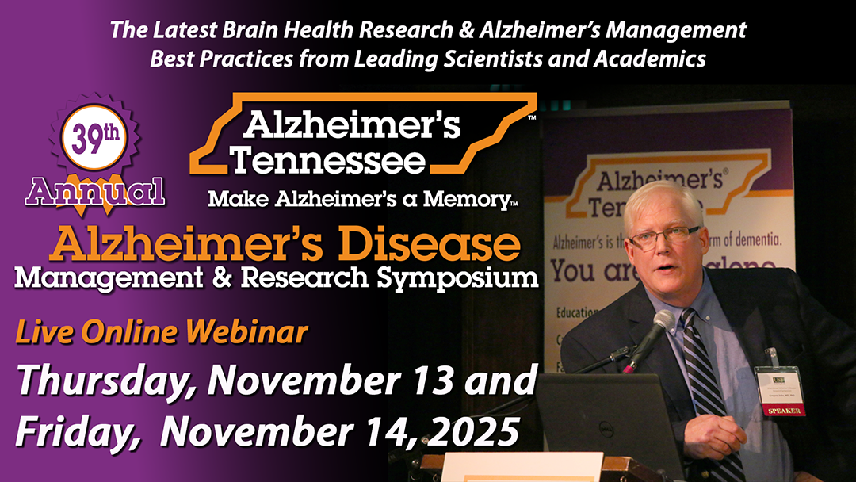
- Highlighted Caring Hearts Recognition Lunches to celebrate outstanding CNAs, PAs, and direct care workers nominated by their communities.

Vanderbilt University Medical Center (VUMC) – Ray Romano
- Explained the TN Dementia ECHO format as a hub-and-spoke model designed to deliver dementia-specific training and foster collaboration among providers and public health professionals statewide. VUMC anchors the Middle Hub, the University of Memphis leads the West Hub, and Erlanger/UTC directs the East Hub. This structure ensures expertise radiates outward while local perspectives shape and strengthen statewide practice.

Over 400 individuals have expressed interest in the program, demonstrating strong demand across the care pathway. Actual enrollment is lower, which underscores the importance of meeting providers where they are and reducing barriers to participation. The ECHO remains open to anyone involved in dementia care including clinicians, caregivers, community partners, and students alike.

VUMC is submitting an R21 grant to the National Institute on Aging (NIA) to continue this program and formally evaluate how participation shifts care metrics and outcomes. At the same time, they are seeking external investment, including support from the West End Home Foundation to sustain and grow the West Hub.

Pitt proposed leveraging the Council’s health system connections (West TN Healthcare, HCA) to distribute ECHO materials. Robeson recommended engaging the Regional Mental Health Institutes (Bolivar, Chattanooga, Memphis, Nashville), highlighting the intersection of behavioral health and cognitive decline, and suggested featuring ECHO at the Older Adult Health Conference in May 2026, which drew more than 500 virtual attendees in 2025. Earle noted that Romano will participate in the LeadingAge Tennessee Annual Meeting on September 23rd, a one-day event for long-term care providers with vendor and student engagement.

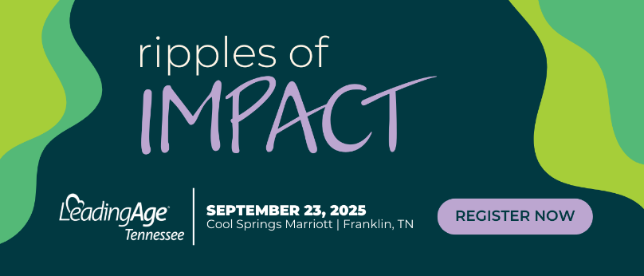
Roberts shared two flyers: one outlining the Fall cohort schedule and another tailored to public health students (see below).
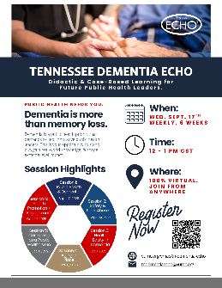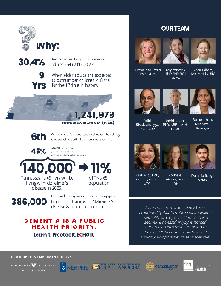
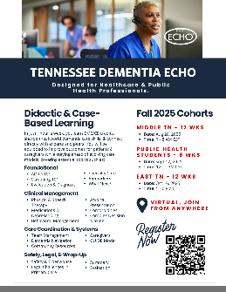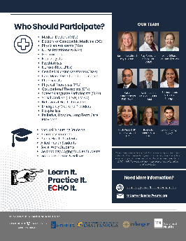
Bunn discussed the Accelerating Access to Dementia & Alzheimer’s Provider Training (AADAPT) Act that was reintroduced in 2025 to reauthorize Project ECHO grants and specifically dedicate a subset for Alzheimer’s and dementia care. The Department of Health & Human Services will allocate grants within one year of enactment for tech-enabled, collaborative-learning programs aimed at primary care providers in rural, underserved, or medical underserved areas. It authorizes $10M (FY 2022-2032) annually for general ECHO grants and $1M (FY 2027-2032) annually for Alzheimer’s related ECHO initiatives.

TN Dementia ECHO LinkedIn.

LeadingAge TN - Gwyn Earle
- Careers That Love You Back is an elementary-school career awareness initiative to shine a light on aging services careers like nursing, home care, marketing, IT, dining services, and more, by introducing students in grades K-6 through engaging, profession-themed posters (18) and an accompanying curriculum guide. This was funded through an 18-month grant, that engaged 35 assisted livings in developing the curriculum and implementation.
- Seeking funding for staff education through multiple channels, she highlighted ongoing work on an Appalachian Regional Commission grant focused on substance use disorder and long-term care. She noted that TN law and federal CMS regulations impose blanket prohibitions on individuals with certain criminal backgrounds, including drug-related convictions, from working in long-term care, effectively excluding even highly qualified candidates in sustained recovery.

Kumar raised questions for Earle regarding these restrictions, including approaches for ongoing monitoring of staff with a history of substance use, liability and insurance implications, strategies for managing current staff identified as substance users, and the potential for a mentorship program to support internal staff.
Robeson discussed the Supported Employment Services Program that has established training and certification programs enabling people in recovery to be reimbursed through Medicaid for delivering peer support services in mental health and substance use disorder care settings. They are legitimate, credentialed career paths rooted in recovery experience. This is in place in 42 counties across TN, 29 of which are rural and 17 urban, having served 1,611 people in FY24 (increase of 24%).

Tennessee Department of Mental Health and Substance Abuse Services (TDMHSAS) – Alicia Robeson
- TDMHSAS serves as the state authority on mental health, substance use, and opioid treatment. Its workforce goals center on expanding service capacity, strengthening community-based care, advancing prevention and education, reducing prescription drug abuse, and promoting recovery and wellness statewide. TDMHSAS is prioritizing expansion of community mental health providers, particularly in rural regions, and investing in scholarship funding and training programs to build and sustain the behavioral health workforce.

Facts provided:
  - Provider Rate Increases: $10.2 million in appropriated funds were directed to increase provider rates, offset rising costs, and strengthen capacity to deliver quality prevention, treatment, and recovery services.
  - Workforce Development: Investments in scholarships and training opportunities to grow a qualified behavioral health workforce pipeline.
  - Scholarship Impact: The Tennessee Behavioral Health Pathways Scholarship provided tuition stipends for graduate-level behavioral health students.
  - Retention Impact: The Public Behavioral Health Workforce Sign-On and Retention Bonus Program supported over 3,000 behavioral health workers across TN.
  - Mobile Health: Through Project Rural Recovery, four (4) mobile health clinics to deliver integrated physical, mental health, and substance use services. It is funded through SAMSHA and state ARPA dollars. Services are free, though insurance is billed when available. They are seeing a large portion of older adult usage. Providers include McNabb Center (East), Buffalo Valley, Inc (Middle), and Ridgeview Behavioral Health Services & Pathways Behavioral Health (East and West). Clinics rotate weekly through designated counties and regions. In five years, they’ve served 1,839 clients, delivering 5,391 visits in 20 counties, using four mobile clinics. Each mobile unit includes a dual-certified Nurse Practitioner, Behavioral Health Therapist, Case Manager, and Medical Assistant. Per the website, 75% were unemployed, 48% were facing housing instability, and 80% had at least one (1) chronic physical health issue.
  - Measurement: Progress is assessed through an annual statewide and regional Needs Assessment and incorporated into the Department’s Three (3)-Year Plan to ensure resources align with prioritized needs.

- Barriers and Needs: Challenges include rising operational costs, heightened service demand, and the need for additional staffing and resources. The department seeks collaborative strategies and innovative partnerships, including efforts supporting Tennesseans living with ADRD.

- Next Steps: The department is compiling year-end data to forecast service needs and inform resource allocation for the next contract cycle. Through its needs assessment process, TDMHSAS aims to design a more targeted, efficient, and data-informed behavioral health service delivery system over the next 6 – 12 months.

Council Discussion
Council members emphasized the need for stronger collaboration, resource sharing, and braiding funding across organizations. Pitt proposed establishing a work group to map existing resources and pinpoint partnership opportunities. The intent is to prevent duplication, maximize impact, and align funding streams more strategically. Council members also noted alignment with the TN Legislative Task Force for Reimbursement goals, particularly around advancing sustainable funding models and strengthening cross-sector reimbursement strategies. A question was raised on whether this effort could be embedded within the Multi-Sector Plan for Aging (MPA).

Kumar stated that the Council is on a constructive path.

  - State Dementia Director Updates (2:00 – 2:10)
- Age-Friendly Public Health System: All 89 county health departments and two (2) metros have been recognized. TN is the first in the nation to achieve this designation.
- Education Materials: Over 13,960 With to Do Next trifolds have been requested along with over 130,000 rack cards, statewide.
- Multisector Plan for Aging Data Dashboard V2: Since the May launch, the platform has engaged 172 unique users across 339 sessions. Continuous updates are underway. ETSU is positioned to expand with additional data points and will integrate focus groups to deliver both qualitative and quantitative insights.
- Pointer Study: TN was selected to participate in the U.S. POINTER. Plans include collaboration with the Knox County Health Department to integrate lifestyle interventions into public health work.
- TN Dementia Navigator Program (TDH): Navigators have received 66% of referrals from providers, 12% (each) from families and older adult services. Feedback from caregivers included: I feel heard and understood and I never really understood what my husband was going through until now.
- Upcoming Engagements:
  - Supporting Caregivers: Opportunities for Public Health to Support Adult Day Service Programs. Hosted by the University of Minnesota, BOLD Public Health Center of Excellence – Dementia Caregiving on September 16 at 11:00 AM CST. Topic: Adult Day Services (ADS) play a critical role in dementia care by engaging participants while providing caregivers with essential respite. This webinar will highlight strategies for integrating ADS into broader public health efforts. Register here.
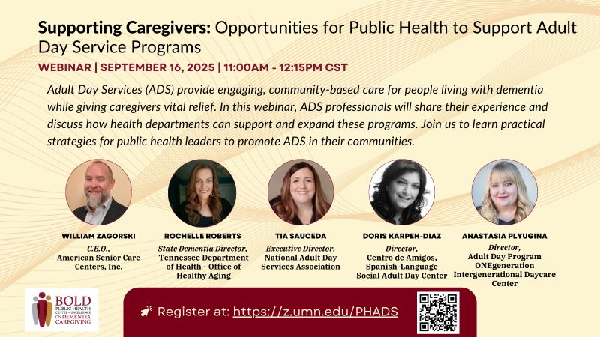
  - 39th Annual Geriatric Update. Hosted by Vanderbilt Geriatric Workforce Enhancement Program (GWEP) on September 26th. Roberts to host the panel discussion on Age- & Dementia-Friendly Initiatives Panel Discussion: Collaborating Across Sectors to Transform Care, Connection, & Compassion, bringing together leaders from across healthcare, public health, and community organizations to share strategies, models, and outcomes that strengthen systems of care for older adults with Musgrave serving on the panel.
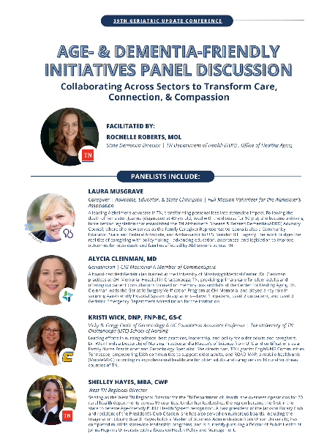
  - National Dementia Services Summit in Washington, DC in October. Hosted by the Alzheimer’s Association.

- Planning the Agenda for the Next Council Meeting (2:10 – 2:40)
- Focus Area: Goal 5: Policy Development
  - A Big P and Little P policy discussion was proposed. Including high-level discussions from liaisons from the Alzheimer’s Association and Alzheimer’s Tennessee. Government department Legislative Liaisons could be invited to listen to national initiatives for information only.
  - Wade-Whitehead mentioned threading the needle reading from the State Plan:
    - Support better informed decisions by educating policymakers on the basics of cognitive health and impairment, the impact of dementia on caregivers and communities, and the role of public health in addressing this priority problem. Wade-Whitehead suggested developing one (1) strategy.
      - Pitt recommended developing a one-page executive summary or trifold handout highlighting funding allocations and impact metrics across key initiatives (e.g., Dementia Navigator Program, TN Dementia ECHO, Alzheimer’s Tennessee Curriculum, LeadingAge’s Careers that Love You Back, MobileMoc, Project Rural Recovery). Earle underscored the importance of communicating core messages on cognitive health, the burden of dementia on caregivers and communities, and the role of public health in response. Robeson proposed leveraging the Office of Evidence & Impact’s Program Inventory Dashboard, a searchable, interactive tool within TN Department of Finance & Administration, to align with state-funded program performance and evidence metrics.
    - Engage public and private partners in ongoing planning efforts to establish services and policies that promote supportive communities and workplaces for people with dementia and their caregivers. Wade-Whitehead suggested the Compensation Council would fit nicely.
    - Provide emergency preparedness teams and first responders with tools and resources related to supporting those experiencing cognitive decline in crisis situations. She mentioned the work of the Navigators to address this, and Pitt added CARETag and Silver Alert.
- Action Item: The Council will develop a one-page executive summary or trifold handout, incorporating both program impact metrics (e.g., Dementia Navigator Program, TN Dementia ECHO, Alzheimer’s Tennessee Curriculum, LeadingAge’s Careers that Love You Back, MobileMoc, Project Rural Recovery) and key public health framing (e.g., cognitive health basics, dementia’s impact on caregivers/communities, and the role of public health).
  - Cothran and Pitt reinforced the Council Members must complete the REDCap.
  - A motion was introduced for the Council to develop one-page highlights of the ADRD Council at the next meeting. The motion was supported by Robeson, seconded by Earle, and unanimously approved by all members present.

- Council Member Comments/Announcements (2:40 – 2:50)
Bunn presented on the POINTER (Protect Brain Health through Lifestyle Intervention to Reduce Risk) Study: An eight (8)-year clinical trial led by the Alzheimer’s Association testing how multi-component lifestyle interventions can protect cognitive function in older adults at increased risk for dementia. TDH as one of 10 selected locations to receive funding to support an initiative for the Study. The results confirm the power of combining physical activity, MIND-style diet, cognitive training, social engagement, and heart health monitoring into a multidomain intervention. The U.S. Pointer Brain Health Recipe includes physical activity, health monitoring, nutrition, and cognitive exercise. It is now a validated, evidence-backed strategy that can inform dementia prevention efforts nationwide.

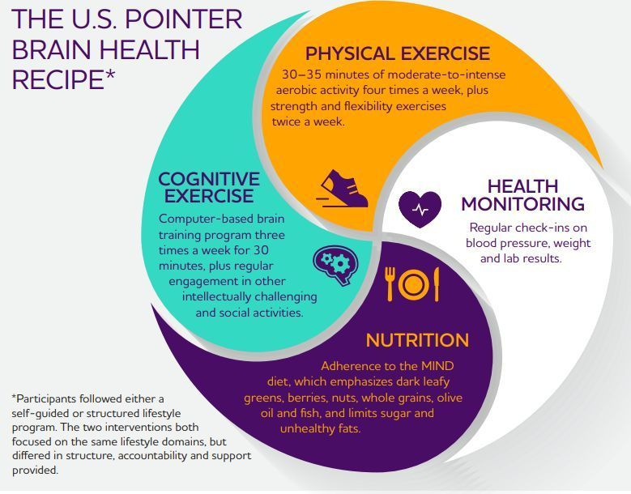
Discussion continued around the topic, with Cothran linking this back to Goal 4: Research including conversations about GLP, magnesium, and more from a medical to public health standpoint.

Bunn reminded the Council of upcoming Walk to End Alzheimer’s events including:
Chattanooga, TN Oct 25, 2025
Clarksville, TN Oct 11, 2025
Cleveland, TN Sep 27, 2025 – Led by Musgrave.
Jackson, TN Sep 27, 2025
Johnson City, TN Oct 4, 2025
Knoxville, TN Sep 20, 2025
Lynchburg, TN Sep 20, 2025
Memphis, TN Nov 1, 2025
Murfreesboro, TN Oct 18, 2025
Nashville, TN Nov 8, 2025

Cole informed the Council that TDDA Dementia Navigators have trained 1,000 people in eight (8) months. Trainings are available virtual and in-person with a flyer provided to in-person attendees.
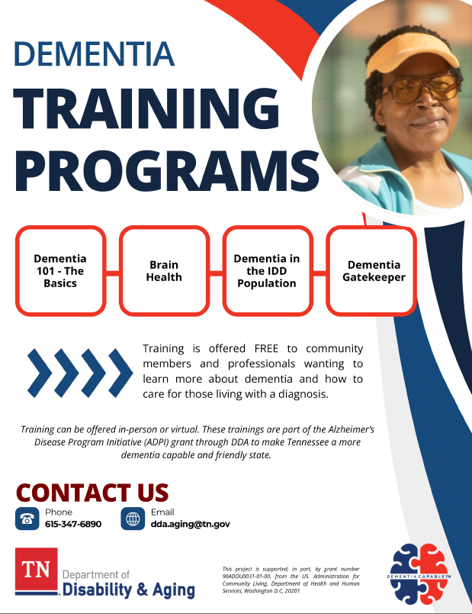
- Public Comment (2:50 – 2:55): No requested comments were received ten (10) business days prior to the meeting.

- Next Council Meeting: November 13, 2025

- Adjournment (2:58)

