
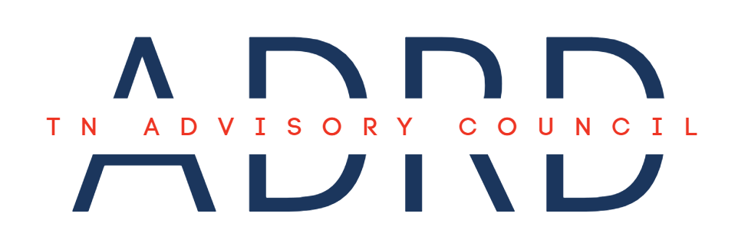
Meeting Agenda

Date: | November 13, 2025 | Time: | 1:00 – 3:00 PM CST
Location: | Tennessee Department of Health,  7th Floor, Conference Room F  710 James Robertson Pkwy, Nashville, TN 37219 | Virtual: | Webex*  Had to convert to Teams.

- Call to Order (1:00)
- Roll Call (1:00 – 1:10)
- State Dementia Director Updates (1:10 – 1:20)
  - ADA Requirements & Protocol
  - 2026 Office of Healthy Aging (OHA) Intern
  - State Dementia Services Coordinator (DSC) Meeting 2025
- Old Business (1:20 – 1:30)
  - Approval of August Meeting Minutes
  - 2026 Meeting Schedule
- New Business (1:30 – 2:15)
  - Dementia: A Year in Review Executive Summary Draft
- Planning the Agenda for the Next Council Meeting (2:15 – 2:45)
- Council Member Comments/Announcements (2:45 – 2:50)
- Public Comment (2:50 – 3:00)
- Next Council Meeting: Unk

