

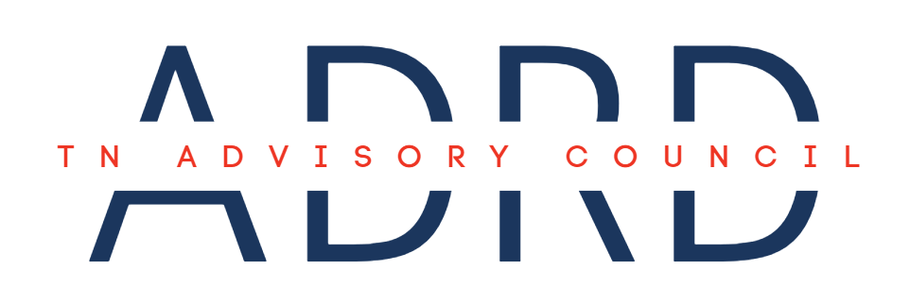

**Meeting Agenda**

|  |  |  |  |
| --- | --- | --- | --- |
| **Date:** | March 21, 2025 | **Time:** | 1:00 – 3:00 PM CST |
| **Location:** | Tennessee Department of Health  710 James Robertson Parkway  Nashville, TN 37243  Conference Room 7F | **Virtual:** | [**Join the meeting now**](https://teams.microsoft.com/l/meetup-join/19%3ameeting_Zjg1ZDgwODEtMTM4Ny00MjY5LTk1Y2EtOTk2OTBlZGQ0NTg1%40thread.v2/0?context=%7b%22Tid%22%3a%22f345bebf-0d71-4337-9281-24b941616c36%22%2c%22Oid%22%3a%22125d5604-4ffb-40a8-917d-f034e1e4039c%22%7d)  Meeting ID: 218 797 831 878  Passcode: CF5jy7  [+1 629-209-4396,,832033361#](tel:+16292094396,,832033361) |

1. **Call to Order**
2. **Roll Call**
3. **New Business**
   1. Sunshine Law with TDH General Counsel
   2. Member Status Updates & Next Steps
   3. State Dementia Director Updates
4. **Old Business**
   1. Approval of November Meeting Minutes
   2. Resource Repository Development
   3. *Advancing the TN ADRD State Plan Together* REDCap Survey
5. **Planning the Agenda for the Next Council Meeting**
6. **Council Member Comments/Announcements**
7. **Public Comment**
8. **Next Council Meeting:** May 15, 2025
9. **Adjournment**