The Tennessee Sunshine Law passed by the General Assembly in 1974 requires that meetings of State, City and County Government bodies be opened to the public and that any such governmental body give adequate public notice of such meeting.

DATE: March 24, 2026
TO: Ramya Kashireddy
FROM: Rochelle Roberts
NAME OF COUNCIL: Tennessee Alzheimer’s Disease and Related Dementia Advisory Council
DATE OF MEETING: April 9, 2026
TIME: 1:00 PM – 3:00 PM CST
PLACE: Cordel Hull State Office Building, Room 8D
425 Rep. John Lewis Way N, Nashville, TN 37243
In-person, only.

In accordance with the Tennessee Open Meetings Act, please notify the council ten (10) business days prior to a scheduled meeting if you wish to participate in public comments. Your email should include the date of the meeting, the specific topic from the published agenda or sunshine notice that you intend to address, and the length of time required. Public comments are limited to topics listed on the sunshine notice or the published agenda and will be permitted during the last ten (10) minutes of the meeting.

For more information or to request public comment, contact Rochelle Roberts at rochelle.l.roberts@tn.gov.

Major Item(s) on Agenda:
Call to Order; Roll Call; Old Business - Approval of Meeting Minutes; New Business – 2027–2030 State Plan Working Session; State Dementia Director Updates – General Updates; Planning the Agenda for the Next Council Meeting; Council Member Comments/Announcements; Public Comment; Next Council Meeting; Adjournment.

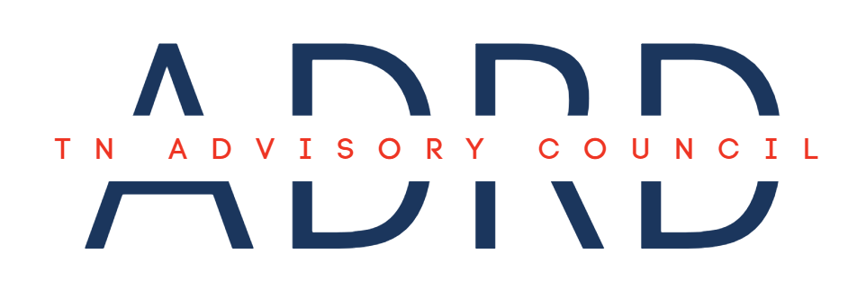
Meeting Agenda

Date: | April 9, 2026 | Time: | 1:00 – 3:00 PM CST
Location: | Cordel Hull State Office Building, Room 8D  425 Rep. John Lewis Way N,  Nashville, TN 37243  In-person, only. | Virtual: | NA

- Call to Order (1:00)
- Roll Call (1:00 – 1:10)
- Old Business (1:10 – 1:20)
  - Approval of November Meeting Minutes
- New Business (1:40 – 2:25)
  - 2027–2030 State Plan Working Session
    - Guest Facilitator:
      - Kelly Estilette | TN Department of Health, Office of Healthy Aging Spring Intern
- State Dementia Director Updates (2:25 – 2:35)
  - General Updates
- Planning the Agenda for the Next Council Meeting (2:35 – 2:45)
- Council Member Comments/Announcements (2:45 – 2:50)
- Public Comment (2:50 – 3:00)
- Next Council Meeting: July 16, 2026

