TENNESSEE DEPARTMENT OF HEALTH

DIVISION OF HEALTH PLANNING

Joint Annual Report
Manual for
Outpatient Diagnostic Center

Facilities

2019

JOINT ANNUAL REPORT

MANUAL

For

Outpatient Diagnostic Center
Facilities

2019

STATE OF TENNESSEE

Department of Health

Health Planning - Facilities

Andrew Johnson Tower

2nd Floor

710 James Robertson Parkway

Nashville, TN 37243

615-741-1954

Table of Contents

Section I: Introduction

 |  | Letter of Information |  |  |  | ………………………………………………..………………… |  |  |  |  |  |  |  |  |  |  |  |  |  | 5
Section II: Rules and Regulation for Reporting
Before beginning your report go to the https://www.tn.gov/content/tn/health/health-program-areas/statistics/health-data/jar/jar-odc.html
website to first download your form and save it with your State ID Number, and Facility Name.

Example: 00000 John Doe Imaging ODC

 | General Reporting Requirements |  |  |  |  |  |  |  |  | …………………………………………………….….. |  |  |  |  |  |  |  |  |  | 6
 | Data System Summary |  |  | ……………………………………………….………………….. |  |  |  |  |  |  |  |  |  |  |  |  |  |  |  | 6
 | Timing and Frequency of Data Submission |  |  |  |  |  |  |  |  |  |  |  |  | …………………………..…………………. |  |  |  |  |  | 7
Section III: Schedules

 |  | Schedule A-Identification |  |  |  |  |  |  | …………………………………………………………….. |  |  |  |  |  |  |  |  |  |  | 9
 |  | Schedule B- Organization Structure |  |  |  |  |  |  |  |  |  | …………………………………….…………….….. |  |  |  |  |  |  |  | 11
 |  | Schedule C- Licensure, Certifications, and Accreditation |  |  |  |  |  |  |  |  |  |  |  |  |  |  |  | ………………..…………….…. |  | 15
 |  | Schedule D-Availability and utilization of Services/Equipment |  |  |  |  |  |  |  |  |  |  |  |  |  |  |  |  | ………………….……... | 17
 |  | Schedule E-Patient Characteristics |  |  |  |  |  |  |  |  | ………………………………………………..……… |  |  |  |  |  |  |  |  | 22
 |  | Schedule F- Financial Data |  |  |  |  |  | ………………………………………………………….……... |  |  |  |  |  |  |  |  |  |  |  | 23
 |  | Schedule G-Personnel |  |  | …………………………………………………………….…… |  |  |  |  |  |  |  |  |  |  |  |  |  |  | 25
 |  | Schedule H-Medical Staff |  |  |  |  | ……………………………………………………………….. |  |  |  |  |  |  |  |  |  |  |  |  | 30
 |  | Schedule Adm. Dec- Administrator’s Declaration |  |  |  |  |  |  |  |  |  |  |  |  |  | ………………………………………… |  |  |  | 31
SAVING YOUR REPORT FORM |  |  |  |  |  |  |  |  |  | ......................................................................................... |  |  |  |  |  |  |  |  |  | 33
Section IV: Appendices

 |  | ODC JAR Form | ……………….………………………………………………………… |  |  |  |  |  |  |  |  |  |  |  |  |  |  |  |  | 38
 |  | Technical Tips | ………………….……………………………………………………… |  |  |  |  |  |  |  |  |  |  |  |  |  |  |  |  | 49

SECTION I

Letter of Information

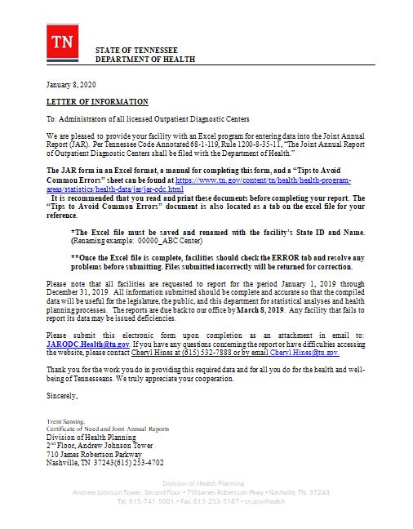
SECTION II
Rules and Regulations for Reporting

General Reporting Requirements
Per T. C. A. 1200-8-35-11 The Joint Annual Report of Outpatient Diagnostic Centers shall be filed with the department. The forms are furnished online to each Outpatient Diagnostic Center by the department each year and the forms must be completed and returned to the department as required.

All facilities are requested to report for the calendar year beginning January 1st through December 31st. Information should be complete and accurate as possible so that the compiled data will be useful for the legislature, the public and the department’s statistical analyses and health planning process.

Forty-five days after the facility gets the form from the department it needs to be completed. Any facility that fails to report its data could be issued deficiencies.

Data Editing and Quality Control

The department will review data submitted. Incomplete reports or inaccuracies will be queried. The facility will be asked to investigate these errors and to supply correct information within 15 working days of the date that the error is reported to the facility.

Data System Summary

Data Set Name: Outpatient Patient Diagnosis (ODC)

Location/Owner of Data Set: Tennessee Department of Health, Office of Health Statistics

Contact Person: Cheryl Hines (615) 532-7888 Email Address: Cheryl.Hines@tn.gov

Purpose for Which Data Collected: This system collects and compiles data that will be useful for the legislature, the public and the department’s statistical analysis and health planning process.

Process for Accessing Data: Requests for data are handled by Statistical Services. Contact Statistical Services at (615) 741-4939 or HealthStatistics.Health@tn.gov.

Description:
Method of Data Collection: JAR for ODC forms
Percent Return: 95% - 99%
Frequency of Updating: Annually
Years of Data: One
Types of Data Output Available: Excel format files
Cost for Data Output: No
Standard Reports Generated: ODC Joint Annual Reports

Timing and Frequency of Data Submission

All data submitted must be approved by the Department of Health. The Department of Health must receive all required data from the facility 45 days following the close of the calendar year.

Date Sent to Facility | Date Due to TDOH | Reporting Period
January 8, 2020 | March 9, 2020 | January 1^{st,} 2019  through  December 31, 2019

Data reported to the Department of Health should be e-mailed to:

Facilities

Office of Health Statistics

Andrew Johnson Tower

2nd Floor
710 James Robertson Boulevard

Nashville, Tennessee 37243

JARODC.Health@tn.gov

ODC JAR Contacts

Technical questions regarding the Tennessee Outpatient Diagnostic Center Joint Annual Reports should be directed to:

Cheryl Hines*
Division of Health Planning
Health Facilities
(615) 532-7888
Cheryl.Hines@ tn.gov

All other JAR inquiries should be referred to:
Trent Sansing
Division of Health Planning
Health Facilities
(615) 253-4702
Email to trent.sansing@tn.gov

SECTION III

Schedules

Schedule A – Identification | Facility | Required Fields - Yes

The State Identification number for all ODC facilities is found on the “State ID” sheet of the computer form. This information is protected and cannot be accessed. If the facility had a name change that is not reflected on this data base, please contact Facilities, TN Department of Health. See page 11 for all contact information.

Facility – State ID
The State ID is accessed from the “drop” box on the computer form. Once the State ID is selected, the Street Address, City, State, County, and Zip Code fields will automatically populate the form. This ID will automatically populate Schedule A through Administration Declaration.
DO NOT KEY in this field. Select the State ID from the “drop” box for this field.

Facility – Did the facility’s name change during the reporting period?
This is a Required Field and must be answered with “Yes” or “No”.
DO NOT KEY in this field. Make the selection from the “drop” box for this field.

If “Yes”, key in the facility’s Prior Name.

If “No”, leave blank.

Facility – Telephone
This is a 10 digit field. Key the telephone number starting with the area code, i.e. 1234567890. DO NOT use brackets or dashes. This field will automatically place the number in the telephone format (123) 456-7890.

Facility – Mailing Address same as Street Address?
This is a Required Field and must be answered with “Yes” or “No”. DO NOT KEY in this field. Make the selection from the “drop” box for this field.

If “Yes”, the Mailing Address, City, State and Zip Code will be automatically populated.

If “No”, manually key in the following information
Mailing Address – Put in the Mailing Address for the facility (P. O. Box, Street, etc.)
Mailing City – Put in the City for the facility
Mailing State – DO NOT KEY in this field. Make the selection from the “drop” box.
Mailing Zip Code – Put in the facility’s zip code. The 4 digit extension may also be added if available.

Schedule A – Identification (cont.) | Preparer | Required Fields - Yes
The person that prepared this form information should go here.

Preparer – Name
Enter in the name of the person who prepared the form.

Preparer – Title
Enter in the work title of the person who prepared the form i.e. Supervisor, etc.

Preparer – Phone
This is a 10 digit field. Enter the telephone number starting with the area code, i.e. 1234567890. DO NOT use brackets or dashes. This field will automatically place the number in the telephone format (123)456-7890.

Preparer – E-Mail Address
Enter in a valid work e-mail address of the person who prepared the “JAR” form.

Schedule A – Identification (cont.) | Reporting Period | Required Fields - Yes

In the event your organizations’ reporting period is different from that of our January 1st through December 31^{st,}, 2019 requested reporting period, due to your facility having newly opened or your facility having closed prior to December 31st; please provide the data including the actual beginning and ending dates for the period of time you are reporting for your facility.

Reporting Period – Is the Reporting Period from January 1st through December 31st of the year specified above?

This is a Required Field and must be answered with “Yes” or “No”. DO NOT KEY in this field. Make the selection from the “drop” box for this field.

If “Yes”, the Beginning and Ending date fields will be automatically populated.

If “No”, then key in the dates. The format for the Beginning and Ending date is MMDDYYYY.

*If the reporting year is contained within a Leap Year, please use 366 reporting days. Example the year 2012 was a Leap Year.

Schedule A – Identification (cont.) | Administration | Required Fields - Yes

Administration – Administrator’s Name
Put in Administrator’s Name of facility along with any title if present or applicable, i.e. RN, Dr., etc.
Administration – Medical Director’s Name
Enter in the Medical Director’s Name of facility along with any title if present or applicable, i.e. RN, Dr., etc.
Schedule B – Organization Structure | Owner | Required Fields – Yes

Owner – Name
Put in the owners’ complete Name (along with suffix if applicable).

Owner – Street
Put in the owner’s Street address. This may also include Apt. No., P. O. Box, etc.

Owner – City
Put in the owner’s City.

Owner –State

DO NOT KEY in this field. Make the selection from the “drop” box for this field.

Owner – Zip Code
Put in the owner’s zip code. The 4 digit extension may be added if available.

Owner – Telephone
This is a 10 digit field. Key the telephone number starting with the area code, i.e. 1234567890. Do not use brackets or dashes. This field will automatically place the number in the telephone format (123)456-7890.

Schedule B – Organization Structure (cont.) | Managed By | Required Fields – Yes

Select only one from this group. A “drop box” is provided to place an “X” beside the selection. If you choose one from this group DO NOT choose one from another group.

Management Provided By – Owner
Please give Management Name. No other information is required.

Management Provided By – Contract with Firm
Name – Put in Firm Name

Street – Put in Firm Street

City --– Put in Firm City

State – DO NOT KEY in this field. Make the selection from the “drop” box for this field.

Zip Code – Put in Firm 5 digit Zip Code. The 4 digit extension may also be given if available

Phone Number – This is a 10 digit field. Key the telephone number starting with the area code, i.e. 1234567890. This field will automatically place the number in the telephone format (123)456-7890.

Management Provided By – Other (Specify)
Name – Put in Other Name

Street – Put in Other Street

City --– Put in Other City

State – DO NOT KEY in this field. Make the selection from the “drop” box for this field.

Zip Code – Put in Other 5 digit Zip Code. The 4 digit extension may also be given if available

Phone Number – This is a 10 digit field. Key the telephone number starting with the area code, i.e. 1234567890. This field will automatically place the number in the telephone format (123)456-7890.

Schedule B – Organization Structure (cont.) | Building Owner | Required Fields – Yes

Building Owner – Name
Put in the building owners’ Name.

Building Owner – Street
Put in the building owner’s Street.

Building Owner – City
Put in the building owner’s City.

Building Owner – State

DO NOT KEY in this field. Make the selection from the “drop” box for this field.

Building Owner – Zip Code
Put in the owner’s zip code. The 4 digit extension may also be added if available.

Building Owner – Telephone
This is a 10 digit field. Key the telephone number starting with the area code, i.e. 1234567890. Do not use brackets or dashes. This field will automatically place the number in the telephone format (123)456-7890.

Schedule B – Organization Structure (cont.) | Building | Required Fields – Yes

Building – Do you know the year of the original Construction Date?

DO NOT KEY in this field. This is a Required Field and must be answered with “Yes” or “No”. Make the selection from the “drop” box.

If “Yes”, the Year must be keyed in. The format for Year is “YYYY”.

If “No”, leave blank.

Building – Has the building had a major renovation?
DO NOT KEY in this field. This is a Required Field and must be answered with “Yes” or “No”. Make the selection from the “drop” box.

If “Yes”, the Year must be keyed in. The format for Year is “YYYY”.

If “No”, leave blank.

Schedule B – Organization Structure (cont.) | Type of Facility | Required Fields – Yes

Please check Yes or No in each of the four types to describe your facility and include the information requested for that type.

Type of Facility – Free-Standing
DO NOT KEY in this field. This is a Required Field and must be answered with “Yes” or “No”. Make the selection from the “drop” box for this field. No other information is required.

Type of Facility – Hospital Based
DO NOT KEY in this field. This is a Required Field and must be answered with “Yes” or “No”. Make the selection from the “drop” box for this field.

If “Yes”, provide the Name, Street, City, State and Zip Code.
State: DO NOT KEY in this field. Make the selection from the “drop” box for this field.

If “No”, leave blank.

Type of Facility – Doctor’s Office
DO NOT KEY in this field. This is a Required Field and must be answered with “Yes” or “No”. Make the selection from the “drop” box for this field.

If “Yes”, provide the Name, Street, City, State and Zip Code.
State: DO NOT KEY in this field. Make the selection from the “drop” box for this field.

If “No”, leave blank.

Type of Facility – Other
DO NOT KEY in this field. This is a Required Field and must be answered with “Yes” or “No”. Make the selection from the “drop” box for this field.

If “Yes”, provide the Name, Street, City, State and Zip Code.
State: DO NOT KEY in this field. Make the selection from the “drop” box for this field.

If “No”, leave blank.

Schedule B – Organization Structure (cont.) | Type of Service | Required Fields – Yes

Type of Service – Multi-Specialty
DO NOT KEY in this field. This is a Required Field and must be answered with “Yes” or “No”. Make the selection from the “drop” box for this field. . No other information is required.

Type of Service – Limited-Purpose
DO NOT KEY in this field. This is a Required Field and must be answered with “Yes” or “No”. Make the selection from the “drop” box for this field. No other information is required.

Type of Service – Cancer Treatment and Radiation Clinic
DO NOT KEY in this field. This is a Required Field and must be answered with “Yes” or “No”. Make the selection from the “drop” box for this field. No other information is required.

Type of Service – Other, Specify*
DO NOT KEY in this field. This is a Required Field and must be answered with “Yes” or “No”. Make the selection from the “drop” box for this field.

*If “Yes”, please provide description of Type of Service.

*If “No”, leave blank.

Schedule C – Licensure, Certifications, Accreditation | Certifications | Required Fields – Yes

Certifications – Participation in TennCare
DO NOT KEY in this field. This is a Required Field and must be answered with “Yes” or “No”. Make the selection from the “drop” box for this field.

If “Yes”, enter the Provider Number.
If “No”, leave blank.

Certifications – Participation in Medicare
DO NOT KEY in this field. This is a Required Field and must be answered with “Yes” or “No”. Make the selection from the “drop” box for this field.

If “Yes”, enter the Provider Number.
If “No”, leave blank.

Schedule C – Licensure, Certifications, Accreditation (cont.) | Accreditation and Audits | Required Fields – Yes

Accreditation and Audits – Joint Commission on Accreditation of Healthcare Organizations (JCAHO)
DO NOT KEY in this field. This is a Required Field and must be answered with “Yes” or “No”. Make the selection from the “drop” box for this field.

If “Yes”, provide the Approval Year and Expiration Year. The format for Year is “YYYY”.
If “No”, leave blank.

Accreditation and Audits – Clinical Laboratory Improvement Amendments (CLIA)
DO NOT KEY in this field. This is a Required Field and must be answered with “Yes” or “No”. Make the selection from the “drop” box for this field.

If “Yes”, provide the Approval Year and Expiration Year. The format for Year is “YYYY”.
If “No”, leave blank.

Accreditation and Audits – Laboratory Proficiency Testing
DO NOT KEY in this field. This is a Required Field and must be answered with “Yes” or “No”. Make the selection from the “drop” box for this field.

If “Yes”, provide the Approval Year and Expiration Year. The format for Year is “YYYY”.
If “No”, leave blank.

Accreditation and Audits – American Association of Blood Banks (AABB)
DO NOT KEY in this field. This is a Required Field and must be answered with “Yes” or “No”. Make the selection from the “drop” box for this field.
If “Yes”, provide the Approval Year and Expiration Year. The format for Year is “YYYY”.
If “No”, leave blank.

Accreditation and Audits – American Osteopathic Association (AOA)
DO NOT KEY in this field. This is a Required Field and must be answered with “Yes” or “No”. Make the selection from the “drop” box for this field.

If “Yes”, provide the Approval Year and Expiration Year. The format for Year is “YYYY”.
If “No”, leave blank.

Schedule C – Licensure, Certifications, Accreditations (cont.) | Accreditation and Audits | Required Fields – Yes

Accreditation and Audits – College of American Pathologist (CAP)
DO NOT KEY in this field. This is a Required Field and must be answered with “Yes” or “No”. Make the selection from the “drop” box for this field.

If “Yes”, provide the Approval Year and Expiration Year. The format for Year is “YYYY”.
If “No”, leave blank.

Accreditation and Audits – American College of Radiology (ACR)
DO NOT KEY in this field. This is a Required Field and must be answered with “Yes” or “No”. Make the selection from the “drop” box for this field.

If “Yes”, provide the Approval Year and Expiration Year. The format for Year is “YYYY”.
If “No”, leave blank.

Accreditation and Audits – Other, Specify 1, 2, and 3.*
DO NOT KEY in this field. This is a Required Field and must be answered with “Yes” or “No”. Make the selection from the “drop” box for this field.

*If “Yes”, must specify other services in corresponding cell. Provide the Approval Year and Expiration Year. The format for Year is “YYYY”.
*If “No”, leave blank.

Schedule D –  Availability and Utilization of Svcs/Equip | Cardiopulmonary | Required Fields – Yes

Please provide information requested and indicate the number of patients and diagnostic procedures for those services during the reporting period. Number of patients may include duplicates because the same patient may receive several of the services listed. Mobile units are units regularly transported to your facility that are not installed for daily use. Do not report equipment, patients or procedures already reported on a hospital Joint Annual Report.

Cardiopulmonary Type of Service – Electroencephalogram (EEG)
DO NOT KEY in this field. This is a Required Field and must be answered with “Yes” or “No”. Make the selection from the “drop” box for this field. Enter number of Patients and Procedures.*
*DO NOT ENTER ZERO in these fields. Blank fields represent zero (0) for ALL fields.

Cardiopulmonary Type of Service – Electrocardiogram (EKG)
DO NOT KEY in this field. This is a Required Field and must be answered with “Yes” or “No”. Make the selection from the “drop” box for this field. Enter number of Patients and Procedures.*
*DO NOT ENTER ZERO in these fields. Blank fields represent zero (0) for ALL fields.

Cardiopulmonary Type of Service – Holter Monitoring
DO NOT KEY in this field. This is a Required Field and must be answered with “Yes” or “No”. Make the selection from the “drop” box for this field. Enter number of Patients and Procedures.*
*DO NOT ENTER ZERO in these fields. Blank fields represent zero (0) for ALL fields.

Cardiopulmonary Type of Service – Exercise Tolerance Testing
DO NOT KEY in this field. This is a Required Field and must be answered with “Yes” or “No”. Make the selection from the “drop” box for this field. Enter number of Patients and Procedures.*
*DO NOT ENTER ZERO in these fields. Blank fields represent zero (0) for ALL fields.

Cardiopulmonary Type of Service – Cardiac Catheterization
DO NOT KEY in this field. This is a Required Field and must be answered with “Yes” or “No”. Make the selection from the “drop” box for this field. Enter number of Patients and Procedures.*
*DO NOT ENTER ZERO in these fields. Blank fields represent zero (0) for ALL fields.

Schedule D –  Availability and Utilization of Svcs/Equip (cont.) | Cardiopulmonary | Required Fields – Yes

Cardiopulmonary Type of Service – Percutaneous Transiuminal Coronary Angioplasty
DO NOT KEY in this field. This is a Required Field and must be answered with “Yes” or “No”. Make the selection from the “drop” box for this field. Enter number of Patients and Procedures.*
*DO NOT ENTER ZERO in these fields. Blank fields represent zero (0) for ALL fields.

Schedule D –  Availability and Utilization of Services/Equip (cont.) | Radiology  Type of Service | Required Fields – Yes

Radiology Type of Service – Radiography (Diagnostic and Special Procedures-e.g. Angiography)
DO NOT KEY in this field. This is a Required Field and must be answered with “Yes” or “No”. Make the selection from the “drop” box for this field. Enter number of Patients and Procedures.*
*DO NOT ENTER ZERO in these fields. Blank fields represent zero (0) for ALL fields.

Radiology Type of Service – Ultrasound (General/Vascular/Cardiac)
DO NOT KEY in this field. This is a Required Field and must be answered with “Yes” or “No”. Make the selection from the “drop” box for this field. Enter number of Patients and Procedures.*
*DO NOT ENTER ZERO in these fields. Blank fields represent zero (0) for ALL fields.

Radiology Type of Service – Nuclear Medicine
DO NOT KEY in this field. This is a Required Field and must be answered with “Yes” or “No”. Make the selection from the “drop” box for this field. Enter number of Patients and Procedures.*
*DO NOT ENTER ZERO in these fields. Blank fields represent zero (0) for ALL fields.

Schedule D –  Availability and Utilization of Services/Equip (cont.) | Radiology  Type Equipment | Required Fields – Yes

Mobile units are units regularly transported to your facility that are not installed for daily use. Do not report equipment, patients or procedures already reported on a hospital Joint Annual Report.

Radiology Type of Equipment on Site –Position Emission Tomography (PET scan)
DO NOT KEY in this field. This is a Required Field and must be answered with “Yes” or “No”. Make the selection from the “drop” box for this field.
Enter Number of Units Fixed and/or Mobile. If Mobile, enter number of days. Enter number of Fixed plus Mobile Patients and/or Procedures.*
*DO NOT ENTER ZERO in these fields. Blank fields represent zero (0) for ALL fields.

Radiology Type of Equipment on Site – Computed Tomography (CT Scan)
DO NOT KEY in this field. This is a Required Field and must be answered with “Yes” or “No”. Make the selection from the “drop” box for this field.
Enter Number of Units Fixed and/or Mobile. If Mobile, enter number of days. Enter number of Fixed plus Mobile Patients and/or Procedures.*
*DO NOT ENTER ZERO in these fields. Blank fields represent zero (0) for ALL fields.

Radiology Type of Equipment on Site – Ultrafast CT
DO NOT KEY in this field. This is a Required Field and must be answered with “Yes” or “No”. Make the selection from the “drop” box for this field.
Enter Number of Units Fixed and/or Mobile. If Mobile, enter number of days. Enter number of Fixed plus Mobile Patients and/or Procedures.*
*DO NOT ENTER ZERO in these fields. Blank fields represent zero (0) for ALL fields.

Radiology Type of Equipment on Site – Magnetic Resonance Imaging (MRI)
DO NOT KEY in this field. This is a Required Field and must be answered with “Yes” or “No”. Make the selection from the “drop” box for this field.
Enter Number of Units Fixed and/or Mobile. If Mobile, enter number of days. Enter number of Fixed plus Mobile Patients and/or Procedures.*
*DO NOT ENTER ZERO in these fields. Blank fields represent zero (0) for ALL fields.

Radiology Type of Equipment on Site – Hi Field MRI and Open MRI
DO NOT KEY in this field. This is a Required Field and must be answered with “Yes” or “No”. Make the selection from the “drop” box for this field.
Enter Number of Units Fixed and/or Mobile. If Mobile, enter number of days. Enter number of Fixed plus Mobile Patients and/or Procedures.*
*DO NOT ENTER ZERO in these fields. Blank fields represent zero (0) for ALL fields.

Schedule D –  Availability and Utilization of Services/Equip (cont.) | Radiology  Type Equipment | Required Fields – Yes

Mobile units are units regularly transported to your facility that are not installed for daily use. Do not report equipment, patients or procedures already reported on a hospital Joint Annual Report. **

Radiology Type of Equipment on Site –Megavoltage Radiation Therapy
DO NOT KEY in this field. This is a Required Field and must be answered with “Yes” or “No”. Make the selection from the “drop” box for this field.
Enter Number of Units Fixed and/or Mobile. If Mobile, enter number of days. Enter number of Fixed plus Mobile Patients and/or Procedures.*

*DO NOT ENTER ZERO in these fields. Blank fields represent zero (0) for ALL fields.

Radiology Type of Equipment on Site –Stereotactic Procedure (including Breast Biopsy)**
DO NOT KEY in this field. This is a Required Field and must be answered with “Yes” or “No”. Make the selection from the “drop” box for this field.
Enter number of Fixed plus Mobile Patients and/or Procedures.*

*DO NOT ENTER ZERO in these fields. Blank fields represent zero (0) for ALL fields.

Radiology Type of Equipment on Site – Mammography**
DO NOT KEY in this field. This is a Required Field and must be answered with “Yes” or “No”. Make the selection from the “drop” box for this field.
Enter number of Fixed plus Mobile Patients and/or Procedures.*

*DO NOT ENTER ZERO in these fields. Blank fields represent zero (0) for ALL fields.

Schedule D –  Availability and Utilization of Services/Equip (cont.) | Other  Type of Service | Required Fields – Yes

Other Type of Service – Vascular Embolization
DO NOT KEY in this field. This is a Required Field and must be answered with “Yes” or “No”. Make the selection from the “drop” box for this field. Enter number of Patients and Procedures.*
*DO NOT ENTER ZERO in these fields. Blank fields represent zero (0) for ALL fields.

Other Type of Service – Anesthesia
DO NOT KEY in this field. This is a Required Field and must be answered with “Yes” or “No”. Make the selection from the “drop” box for this field. Enter number of Patients and Procedures.*
*DO NOT ENTER ZERO in these fields. Blank fields represent zero (0) for ALL fields.

Other Type of Service – Ultrasound (ACR Accredited Breast/Pelvic/OB)
DO NOT KEY in this field. This is a Required Field and must be answered with “Yes” or “No”. Make the selection from the “drop” box for this field.
Enter number of Patients and Procedures.*
*DO NOT ENTER ZERO in these fields. Blank fields represent zero (0) for ALL fields.

Other Type of Service – Chemotherapy
DO NOT KEY in this field. This is a Required Field and must be answered with “Yes” or “No”. Make the selection from the “drop” box for this field. Enter number of Patients and Procedures.*
*DO NOT ENTER ZERO in these fields. Blank fields represent zero (0) for ALL fields.

Schedule D –  Availability and Utilization of Svcs/Equip (cont.) | Other  Type Equipment | Required Fields – Yes

Mobile units are units regularly transported to your facility that are not installed for daily use. Do not report equipment, patients or procedures already reported on a hospital Joint Annual Report.

Other Type of Equipment on Site – Lithotripsy
DO NOT KEY in this field. This is a Required Field and must be answered with “Yes” or “No”. Make the selection from the “drop” box for this field.
Enter Number of Units Fixed and/or Mobile. If Mobile, enter number of days. Enter number of Fixed plus Mobile Patients and /or Procedures.*

*DO NOT ENTER ZERO in these fields. Blank fields represent zero (0) for ALL fields.

Other Type of Equipment on Site – Bone, Densitometry
DO NOT KEY in this field. This is a Required Field and must be answered with “Yes” or “No”. Make the selection from the “drop” box for this field.
If “Yes”, enter Number of Units Fixed and/or Mobile. If Mobile, enter number of days. Enter number of Fixed plus Mobile Patients and /or Procedures.*

*DO NOT ENTER ZERO in these fields. Blank fields represent zero (0) for ALL fields.

Other Type of Equipment on Site – Other, Specify
DO NOT KEY in this field. This is a Required Field and must be answered with “Yes” or “No”. Make the selection from the “drop” box for this field.
If “Yes”, provide Other description for Type of Service. Enter Number of Units Fixed and/or Mobile. If Mobile, enter number of days. Enter number of Fixed plus Mobile Patients and /or Procedures. Procedures must equal or exceed number of Patients.*

*DO NOT ENTER ZERO in these fields. Blank fields represent zero (0) for ALL fields.

Schedule D –  Availability and Utilization of Svcs/Equip (cont.) | Total and Rooms | Required Fields – Yes

Total – Number of patients and diagnostic procedures during this reporting period.
DO NOT KEY in this field. This field is cumulative of the Cardiopulmonary, Radiology, and Other field of patients and diagnostic procedures.

Total – Unduplicated patients***
This is a Required Field. The number of actual individuals served during the reporting period. This may be less than the number of patients and diagnostic procedures reported. DO NOT ENTER ZERO in this field. Blank fields represent zero patients and/or procedures.

***This count must MATCH Total Patients Served. See page 34.
Rooms – Number of Diagnostic Procedure rooms
This is a Required Field and must be answered.

Schedule E –Patient Characteristics | Number of Patients Served | Required Fields – Yes

Number of Patients Served By Age – Gender
DO NOT ENTER ZERO in these fields. Provide Age by Gender information. Blank fields represent zero patients.

Number of Patients Served By Age – Race
DO NOT ENTER ZERO in these fields. Provide Age by Race information. Blank fields represent zero patients.

Number of Patients Served - Total Patients Served***
This is a calculated field of Patient Age by Gender and Race. Patients by Gender must equal to Patients by Race for each Age group represented.

Schedule E –  Patient Characteristics (cont.) | Number of Patients TN Origin | Required Fields – Yes

Number of Patients Served – Tennessee Patients
DO NOT ENTER ZERO in these fields. Please record the number of Tennessee patients who received services during the reporting period in the corresponding county cells. Blank fields represent zero patients.

Number of Patients Served – Total Tennessee Patients
This is a calculated field. The number “0” will automatically appear in the corresponding cell until data is placed in the patient county cells.

Schedule E –  Patient Characteristics (cont.) | Number of Patients Out of State Origin | Required Fields – Yes

Number of Patients Served – Out-of-state & Other State or Country Patients
DO NOT ENTER ZERO in these fields. Please record the number of Out-of-state and or Other State/Country patients who received services during the reporting period in the corresponding cells. Blank fields will represent zero patients.

Number of Patients Served – Total Non-Tennessee Patients
This is a calculated field. The number “0” will automatically appear in the corresponding cell until data is placed in the Out-of-state and or Other State/Country fields.

Number of Patients Served – Total Tennessee and Non-Tennessee Patients****
This is a cumulative calculated field. The number “0” will automatically appear in the corresponding cell until data is placed in the County, Out-of-state, and Other State or Country fields.

****This total must equal the Total Patients Served field in Schedule E

Schedule F –Financial Data | Expenses | Required Fields – Yes

Expenses – Payroll
Include salaries for all full-time and part-time personnel who are included in Schedule G.
This is a required field. Data must be placed in this field. This field will accept zero (0).

Expenses – Fringe Benefits
Social Security, group insurance, retirement benefits, etc.
This is a required field. Data must be placed in this field. This field will accept zero (0).

Expenses – Other Operating Expenses
These are expenses for all contract staff, professional fees, energy expense (oil, natural gas, electricity, etc.) and all other operating expenses.
This is a required field. Data must be placed in this field. This field will accept zero (0).

Expenses – Depreciation Expense
This is a required field. Data must be placed in this field. This field will accept zero (0).

Expenses – Non-Operating Expenses
Include all other expenses for interest, taxes, real estate ease expenses, and other non-operating expenses.
This is a required field. Data must be placed in this field. This field will accept zero (0).

Schedule F –Financial Data | Patient Revenue | Required Fields – Yes

Government – Gross Patient Charges
This is the sum of the facility’s established rate for all services rendered to patients during the reporting year. Show the revenue source from Medicare, TennCare, and Other Government.
This is a required field. If there are no transactions enter zero (0).

Government – Adjustment to Charges
The difference between the gross patient charges and the actual amount of payment received by the facility during the reporting period should be reported here. Adjustments to previous year’s revenue (Medicare or TennCare) should be reported as non-operating revenue, not as current year adjustments.
Show the revenue source from Medicare, TennCare, and Other Government.
This is a required field. If there are no transactions enter zero (0).

Government – Total Government Gross Patient Charges and Adjustment to Charges
This is a cumulative calculated field of Gross Patient Charges and Adjustment to Charges field. The number “0” will automatically appear in this cell until an amount is placed in these fields.

Non-Government – Gross Patient Charges
This is the sum of the facility’s established rate for all services rendered to patients during the reporting year. Show the charges are from “Self-Pay”, Insurance, Other Non-Government.
This is a required field. If there are no transactions enter zero (0).

Non-Government Revenue Source – Adjustment to Charges
The difference between the gross patient charges and the actual amount of payment received by the facility during the reporting period should be reported here. Adjustments to previous year’s revenue (Medicare or TennCare) should be reported as non-operating revenue, not as current year adjustments.
Show the charges are from “Self-Pay”, Insurance, Other Non-Government.
This is a required field. If there are no transactions enter zero (0).

Non-Government Revenue Source – Total Non-Government
This is a cumulative calculated field of the Non-Government Gross Patient Charges and Non-Government Adjustment to Charges fields. The number “0” will automatically appear in this cell until an amount is placed in these fields.

Patient Revenue – Total Patient Revenue
This is a cumulative calculated field. The number “0” will automatically appear in this cell and sums the amounts in the Total Government plus Total Non-Government cells.

Schedule F –Financial Data (cont.) | Patient Revenue | Required Fields – Yes

Patient Revenue – All Non-Patient Revenue
This is a required field. Data must be placed in this field. If there are no transactions enter zero (0).

Patient Revenue – Net Patient Revenue
This is a calculated field. The difference obtained by subtracting Adjustments to Charges from Gross Patient Charges. This difference represents the actual amount of revenue that the facility received.

Patient Revenue – Total Net Revenue: Net Total Patient Revenue plus All Non-Patient Revenue
This is a calculated field. This is the sum of the Total patient Revenue plus All Non-Patient Revenue.

Schedule F –Financial Data (cont.) | Non-Government Adjustment | Required Fields – Yes

Non-Government Adjustment – Bad Debt
Uncompensated care for which the facility directly billed the patient and for which the patient should reasonably be expected to pay.
This is a required field. If there are no transactions enter zero (0).

Non-Government Adjustment – Charity Care
Services provided to medically needy persons for which the facility does not expect payment.
This is a required field. If there are no transactions enter zero (0).

Non-Government Adjustment – Other
Any other adjustments that are not appropriately reported in either Bad Debt or Charity
This is a required field. If there are no transactions enter zero (0).

Non-Government Adjustment –Total Non-Government Adjustment to Charges Subcategories
This is a cumulative calculated field. The number “0” will automatically appear in this cell and sums the amounts in the Bad Debt, Charity Care, and Other cells.

Schedule G – Personnel | Type of Personnel by Service | Required Fields – Yes

Please indicate the number of paid personnel as of the last day of reporting period. Do not include a type of personnel for which you do not provide that type of service. For example, do not include Physical Therapist unless you provide Physical Therapy Services.

Full Time Equivalent (FTE)
Part-time is the Number of hours worked by part-time employees per week/40.
Example: Three Registered Nurses, each working 20 hours a week, the FTE would be (3X20)/40=1.5.

Additional Example of FTE
40 Hours = 1.00
30 Hours = .75
20 Hours = .50
10 Hours = .25

For the purpose of this calculation if your agency reimburses employees per visit rather than per hour worked, one visit equals one hour in FTE.

The sum of full-time personnel plus part time personnel (in full-time equivalents) added together equals the total number of full-time equivalents.

Type Administrators – Employee and Contract – Full-Time / Part-Time
Use the formula for FTE to determine number of persons that represent each column. Full-time is represented in whole numbers. Part-Time is represented in numbers with two decimal points in FTE. Leave the item BLANK if the value is unknown or zero (0).

Type Medical Director – Employee and Contract – Full-Time / Part-Time
Use the formula for FTE to determine number of persons that represent each column. Full-time is represented in whole numbers. Part-Time is represented in numbers with two decimal points in FTE. Leave the item BLANK if the value is unknown or zero (0).

Type Physicians (M.D. and D. O.) – Employee and Contract – Full-Time / Part-Time
Use the formula for FTE to determine number of persons that represent each column. Full-time is represented in whole numbers. Part-Time is represented in numbers with two decimal points in FTE. Leave the item BLANK if the value is unknown or zero (0).

Type Dentist – Employee and Contract – Full-Time / Part-Time
Use the formula for FTE to determine number of persons that represent each column. Full-time is represented in whole numbers. Part-Time is represented in numbers with two decimal points in FTE. Leave the item BLANK if the value is unknown or zero (0).

Schedule G – Personnel (cont.) | Type of Personnel by Service | Required Fields – Yes

Type Financial/Billing Personnel – Employee and Contract – Full-Time / Part-Time
Use the formula for FTE to determine number of persons that represent each column. Full-time is represented in whole numbers. Part-Time is represented in numbers with two decimal points in FTE. Leave the item BLANK if the value is unknown or zero (0).

Type Nursing (R.N., L.P.N., and Ancillary) – Employee and Contract – Full-Time / Part-Time
Use the formula for FTE to determine number of persons that represent each column. Full-time is represented in whole numbers. Part-Time is represented in numbers with two decimal points in FTE. Leave the item BLANK if the value is unknown or zero (0).

Type Medical Records – Employee and Contract – Full-Time / Part-Time
Use the formula for FTE to determine number of persons that represent each column. Full-time is represented in whole numbers. Part-Time is represented in numbers with two decimal points in FTE. Leave the item BLANK if the value is unknown or zero (0).

Type Registered Technologist – Employee and Contract – Full-Time / Part-Time
Use the formula for FTE to determine number of persons that represent each column. Full-time is represented in whole numbers. Part-Time is represented in numbers with two decimal points in FTE. Leave the item BLANK if the value is unknown or zero (0).

Type Technical – Employee and Contract – Full-Time / Part-Time
Use the formula for FTE to determine number of persons that represent each column. Full-time is represented in whole numbers. Part-Time is represented in numbers with two decimal points in FTE. Leave the item BLANK if the value is unknown or zero (0).

Type Maintenance/Services – Employee and Contract – Full-Time / Part-Time
Use the formula for FTE to determine number of persons that represent each column. Full-time is represented in whole numbers. Part-Time is represented in numbers with two decimal points in FTE. Leave the item BLANK if the value is unknown or zero (0).

Schedule G – Personnel (cont.) | Type of Personnel by Service | Required Fields – Yes

Type Other 1, 2, and 3 Specify – Employee and Contract – Full-Time / Part-Time
Supply name of other service if indicated. Use the formula for FTE to determine number of persons that represent each column. Full-time is represented in whole numbers. Part-Time is represented in numbers with two decimal points in FTE. Leave the item BLANK if the value is unknown or zero (0).

Type – Total Number of Personnel by Type
This is a cumulative calculated field. The number “0” will automatically appear in this cell and sums the amounts in the Employee Full-Time, Employee Part-Time, Contract Full-Time, and Contract Part-Time cells separately.

Schedule G – Personnel (cont.) | Nursing Personnel – RN | Required Fields – Yes

Please indicate the number of personnel as of the last day of the reporting period.

Registered Nurses – Highest Education Level – Number Currently Employed
Associate, Diploma, Bachelors, Masters, and Doctorate: Indicate number of personnel as of the last day of reporting period. DO NOT enter zero (0). Blank field represents zero (0) personnel.

Registered Nurses – Highest Education Level – Number of Budgeted Vacancies
Associate, Diploma, Bachelors, Masters, and Doctorate: Indicate number of personnel as of the last day of reporting period. DO NOT enter zero (0). Blank field represents zero (0) personnel.

Registered Nurses – Highest Education Level – Average Number of Weeks Required to Recruit Staff
Associate, Diploma, Bachelors, Masters, and Doctorate: Indicate number of personnel as of the last day of reporting period. DO NOT enter zero (0). Blank field represents zero (0) personnel.
Registered Nurses – Highest Education Level – Number Added in Past 12 Months
Associate, Diploma, Bachelors, Masters, and Doctorate: Indicate number of personnel as of the last day of reporting period. DO NOT enter zero (0). Blank field represents zero (0) personnel.

Registered Nurses – Highest Education Level – Number Eliminated in Past 12 Months
Associate, Diploma, Bachelors, Masters, and Doctorate employed in Clinical and Administration: Indicate number of personnel as of the last day of reporting period. DO NOT enter zero (0). Blank field represents zero (0) personnel.

Registered Nurses – Highest Education Level – Total
This is a cumulative calculated field. The number “0” will automatically appear in this cell and sums the amounts in the Number Currently Employed, Number Budgeted Vacancies, Number Added in Past 12 Months, and Number Eliminated in Past 12 Months (Clinical and Administrative) cells separately.

Schedule G – Personnel (cont.) | Nursing Personnel – Advanced | Required Fields – Yes

Please indicate the number of personnel as of the last day of the reporting period.

Advanced Practical Nurses – Category – Number Currently Employed
Nurse Practitioner, Clinical Nurse Specialist, and Certified Registered Nurse Anesthetist: Indicate number of personnel as of the last day of reporting period. DO NOT enter zero (0). Blank field represents zero (0) personnel.

Advanced Practical Nurses – Category – Number of Budgeted Vacancies
Nurse Practitioner, Clinical Nurse Specialist, and Certified Registered Nurse Anesthetist: Indicate number of personnel as of the last day of reporting period. DO NOT enter zero (0). Blank field represents zero (0) personnel.

Advanced Practical Nurses – Category – Average Number of Weeks Required to Recruit Staff
Nurse Practitioner, Clinical Nurse Specialist, and Certified Registered Nurse Anesthetist: Indicate number of personnel as of the last day of reporting period. DO NOT enter zero (0). Blank field represents zero (0) personnel.

Advanced Practical Nurses – Category – Number Added in Past 12 Months
Nurse Practitioner, Clinical Nurse Specialist, and Certified Registered Nurse Anesthetist: Indicate number of personnel as of the last day of reporting period. DO NOT enter zero (0). Blank field represents zero (0) personnel.

Advanced Practical Nurses – Category – Number Eliminated in Past 12 Months
Nurse Practitioner, Clinical Nurse Specialist, and Certified Registered Nurse Anesthetist employed in Clinical and Administration: Indicate number of personnel as of the last day of reporting period. DO NOT enter zero (0). Blank field represents zero (0) personnel.

Advanced Practical Nurses – Category – Total
This is a cumulative calculated field. The number “0” will automatically appear in this cell and sums the amounts in the Nurse Practitioner, Clinical Nurse Specialist, and Certified Registered Nurse Anesthetist employed in Number Added in Past 12 Months and Number Eliminated in Past 12 Months (Clinical and Administrative) cells separately.

Schedule G – Personnel (cont.) | Nursing Personnel – Other | Required Fields – Yes

Please indicate the number of personnel as of the last day of the reporting period.

Other Nurses – Other Nursing Staff – Number Currently Employed
Licensed Practical Nurses, Certified Nurses’ Aides, Other 1, Specify, Other 2, Specify: Indicate number of personnel as of the last day of reporting period. If data is given for Other 1 or 2, please describe the Other Nursing Staff for that field. DO NOT enter zero (0). Blank field represents zero (0) personnel.

Other Nurses – Other Nursing Staff – Number of Budgeted Vacancies
Licensed Practical Nurses, Certified Nurses’ Aides, Other 1, Specify, Other 2, Specify: Indicate number of personnel as of the last day of reporting period. If data is given for Other 1 or 2, please describe the Other Nursing Staff for that field. DO NOT enter zero (0). Blank field represents zero (0) personnel.

Other Nurses – Other Nursing Staff – Average Number of Weeks Required to Recruit Staff
Licensed Practical Nurses, Certified Nurses’ Aides, Other 1, Specify, Other 2,Specify: Indicate number of personnel as of the last day of reporting period. If data is given for Other 1 or 2, please describe the Other Nursing Staff for that field. DO NOT enter zero (0). Blank field represents zero (0) personnel.

Other Nurses – Other Nursing Staff – Number Added in Past 12 Months
Licensed Practical Nurses, Certified Nurses’ Aides, Other 1, Specify, Other 2, Specify: Indicate number of personnel as of the last day of reporting period. If data is given for Other 1 or 2, please describe the Other Nursing Staff for that field. DO NOT enter zero (0). Blank field represents zero (0) personnel.

Other Nurses – Other Nursing Staff – Number Eliminated in Past 12 Months
Licensed Practical Nurses, Certified Nurses’ Aides, Other 1, Specify, Other 2, Specify: Indicate number of personnel as of the last day of reporting period. If data is given for Other 1 or 2, please describe the Other Nursing Staff for that field. DO NOT enter zero (0). Blank field represents zero (0) personnel.

Schedule G – Personnel (cont.) | Nursing Personnel – Contract | Required Fields – Yes

Please indicate the number of personnel as of the last day of the reporting period.

Contract Nursing – Does your organization use contract nursing personnel?
This is a Required Field and must be answered with “Yes” or “No”. DO NOT KEY in this field. Make the selection from the “drop” box for this field.

If “Yes”, indicate the number of contract personnel in the categories below.
If “No”, continue to the next schedule. Leave fields blank.

Contract Nursing – Number Currently Employed
Registered Nurses, Licensed Practical Nurses, and Certified Nurses’ Aides: Indicate number of personnel as of the last day of reporting period. DO NOT enter zero (0). Blank field represents zero (0) personnel.

Contract Nursing – Number of Budgeted Vacancies
Registered Nurses, Licensed Practical Nurses, and Certified Nurses’ Aides: Indicate number of personnel as of the last day of reporting period. DO NOT enter zero (0). Blank field represents zero (0) personnel.

Contract Nursing – Average Number of Weeks Required to Recruit Staff
Registered Nurses, Licensed Practical Nurses, and Certified Nurses’ Aides: Indicate number of personnel as of the last day of reporting period. DO NOT enter zero (0). Blank field represents zero (0) personnel.

Contract Nursing – Number Added in Past 12 Months
Registered Nurses, Licensed Practical Nurses, and Certified Nurses’ Aides: Indicate number of personnel as of the last day of reporting period. DO NOT enter zero (0). Blank field represents zero (0) personnel.

Contract Nursing – Number Eliminated in Past 12 Months
Registered Nurses, Licensed Practical Nurses, and Certified Nurses’ Aides: Indicate number of personnel as of the last day of reporting period. DO NOT enter zero (0). Blank field represents zero (0) personnel.

Schedule H – Personnel | Medical Staff | Required Fields – Yes

Please include all physicians, whether considered active or associate.
Active: Employed and practicing at the facility.
Associate: Has privileges to practice at the facility but is not employed at the facility.

Medical Staff – Specialty – Total number of Medical Staff
Cardiologist, Neurologist, Pathologist, Radiologist, Technician, Other 1 (specify), Other 2 (specify): Indicate number of medical staff as of the last day of reporting. If data is given for Other 1 or 2, please describe the Other Medical Staff for that field. DO NOT enter zero (0). Blank field represents zero (0) personnel.

Medical Staff – Specialty – Number of Medical Staff who are Board Certified
Cardiologist, Neurologist, Pathologist, Radiologist, Technician, Other 1 (specify), Other 2 (specify): Indicate number of medical staff as of the last day of reporting. If data is given for Other 1 or 2, please describe the Other Medical Staff for that field. Indicate number of personnel as of the last day of reporting period. DO NOT enter zero (0). Blank field represents zero (0) personnel.

Schedule Adm. Dec. – Administrator’s Declaration | Administrator’s Declaration | Required Fields – Yes

Administrator Declaration – “I, the administrator, declare that I have examined this report and to the best of my knowledge and belief, it is true, correct, and complete.”

This is a Required Field and must be answered with “Yes” or “No”. DO NOT KEY in this field. Make the selection from the “drop” box for this field.
If the answer is “Yes”, then key the date acknowledged. The format is MM/DD/YYYY.

Appendix

“Saving your Joint Annual Report Form”

Go to the JAR ODC Website: https://www.tn.gov/content/tn/health/health-program-areas/statistics/health-data/jar/jar-odc.html

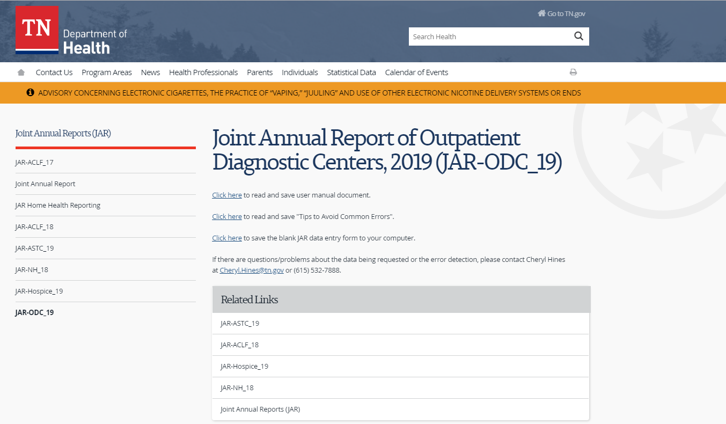

“Saving your Joint Annual Report Form”

- Select: Click here to save the Blank “JAR” data entry form to your computer.

“Saving your Joint Annual Report Form”

- Select File: SAVE AS from your menu bar:

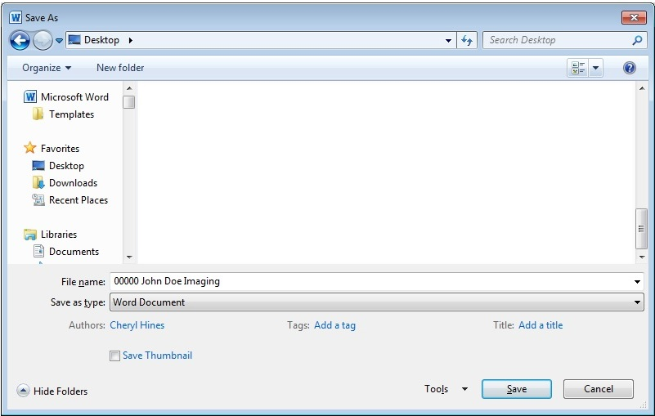
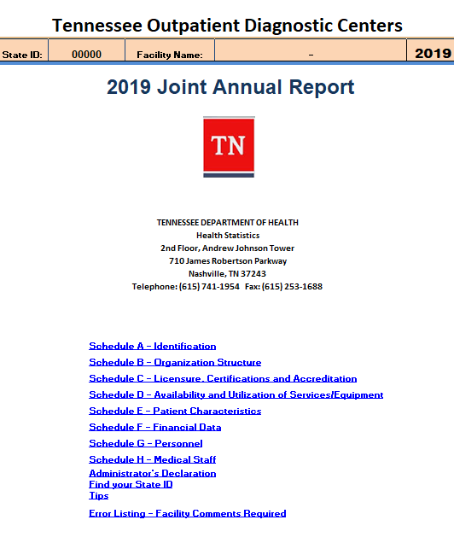

“Saving your Joint Annual Report Form”

- NAME your Joint Annual Report “JAR” Files as:

Example: 00000 John Doe Imaging

State ID Number Your Facility Name
“Saving your Joint Annual Report Form”

- After having downloaded, saved and completed your facility’s ODC Joint Annual Report “JAR” Form. It is time to EMAIL an attached copy of the completed form to the below email address:

EMAIL TO: JARODC.health@tn.gov

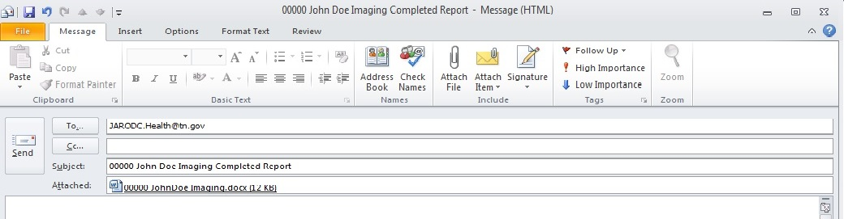

Please include your saved attached file named as:

Example: 00000 John Doe Imaging

State ID Number Your Facility Name

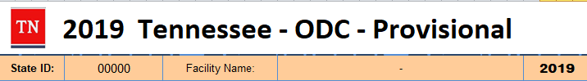
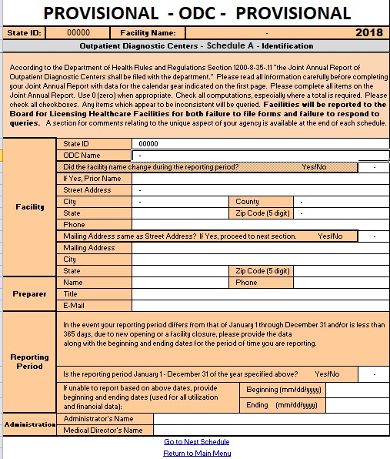

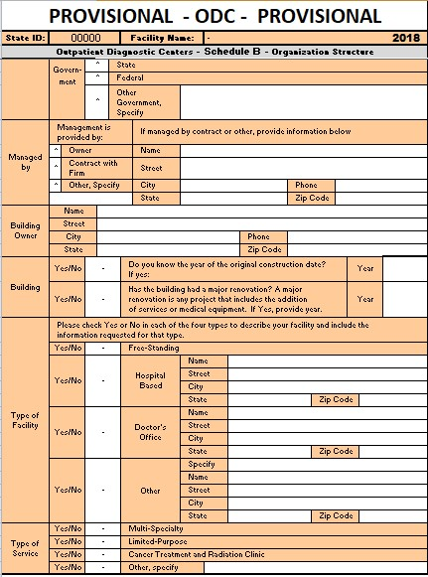
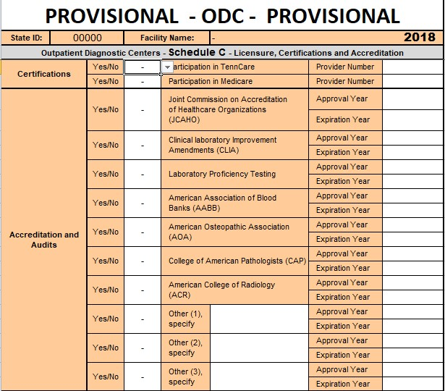
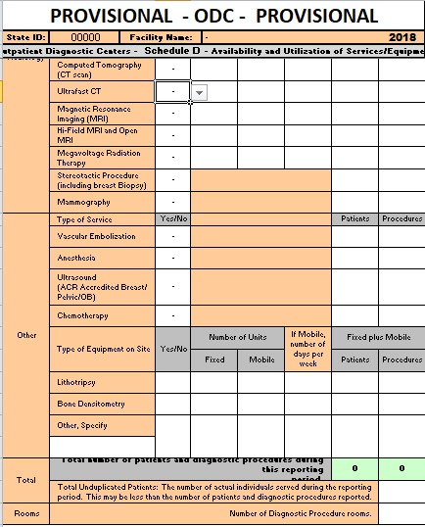
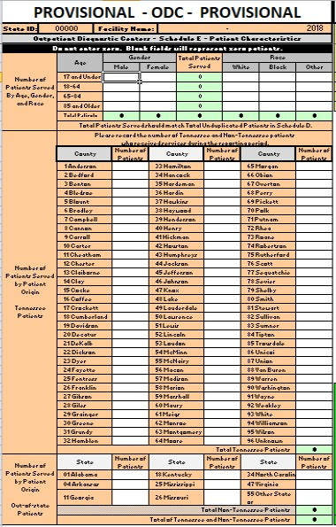
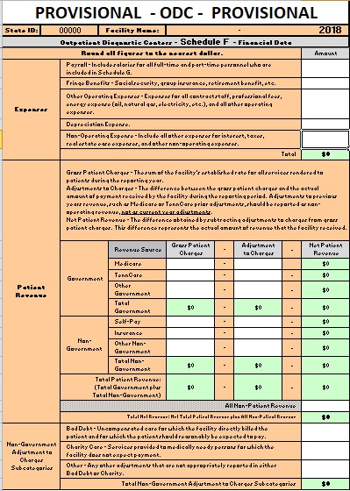

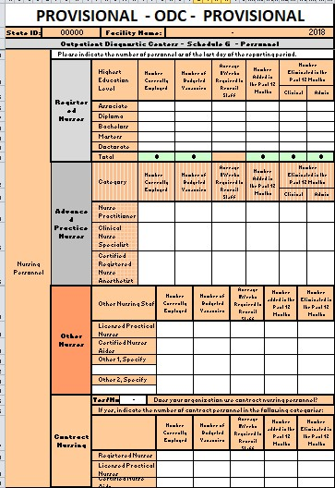
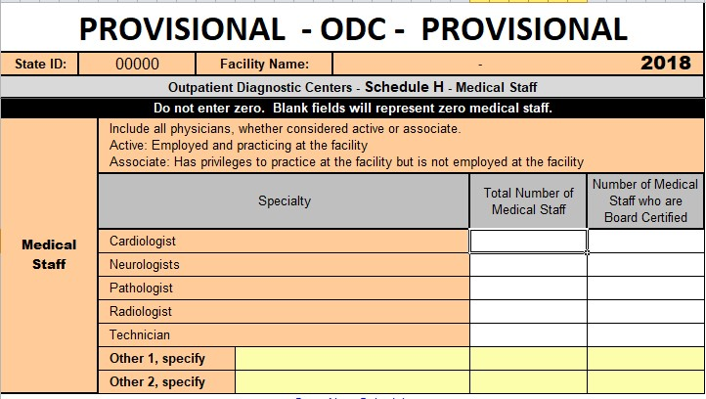
A

1

Error Listing
2
3
Worksheet

6

4
5

- State ID from Schedule A will be populated by the system in column A of the Error Listing worksheet for each error question in the JAR.
- Error message (Ok or Error) will be populated by the system from each error in all schedules.
- Error message color will match on the schedule and in the Error Listing worksheet. A more detailed explanation of the error is in the Error Listing worksheet.

Printing continued

- This is a hyperlink which should return you to the schedule containing the actual error. The cell you are returned to will be the first possible cell where the error may reside; however, this cell may not contain actual the error in question but only reference the error relating cell.

- Error Number is an address/location of each individual error.
The format for the error number A-01-02, A represents the schedule in this example A. 01 represents the first column of errors starting in column “AL”. 02 represent the error number for the column in order from top to bottom.

- Error Comment is used to provide an explanation of why the data of each individual listed error should not be considered a justifiable error.

Joint Annual Report of Outpatient Diagnostic Centers
2019 Tips to Avoid Common Errors

The following guidelines are written to assist you to complete the Joint Annual Report for the Outpatient Diagnostic Center 2019 reporting year.

A User Manual can be found on the website
https://www.tn.gov/content/tn/health/health-program-areas/statistics/health-data/jar/jar-odc.html
Please read all information carefully before completing your Joint Annual Report. Keep the manual and these tips handy as you will need them to fill out the form and export the data. For your reference, this Tips document is also included as a Tab on the Excel data entry form.

B. Please complete all items on the report form.
(1) Use 0 (zero) when appropriate rather than leaving the item blank.
(2) Please select the appropriate answer to all (Yes / No) questions.
(3) Check all computations, especially where a total is required.
(4) Corporate offices that do data entry for several facilities must close out
between each facility to avoid system generated errors. It is requested that
you work on one (1) facility at a time.

(5) In the event that a reporting period other than January1 through December 31
is used by your facility for statistical information, please report that data
including the actual beginning and ending dates of your facilities’ reporting period.

C. Any item which appears to be inconsistent will be queried. Report forms with items left blank
will not be acceptable. The Tennessee Department of Health’s Bureau of Health
Licensure and Regulation may issue deficiencies for either failing to file forms
or submission of incomplete forms.

SCHEDULE A – IDENTIFICATION
Facility

State ID: Select your State ID from the drop down list first. Facility name and address are filled in automatically, unless there is a name change in which case your facility’s new name and your facility’s
new address has to be typed in manually.

Reporting Period: All facilities are requested to report data based on the twelve month period for the calendar year. If reporting period is January 1, 2019 through December 31, 2019 leave date lines blank.

Use Proper Case and not ALL CAPS in Schedule A; such as facility name, address, and city.

Please fill in the e-mail address of the preparer of your facility’s report, so that we may use this address as a means of initial contact.

SCHEDULE B – ORGANIZATION STRUCTURE
Owner Type

Please place an “X” in only one block of the For Profit, Not for Profit or Government Section.

SCHEDULE C – LICENSURE, CERTIFICATIONS AND ACCREDITATION

Please fill in provider numbers. The data field for year of accreditation/audit takes only the four digit year. Do not put in a complete date. Answer all Yes/No questions.

SCHEDULE D – AVAILABILITY AND UTILIZATION OF SERVICES/EQUIPMENT
Fill in the number of patients and diagnostic procedures and number of fixed and mobile units as well as number of days per week for mobile. The total unduplicated patients on this schedule should match the total patients by age, gender, and race in Schedule E.

