Region | Victims | Population Estimates | Rates
SHELBY | 1,104 | 939,452 | 117.5
DAVIDSON | 1,017 | 658,598 | 154.4
MID CUMBERLAND | 868 | 1,159,759 | 74.8
EAST TN | 448 | 751,199 | 59.6
WEST | 432 | 534,395 | 80.8
KNOX | 301 | 444,624 | 67.7
SOUTH CENTRAL | 294 | 385,889 | 76.2
HAMILTON | 219 | 348,669 | 62.8
UPPER CUMBERLAND | 201 | 341,785 | 58.8
SULLIVAN | 187 | 156,599 | 119.4
SOUTHEAST | 185 | 325,516 | 56.8
NORTHEAST | 184 | 350,654 | 52.5
MADISON | 104 | 98,727 | 105.3
TENNESSEE | 5,544 | 6,495,866 | 85.3
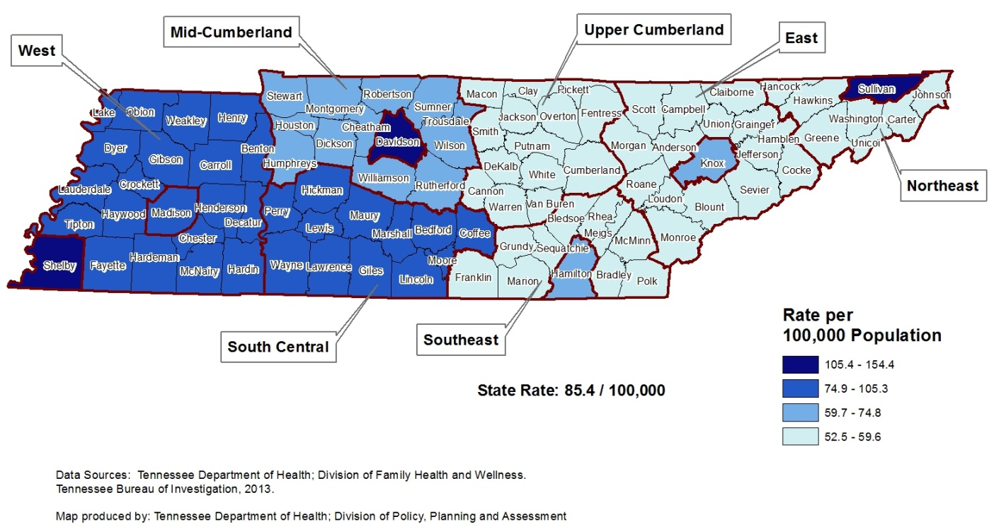
¹Excludes victims (n=4) who had missing regional information.
Data Sources:
Tennessee Bureau of Investigations, Tennessee Incident Based Reporting System (TIBRS), 2013; U.S. Census Bureau
Table 1: Sexual Assault Victim Numbers¹ and Crude Rates per 100,000 Persons by Region, 2013

Tennessee Regional Sexual Assault Data Report, 2013
Race¹ | Victims | Population Estimate | Rate | Relative Rate
White | 3,763 | 5,139,373 | 73.22
Black | 1,656 | 1,107,069 | 149.58 | 2.04*
Other | 37 | 249,424 | 14.83 | 0.20*
Gender² | Victims | Population Estimate | Rate | Relative Rate
Male | 719 | 3,167,029 | 22.7
Female | 4,815 | 3,328,837 | 144.65 | 6.37*
Age³ | Victims | Population Estimate | Rate | Relative Rate
Under 10 | 1,128 | 817,654 | 137.96 | 1.85*
10-13 | 909 | 338,383 | 268.63 | 3.60*
14-17 | 1,476 | 332,939 | 443.32 | 5.94*
18-24 | 788 | 632,547 | 124.58 | 1.67*
25-34 | 632 | 846,326 | 74.68
35-44 | 323 | 841,477 | 38.38 | 0.51*
45-54 | 177 | 902,025 | 19.62 | 0.26*
55-64 | 55 | 832,203 | 6.61 | 0.09*
65 and over | 34 | 952,312 | 3.57 | 0.05*
Table 2: Sexual Assault Victim Number and Rates by Race, Gender and Age, 2013
* Excludes victims who were missing regional information (n=4).

¹Excludes victims (n=92) who had missing race information.
²Excludes victims (n=14) who had missing gender information.
³Excludes victims (n=26) who had missing age information.
* Relative Rate is statistically significant at p<.05 level.

INTRODUCTION:
Sexual Assaults are tracked by the Tennessee Bureau of Investigation (TBI) and are identified as cases involving victims who meet the categories of Forcible Rape, Forcible Sodomy, Sexual Assault with an Object, Forcible Fondling, Incest, or Statutory Rape.

ABOUT THE VICTIMS:
- In 2013, a total of 5,548 persons were recognized as Sexual Assault victims in Tennessee.
- African Americans were twice as likely to be sexually assaulted compared to Whites in 2013.
- Females were more than six times as likely to be sexually assaulted compared to Males in 2013.
- Children under 10 were 85% more likely to be sexually assaulted compared to adults 25-34 in 2013.
- 14-17 year olds were almost six times as likely to be sexually assaulted compared to adults 25-34 in 2013.

REGIONAL DISTRIBUTION:
- Davidson County had the highest rate of victims in 2013 at 154.4 per 100,000 population.
- North East Tennessee had the lowest rate of victims in 2013 at 52.5 per 100,000 population.
- Shelby County had the highest number of victims at 1,104 in 2013.
- Madison County had the lowest number of victims at 104 in 2013.
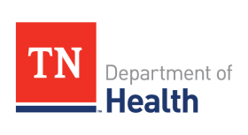
Data Sources:
Tennessee Bureau of Investigations, Tennessee Incident Based Reporting System (TIBRS), 2013;
U.S. Census Bureau

