The Tennessee Open Meetings Act passed by the General Assembly in 1974 requires that meetings of state, city and county government bodies be open to the public and that any such governmental body give adequate public notice of such meeting.

TENNESSEE DEPARTMENT OF HEALTH
MEMORANDUM

Date: October 23, 2015

To: Shelley Walker, Director of Communications and Media Relations
Stephania Willeby, Commissioner Office
Michelle Long, Assistant Commissioner,
Bureau of Health Licensure and Regulation

From: Donna G. Tidwell, Director of Emergency Medical Service

Name of Board or Committee: Electronic Emergency Medical Services Board

Date of Meeting: November 24th, 2015

Time: 10:00 a.m. Central Time

Place: Iris Board Room, First Floor
665 Mainstream Drive
Nashville, TN 37243

Major Item(s) on Agenda: See Attached Agenda

Link to Live Video Stream:
https://web.nowuseeit.tn.gov/Mediasite/Play/797604c8cb25403aa6b92e67b33d82d91d

This memo shall be forwarded from individual programs to the Public Information Office on the 15th day of the preceding month. The Public Information Office will prepare the monthly list of meetings within the Department and have ready for distribution to state media by the 28th day of the preceding month.

PH-1850 (Rev. 3/79) RDA N/A

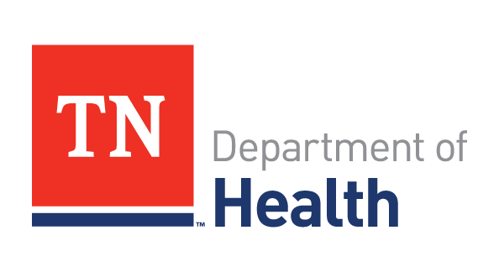
JOHN J. DREYZEHNER, MD, MPH BILL HASLAM COMMISSIONER GOVERNOR

The mission of the Tennessee Department of Health is to protect, promote and improve the health and prosperity of people in Tennessee
AGENDA:
- Introduction
- Emergency Rule Making Hearing Concerning GSA Change 8

Electronic Emergency Medical Services Board
November 24th, 2015
Iris Room
665 Mainstream Drive
Nashville TN 37243

PLEASE REMEMBER TO SILENCE YOUR ELECTRONIC DEVICES WHEN
THE BOARD IS IN SESSION

