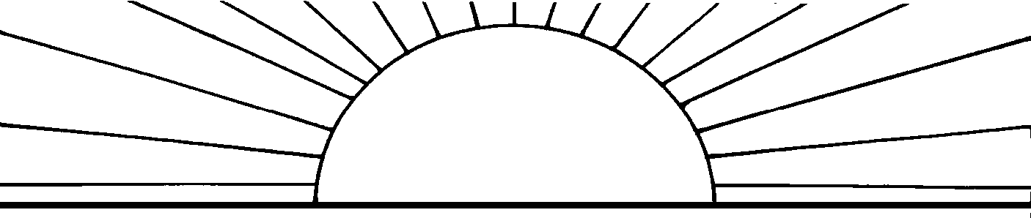
The Tennessee Open Meetings Act passed by the General Assembly in 1974 requires that meetings of state, city and county government bodies be open to the public and that any such governmental body give adequate public notice of such meeting.

TENNESSEE DEPARTMENT OF HEALTH
MEMORANDUM

Date: February 11, 2016

To: Shelley Walker, Director of Communications and Media Relations
Amber Ricks, Commissioner Office
Michelle Long, Assistant Commissioner,
Bureau of Health Licensure and Regulation

From: Donna G. Tidwell, Director of Emergency Medical Service

Name of Board or Committee: Committee of Pediatric Emergency Care -
Joint Committee of the Board of Emergency Medical Services and the Board for Licensing Health Care Facilities

Date of Meeting: February 18, 2016

Time: 11:00 a.m. to 3:00 p.m. Central Time
Place: Lentz Center Metro Public Health Department
2500 Charlotte Ave.
Nashville, TN 37209

Major Item(s) on Agenda: See Attached Agenda

This memo shall be forwarded from individual programs to the Public Information Office on the 15th day of the preceding month. The Public Information Office will prepare the monthly list of meetings within the Department and have ready for distribution to state media by the 28th day of the preceding month.

PH-1850 (Rev. 3/79) RDA N/A

JOHN J. DREYZEHNER, MD, MPH BILL HASLAM COMMISSIONER GOVERNOR

The mission of the Tennessee Department of Health is to protect, promote and improve the health and prosperity of people in Tennessee

AGENDA:

- Introduction
  - Introduction and Roll Call – Dr. Barry Gilmore, CoPEC Chair
- Star of Life presentation
- Membership welcome – Angie Bowen & Kate Copeland, Membership Co-Chairs
  - Q and A
- Upcoming PECF meeting – March 14th
- Address outstanding business if needed
- Task force meeting time
  - Data
  - Membership
  - Standardization
  - Funding
  - Branding

Committee of Pediatric Emergency Care -
Joint Committee of the
Board of Emergency Medical Services and the Board for Licensing Health Care Facilities
February 18, 2016
Lentz Public Health Center
2500 Charlotte Ave. Nashville, TN 37209

PLEASE REMEMBER TO SILENCE YOUR ELECTRONIC DEVICES WHEN
THE BOARD IS IN SESSION

